**The Big Picture *Grade Level***

*Unit 8: Civil War*

|  |  |  |  |  |  |
| --- | --- | --- | --- | --- | --- |
| Name: |  | Date: |  | Period: |  |

**Part I: Analyze an Image**

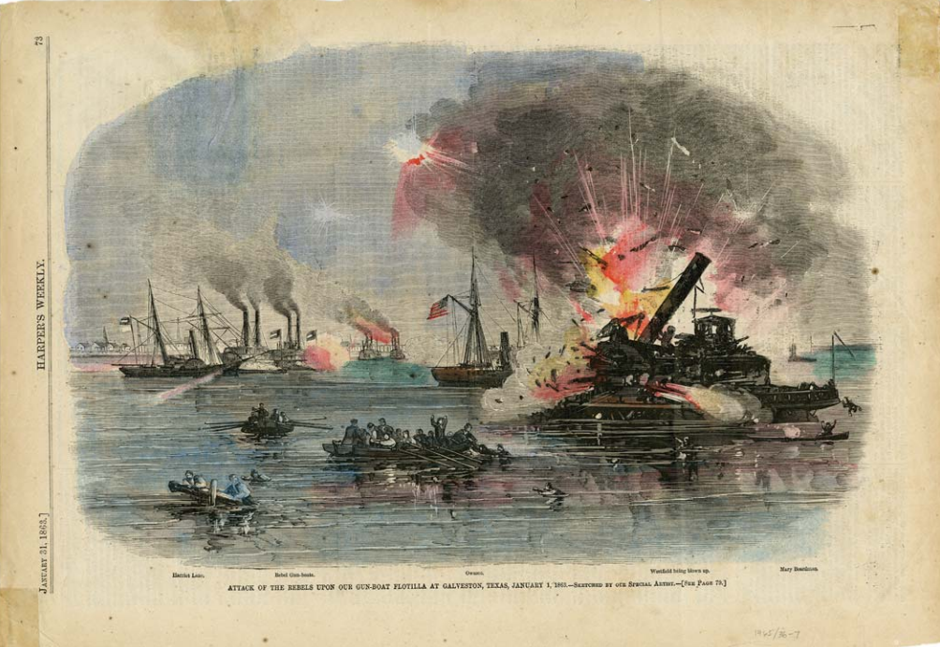

Figure 1: Harper’s Weekly, January 31, 1863, “Attack of the Rebels Upon Our Gun Boat Flotilla at Galveston. Texas State Library and Archives Commission

1. What are two things you observe about the image above?
2. What is one thing you can infer about this era of Texas history based on the image?
3. What do you predict we will see in this unit based on the image?

**Part II: Essential Ideas Reading Passage**

In the previous unit, Early Statehood, Texas joined the United States and quickly grew as a new state within the U.S. People flooded into Texas during the 1850s, mostly from other cotton-producing slave states in the South. As sectional tensions increased between the North and the South over the issue of slavery, the majority of Texans sided with the other Southern slave states.

When an anti-slavery Northerner named Abraham Lincoln was elected president in 1860, many states in the South decided to secede from the U.S. They called themselves the Confederate States of America, or simply the Confederacy. Texas was one of the eleven Southern states that seceded from the Union after Lincoln was elected president. Growing issues between the anti-slavery North and the pro-slavery Confederacy quickly led to a bloody civil war that raged from 1861 to 1865.

The Civil War was the deadliest war in American history, killing more than 750,000 people. Approximately 70,000 Texans served in the war. Most Texans fought for the South in the Confederate army, though a small number of Texans joined the war on the side of the North. The majority of the war was fought far from Texas in far-eastern states like Virginia, Maryland, and Pennsylvania. While some Texans served in the east at places like Gettysburg and Antietam, most Texas soldiers fought closer to home in states like Kentucky, Tennessee, and Mississippi.

Very few battles occurred in Texas, so the state did not experience the level of violence and destruction that occurred in other Southern states. As a result, Texas was able to play a unique role during the Civil War. Texans continued to grow important crops like corn and cotton to help support the Confederate war effort. Texas was able to continue taking part in international trade by moving its goods through Mexico. This allowed Texans to get around the Union navy’s blockade of southern ports. Additionally, Texas provided a safe haven for Southerners who hoped to escape the violence and destruction in the east.

On April 9, 1865, the main Confederate army officially surrendered to the Union, ending the Civil War. Two months later, Union troops arrived in Galveston, Texas, on June 19, 1865. The Union troops announced the end of the Civil War and declared that all enslaved people in the Texas were now free. After four bloody years, the United States faced the challenging task of how to move forward as a nation.

1. Consider the sectional division that divided the Northern and Southern states during this era of Texas history. What side of the sectional divide did the majority of Texans support, and why?

|  |  |
| --- | --- |
| Choose **ONE** answer below to begin your response | Choose **ONE** answer below to complete your response |
| 1. The majority of Texans supported the North because… 2. The majority of Texans supported the South because… | 1. …the abolition movement in Texas had been growing in strength since 1850. 2. …Texas economy depended on slave labor, and most Texans were from Southern states 3. …they supported the Republican president Abraham Lincoln and his anti-slavery platform. 4. … the rapid population growth of Texas had increased the population of immigrants from Central European countries like Germany. |

1. Complete the chart below to provide information from the reading about each of the two opposing sides who were fighting each other during the Civil War. Place a checkmark under the correct section of the U.S. for each characteristic.

|  |  |  |
| --- | --- | --- |
| Sectional Characteristic | Union | Confederacy |
| Composed of Northern states like New York, Massachusetts, and Pennsylvania, as well as western states like California and Oregon. |  |  |
| Composed of Southern states like Virginia, Georgia, Mississippi, and Texas. |  |  |
| Largely supported slavery and secession |  |  |
| An economy based on smaller farms using free labor with a growing manufacturing industry |  |  |
| Largely opposed slavery and secession |  |  |
| An economy based on plantation agriculture growing cash crops using enslaved labor |  |  |

1. Name three ways that Texas was significant to the Confederate war effort.