Vocabulary Advanced
Unit 8: Civil War

Name: |  | Date: |  | Period:

Directions: Use the vocabulary readings on the slideshow presentation to complete the chart below.
Secede (v)

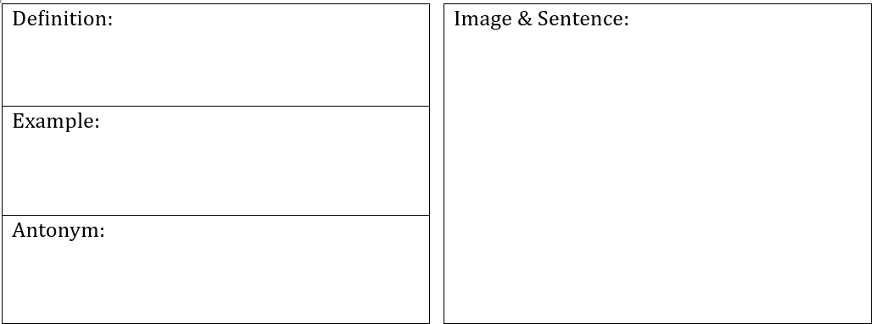

The Confederacy (n)

The Union (n)

Theater (n)
Blockade (n, v)
Emancipation (n)

Casualties (n)

