# **Vocabulary *Grade Level***

*Unit 8: Civil War*

|  |  |  |  |  |  |
| --- | --- | --- | --- | --- | --- |
| Name: |  | Date: |  | Period: |  |

***Directions***: Use the vocabulary readings on the slideshow presentation to complete the chart below.

|  |
| --- |
| **Secede *(v)*** |

|  |
| --- |
| Definition |
| Example |
| Image |

|  |
| --- |
| **The Confederacy *(n)*** |

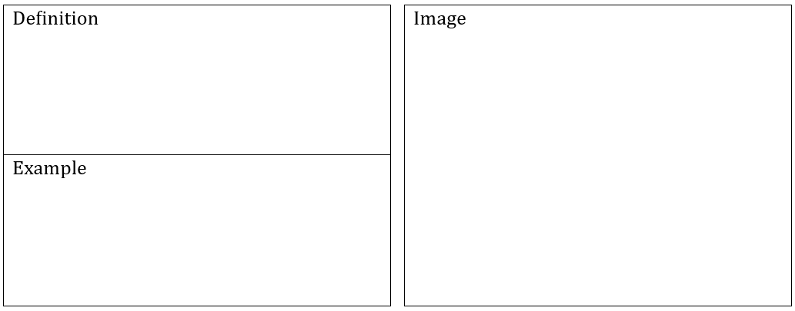

|  |
| --- |
| **The Union *(n)*** |



|  |
| --- |
| **Theater *(n)*** |



|  |
| --- |
| **Blockade *(n, v)*** |



|  |
| --- |
| **Emancipation *(n)*** |



|  |
| --- |
| **Casualties *(n)*** |

