Vocabulary Grade Level
Unit 8: Civil War

Name: |  | Date: |  | Period:

Directions: Use the vocabulary readings on the slideshow presentation to complete the chart below.

Secede (v)

Definition
Example
Image

The Confederacy (n)
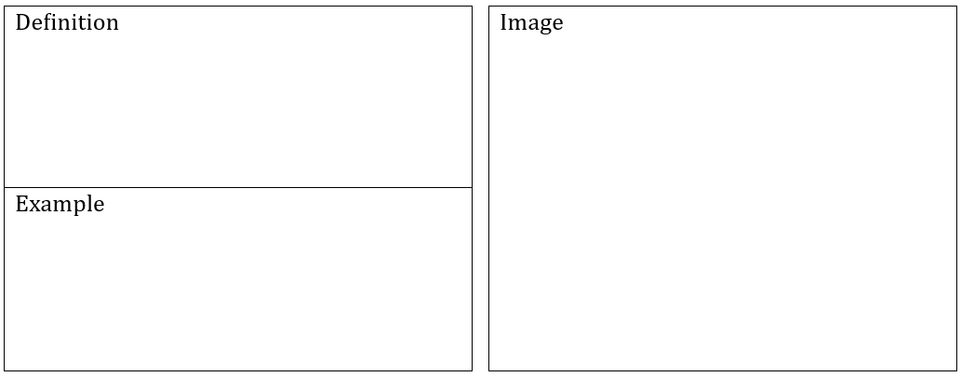

The Union (n)
Theater (n)
Blockade (n, v)
Emancipation (n)

Casualties (n)

