Station 1: The Rise of the Beef Industry
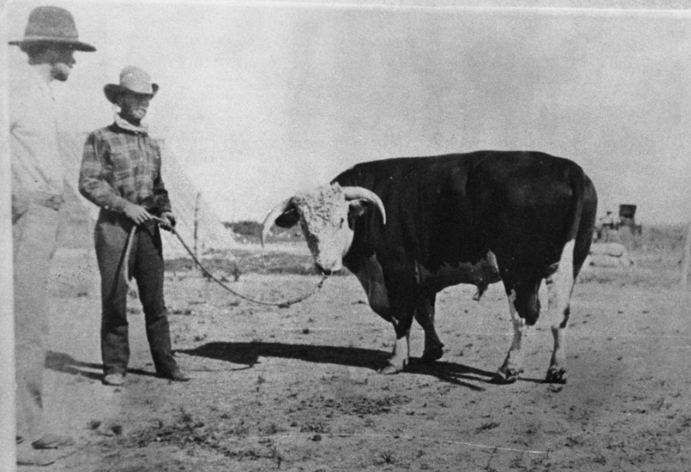
Figure 1: Sir Bredwell at C.C. Slaughter's Lazy "S" Ranch, photograph, 1900.
The Portal to Texas History

1500s – 1865 | 1865 – 1900
Cattle were first introduced to Texas by the Spaniards in the 1500s. Before the Civil War, however, the cattle industry in Texas was primarily composed of small farms raising cattle for hides and tallow (fat used for candles, cooking, and some ointments.) Beef was not yet a popular meat for most to consume.  When the Civil War broke out in 1861, many Texas men left their ranches and farms to serve in the war. During the war, the Texas cattle trade with Northern states was largely closed because of the conflict.  As a result, the cattle population in Texas increased steadily during the Civil War from approximately 3 to 6 million by the end of the war. Texans returning home after their service came back to an abundance of cattle, and Northern markets were available to them once more. | After the Civil War, many Northern states faced a lack of cattle, since most Northern cattle had been used to feed the Union armies during the war.  While the North faced beef shortages, cattle in Texas were abundant. A cow that cost $4.00 in Texas could be sold for $40.00 in Northern states. There were so many wild cows, in fact, that cowboys could simply round up wild cattle and drive them to railroad lines in Kansas and other states and make a significant profit.  The incredible success of the Texas cattle industry led to the establishment of large ranches in the Great Plains. When ranchers then closed off their land and water resources with barbed wire, the cattle drives came to an end. Cattle were then shipped to market on railroad lines, which had expanded throughout the state.

Station 2: Cattle Drive Trails

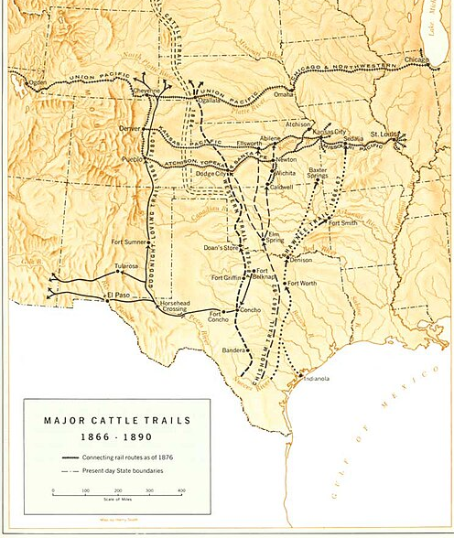  Figure 2: Historical map of cattle drives north from Texas.  National Park Services. | Some of the first major cattle drive trails were established in the eastern part of Texas. As the era of Cotton, Cattle, and Railroads progressed, more trails were established in the western parts of the state.  The first trails utilized during the era included the Shawnee Trail, which shared a similar route with another significant trail (not pictured here) called the Sedalia Trail.  Soon, more trails were established during this era that became important for cattle drives. These trails included the Chisholm Trail, Western Trail, and the Goodnight-Loving Trail.

All of these trails connected to major railroad lines like the Union Pacific in Nebraska and the Kansas Pacific and Santa Fe railroads in Kansas. Cattle were then shipped to various markets around the U.S. from these major railroad lines.

Station 3: Texas Cattle Fever

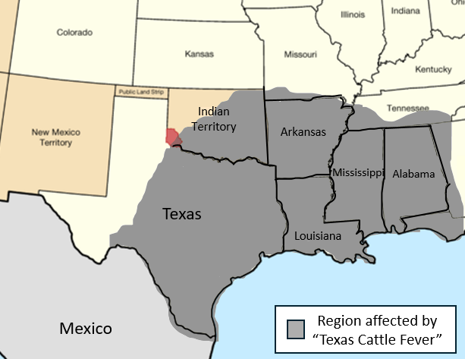
In the 1860s, cattle herds in Northern states started becoming ill and dying whenever they came into contact with Texas herds, though Texas cattle appeared healthy and did not suffer the same fate. Many people began referring to this illness in livestock as the “Texas cattle fever,” or simply “Texas fever.”
Texas fever had a significant impact on cattle drives and the Texas beef industry. Northern states began pushing for trails to be redirected away from their ranches to protect their cattle from the illness, and many northern destinations on the cattle drives required quarantines for Texas herds. This slowed the progress of Texas cattle to market. In 1885, the Kansas government completely prohibited Texas herds from being driven through its state borders. Many of the original trails in east Texas were abandoned and new trails opened in west Texas to avoid the more populated areas of states north of Texas.
Though the cause of Texas fever was initially a mystery, eventually it was determined to be caused by ticks. Texas cattle were raised among the ticks carrying the disease and therefore had developed immunity to it that other cattle in the North did not share. Moving trails farther west helped cowboys avoid many of the challenges associated with Texas fever.

Station 4: Life as a Cowboy

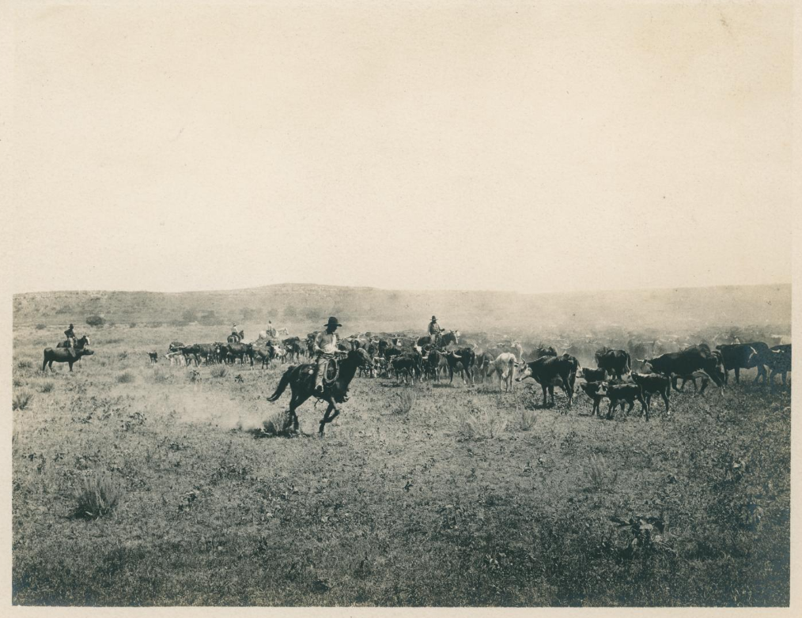
Figure 3: Cowhands guiding a herd of cattle. The Portal to Texas History.

Cowboys existed in Texas long before the era of Cotton, Cattle, and Railroads, with Spanish cowboys known as vaqueros taking part in ranching since the 1500s. Despite the long history of cowboys in the state, the most popular and enduring image of Texas cowboys today originated during the era of Cotton, Cattle, and Railroads.
Life as a cowboy on a cattle drive was often difficult and even dangerous. Cowhands worked long hours on the trails for months at a time managing herds of hundreds or thousands of cattle. Most cowboys did not carry firearms because the sound of gunfire spooked the herd, which could lead to dangerous stampedes.
Usually, eight to ten cowhands took part in each cattle drive under the direction of a trail boss. While trail bosses earned about $125 per month on average (approximately $4,000 today,) cowhands were typically paid very little. The average pay for a cowboy on a cattle drive was about $35 a month (approximately $1,000 today), which was difficult to live on in the late 1800s.

Station 5: Mega Ranches

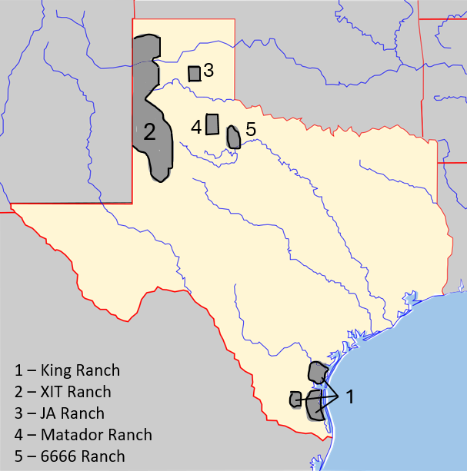 | The cattle industry in Texas grew rapidly during this era due to the abundance of Texas cattle and the high demand for beef in the North. As the industry grew, investors from Northern states like Illinois and even other countries like England began investing money in Texas cattle.  In 1853, a man named Richard King established the King ranch in south Texas. During the era of Cotton, Cattle, and Railroads, the King ranch grew significantly to include more than 600,000 acres and hundreds of thousands of cattle.

In 1879, the Texas state capitol building in Austin was destroyed by fire. To finance the construction of a new building, the state legislature sold 3 million acres in the Texas panhandle to investors in Chicago and London, who established the XIT ranch in 1885. The proceeds of the sale financed the construction of the new capitol without requiring significant taxes or government spending.
In 1876, a cattleman named Charles Goodnight, who had experienced a lot of success as a cowboy in the early years of the cattle drives, established the JA ranch in the panhandle with an English investor named John Adair. The JA ranch spanned 1.3 million acres and held 100,000 cattle. Many other ranches were established during this era as the cattle industry expanded throughout the western part of the state.
Ranchers used innovations like windmills to bring water to their herds in the more arid Great Plains region and barbed wire to fence in their land and water resources. This prevented cowboys on cattle drives from being able to access important land and resources, essentially bringing cattle drives to an end.
Station 6: Innovations

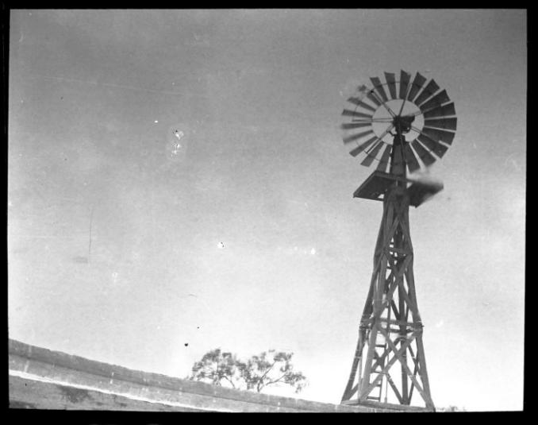  Figure 4: A windmill in Texas. The Portal to Texas History | In the 1870s, ranchers in Texas began using windmills to bring water to their land and livestock in more arid regions of Texas like the Great Plains.  When the wind turns the blades of a windmill, the movement of the blades operates a pump that can transport water from its source over long distances. In this way, ranchers were able to provide water to their herds in the windy Plains region where water sources were scarce.
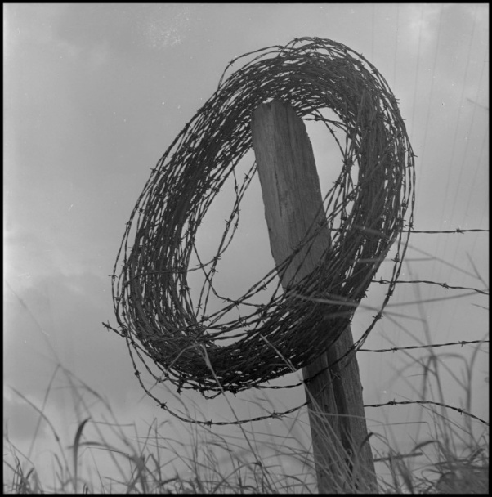  Figure 5: A coil of barbed wire on a fence post.  The Portal to Texas History | In 1873, an Illinois farmer named Joseph Glidden applied for a patent for barbed wire. Glidden was not the first to create the spiked wire, though his wire improved on existing barbed wire by twisting 2 strands of wire together, making it stronger and more stable.  By 1880, 80 million pounds of Glidden’s barbed wire were sold in the U.S. Barbed wire became popular with farmers and ranchers because it was the cheapest way to make strong, durable fencing. Soon, ranchers in Texas were using barbed wire to fence in their property, making large portions of the Plains inaccessible to cowboys on cattle drives.

Patent: An official government license giving someone exclusive rights to create a specific product and profit from the sale of it.

