
Warm-up: Cattle and Cowboys
Unit 10: Cotton, Cattle, and Railroads
Name: |  | Date: |  | Period:

- What do you observe about this image?  - What do you think is happening in this image? | 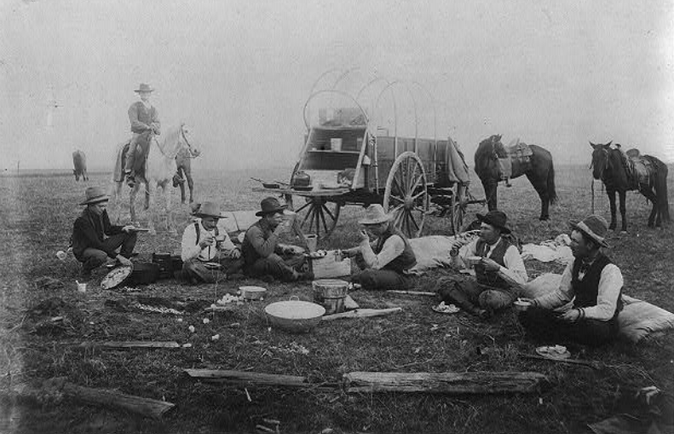  Figure 1: Library of Congress

Warm-up: Cattle and Cowboys
Unit 10: Cotton, Cattle, and Railroads
Name: |  | Date: |  | Period:

- What do you observe about this image?  - What do you think is happening in this image? | Figure 1: Library of Congress


Cattle and Cowboys Exit Ticket

“We arrived at our destination, Joe Taylor’s ranch, on Paint creek a small tributary to the Llano, at last; and it was one of the roughest, rockiest, God-forsaken countries I ever put foot on. We finally, after three weeks hard work, got the herd of twenty-five hundred head started towards the north star. We were awful glad to get out of there too, for our horses were all nearly peetered out, and the men on the war-path, from having to work twenty-six hours a day.”
- Siringo, Charles A. “A Texas Cow Boy.” 1885. Umbdenstock & Company, publishers, 1885.

- How does the passage above relate to the information about cattle and cowboys that we learned in this lesson today?
  - The passage demonstrates the difficult life of a cowboy, including traveling long distances and working long hours every day.
  - The passage demonstrates the low pay that cowboys were forced to accept for their hard work on each cattle drive.
  - The passage demonstrates the dangers that cowboys faced from the elements on the Plains and the possibility of raids by American Indians.
  - All answers are correct.

Cattle and Cowboys Exit Ticket

“We arrived at our destination, Joe Taylor’s ranch, on Paint creek a small tributary to the Llano, at last; and it was one of the roughest, rockiest, God-forsaken countries I ever put foot on. We finally, after three weeks hard work, got the herd of twenty-five hundred head started towards the north star. We were awful glad to get out of there too, for our horses were all nearly peetered out, and the men on the war-path, from having to work twenty-six hours a day.”
- Siringo, Charles A. “A Texas Cow Boy.” 1885. Umbdenstock & Company, publishers, 1885.

- How does the passage above relate to the information about cattle and cowboys that we learned in this lesson today?
  - The passage demonstrates the difficult life of a cowboy, including traveling long distances and working long hours every day.
  - The passage demonstrates the low pay that cowboys were forced to accept for their hard work on each cattle drive.
  - The passage demonstrates the dangers that cowboys faced from the elements on the Plains and the possibility of raids by American Indians.
  - All answers are correct.

