
Warm-up: Frontier Wars
Unit 10: Cotton, Cattle, & Railroads
Name: |  | Date: |  | Period:

- What do you observe about the image?  - What can you infer about this lesson based on the image? | 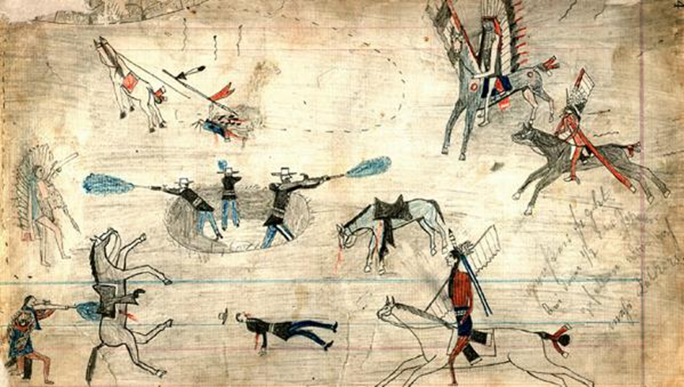  Figure 1: Kiowa Ledger Drawings of the Red River War, 1870s - 1890s. The Newberry Library.

Warm-up: Frontier Wars
Unit 10: Cotton, Cattle, & Railroads
Name: |  | Date: |  | Period:

- What do you observe about the image?  - What can you infer about this lesson based on the image? | Figure 1: Kiowa Ledger Drawings of the Red River War, 1870s - 1890s. The Newberry Library.

Frontier Wars Exit Ticket

Writing Prompt: Explain one major challenge related to the west Texas frontier during the era of Cotton, Cattle, & Railroads, and explain the effect and significance of the challenge you describe.
One major challenge related to the west Texas frontier during the era of Cotton, Cattle, & Railroads was _______________________________________________________________________________________________________________. This challenge was one factor that led to conflict between the _______________________________________________ and __________________________________________________________. One result of conflicts between these groups was that ____________________________________________________________________________________________________________ _____________________________________________________________________________________________________________________

Frontier Wars Exit Ticket

Writing Prompt: Explain one major challenge related to the west Texas frontier during the era of Cotton, Cattle, & Railroads, and explain the effect and significance of the challenge you describe.
One major challenge related to the west Texas frontier during the era of Cotton, Cattle, & Railroads was _______________________________________________________________________________________________________________. This challenge was one factor that led to conflict between the _______________________________________________ and __________________________________________________________. One result of conflicts between these groups was that __________________________________________________________________________________________________________ _____________________________________________________________________________________________________________________

