
Warm-up: Looking Ahead
Unit 10: Cotton, Cattle, & Railroads
Name: |  | Date: |  | Period:

What do you observe about the image?  What do you predict we will see in the next unit based on your observations? | 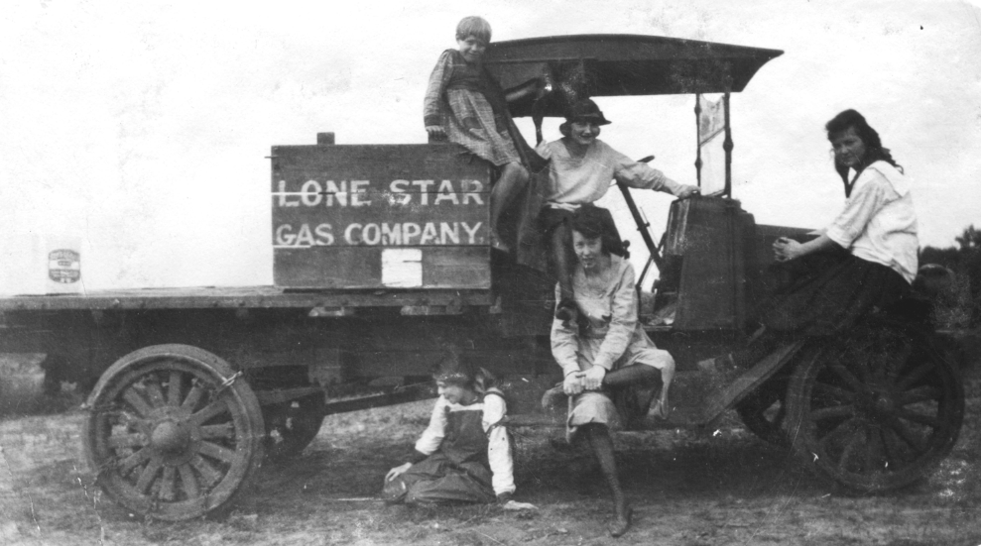  Figure 1: Lonestar Gas Company truck, 1910. The Portal to Texas History.

Warm-up: Looking Ahead
Unit 10: Cotton, Cattle, & Railroads
Name: |  | Date: |  | Period:

What do you observe about the image?  What do you predict we will see in the next unit based on your observations? | Figure 1: Lonestar Gas Company truck, 1910. The Portal to Texas History.


Looking Ahead Exit Ticket

- Which statement below provides an accurate summary of one of the key defining characteristics of our next unit, the Age of Oil?
  - The discovery of enormous quantities of oil in Texas led to significant changes in the Texas economy and society that would have a lasting impact on the U.S. and the world.
  - The discovery of oil at Spindletop initiated a rapid decline in the amount of oil and natural gas production in Texas, leading states like Ohio to become leading produces in the U.S.
  - The Lucas Geyser at Spindletop near Beaumont, Texas produced approximately 100,000 barrels of oil a day for nine days before the geyser was brought under control.
  - All answers are correct.

Looking Ahead Exit Ticket

- Which statement below provides an accurate summary of one of the key defining characteristics of our next unit, the Age of Oil?
  - The discovery of enormous quantities of oil in Texas led to significant changes in the Texas economy and society that would have a lasting impact on the U.S. and the world.
  - The discovery of oil at Spindletop initiated a rapid decline in the amount of oil and natural gas production in Texas, leading states like Ohio to become leading produces in the U.S.
  - The Lucas Geyser at Spindletop near Beaumont, Texas produced approximately 100,000 barrels of oil a day for nine days before the geyser was brought under control.
  - All answers are correct.

