Looking Ahead Foundations
Unit 10: Cotton, Cattle, & Railroads

Name: |  | Date: |  | Period:

Part I: Oil at Spindletop!
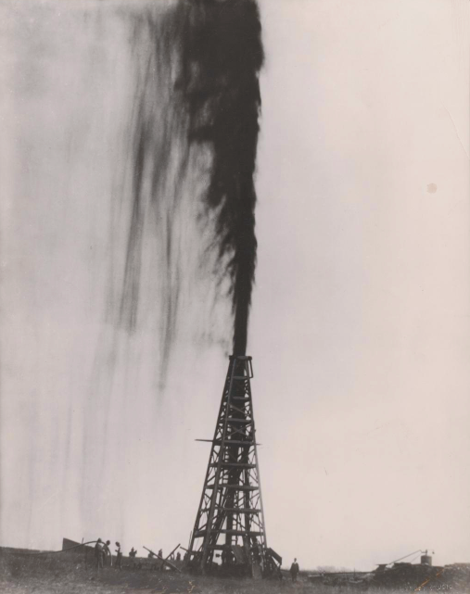  Figure 1: The Lucas gusher at Spindletop oil field, Beaumont, TX.  The Portal to Texas History. | On the morning of January 10, 1901, Anthony F. Lucas stood near an oil well he had established three months earlier at a place known as Spindletop near Beaumont, Texas. After three months of drilling, the ground under Lucas’s feet began to rumble, and mud bubbled up from the well.  Then, at 10:30 AM, a powerful stream of oil burst out of the ground, shooting more than one hundred feet into the air. It took nine days for Lucas and his team to get control of the geyser. By the time they managed to control the Lucas geyser, it had released an estimated 900,000 barrels of oil, which now lay in pools on the ground all around the oil well at Spindletop.

“Imagine a big column of midnight blackness shooting up from a hole in the ground to a sheer height of 150 feet, overtopping the scaffolding around the well and falling with the reverberations of distant thunder. The whole place reeks of oil. It is in the air, on the grass, and falls in a mist over the whole place. There is already a small lake of crude oil formed by the geyser, and in order to get anywhere near the well we had to roll up our trousers to the knees to avoid the oil that lies on the grass adjacent to the well.”  - Galveston Tribune. (Galveston, Tex.) Monday, January 14, 1901. The Portal to Texas History | Scaffolding: A temporary structure built to support something  Reeks: Smells strongly  Crude oil: oil straight from the ground, before it’s been processed.  Trousers: Pants  Adjacent to: Next to

Part II: Texas in the Age of Oil
Overnight, Texas was transformed by oil as people rushed in to take part in the state’s new oil industry. People flocked to new oil boom towns and other Texas cities all over the state in search of opportunities. Oil and the rapid urbanization it caused dramatically changed Texas, the United States, and the world.
“In the year 1900 the State of Texas produced 836,039 barrels of crude petroleum, entitling it to seventh place in the list of petroleum producing states ….The importance of the Spindletop strike will be fully appreciated when it is stated that the drilling of wells which followed the coming in of the Lucas gusher developed a production of petroleum which, according to the records of the United States Geological Survey, amounted to 17,852,308 barrels in the year 1902. This production from the Spindletop pool advanced Texas to second place in the rank of petroleum producing states, Ohio leading by about 3,000,000 barrels. But it had a wider influence by swelling the total production of the United States to a point exceeding the production of the Russian fields, and thus giving to this country first place among the petroleum producing countries of the world.”  - “Texas Almanac and State Industrial Guide for 1904.” The Portal to Texas History. | Crude Petroleum: oil straight from the ground, before processing.  Strike: Oil discovery  Barrel: One barrel holds 42 gallons of oil.  Swelling: Increasing  Exceeding: More than

Writing Prompt: In three complete sentences, explain ONE of the ways in which the discovery of oil at Spindletop was significant to both Texas and the United States. Give examples and evidence from the material to support your claims.
The discovery of oil at Spindle was significant to both Texas and the United States in a number of ways. One significant way that oil changed Texas and the United States is ________________________________________________________________________________________________ _____________________________________________________________________________________________________.
The Spindletop oil discovery changed Texas, U.S., and world history forever.

