 Warm-up: Mind Map Review
Unit 10: Cotton, Cattle, & Railroads
Name: |  | Date: |  | Period:

Look at the word bank below. Complete the mind map diagram by putting each term where you think it fits best.

- Farming  - Cotton, Cattle, & Railroads  - Westward Expansion  - Falling Cotton Prices  - Conflict with Plains Tribes | 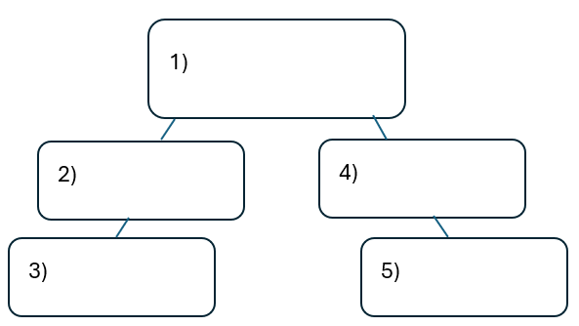

Warm-up: Mind Map Review
Unit 10: Cotton, Cattle, & Railroads
Name: |  | Date: |  | Period:

Look at the word bank below. Complete the mind map diagram by putting each term where you think it fits best.

- Farming
- Cotton, Cattle, & Railroads
- Westward Expansion
- Falling Cotton Prices
- Conflict with Plains Tribes

Exit Ticket: Mind Map Review
Unit 10: Cotton, Cattle, & Railroads
Name: |  | Date: |  | Period:

Directions: Complete the sentence by choosing the best answer for each blank from the chart below.
The (1) ____________ era is primarily characterized by (2)____________

Answer choices for blank (1)  Circle the best answer | Answer choices for blank (2)  Circle the best answer
- Cotton, Cattle, & Railroads  - Industrialization and Urbanization  - Progressive Reform  - Westward Expansion | - The laws passed to limit Southern Black citizens and the push for farmers to gain protections from big corporations.  - The rise in the beef industry, farmer and labor organizations, and the forced removal of American Indians from the Plains.  - The decline in the beef industry in the South as a result of challenges including Texas Fever, decreased demand in Northern states, and conflict with Plains tribes.

Exit Ticket: Mind Map Review
Unit 10: Cotton, Cattle, & Railroads
Name: |  | Date: |  | Period:

Directions: Complete the sentence by choosing the best answer for each blank from the chart below.
The (1) ____________ era is primarily characterized by (2)____________

Answer choices for blank (1)  Circle the best answer | Answer choices for blank (2)  Circle the best answer
- Cotton, Cattle, & Railroads  - Industrialization and Urbanization  - Progressive Reform  - Westward Expansion | - The laws passed to limit Southern Black citizens and the push for farmers to gain protections from big corporations.  - The rise in the beef industry, farmer and labor organizations, and the forced removal of American Indians from the Plains.  - The decline in the beef industry in the South as a result of challenges including Texas Fever, decreased demand in Northern states, and conflict with Plains tribes.

