Texas Today Advanced
Unit 10: Cotton, Cattle, & Railroads

Name: |  | Date: |  | Period:

Part I: The Texas Railroad Commission
The Texas Railroad Commission was established by the state legislature under Governor James Hogg in 1891 to regulate railroads as they expanded across the state.  Today, the Railroad Commission has grown into one of the most significant regulating bodies in the whole United States.  So, how did this happen? Let’s take a look! | 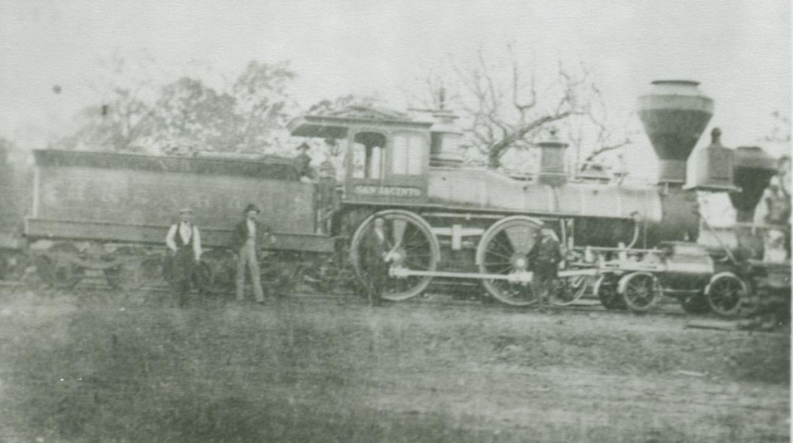  Figure 1: A railroad in Longview, Texas. 1870.  The Portal to Texas History.

From 1870 to 1900, railroads were expanding rapidly across Texas, and many farmers in east Texas were using the railroads to ship their cotton crops to market. In many places, in fact, the only available transportation for shipping crops was the railroads. With little competition, railroad companies often charged high rates to ship goods, making it very difficult for many farmers who were already struggling due to falling cotton prices.
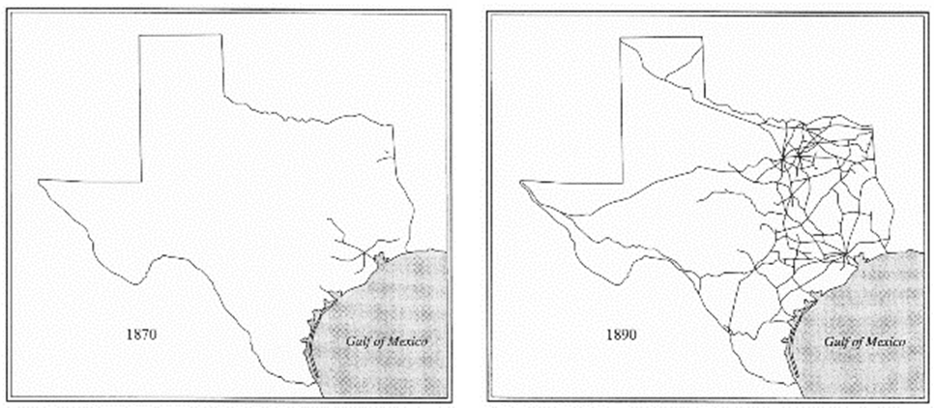
High railroad rates were just one of the larger economic challenges farmers faced during this era. The dramatic decrease in cotton prices meant that farmers were paid less for their crops.  As a result, farmers grew more cotton hoping to increase their profit, but the increase in cotton production flooded the market, causing prices to drop even further. | 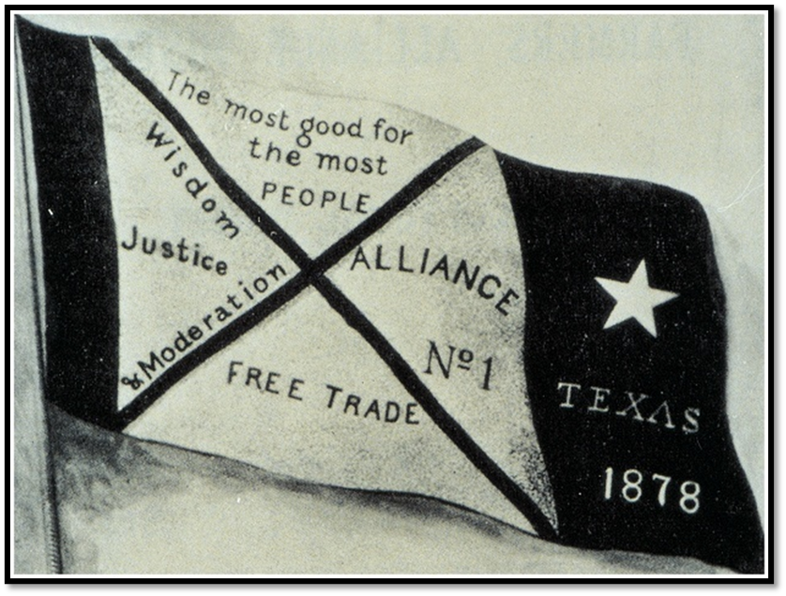  Figure 2: The banner of the Farmer's Alliance.
Many farmers went into debt, unable to afford their basic expenses. Nearly half of all Texas farmers during this era turned to tenant farming, which means they were renting land for farming and paying a portion of their crop as rent to their landlord. Often, the small income from farming cotton was not enough to cover rent and expenses like railroad rates, leading farmers into cycles of increasing debt.
During this period, farmers organized groups like the Grange and the Farmer’s Alliance to provide support for struggling farmers and work for political reforms that would benefit farmers. One reform these farmers’ organizations wanted was government regulation of railroads to prevent them from charging excessive fees to transport cotton crops.
In 1891, a man named James Hogg ran for governor of Texas. In order to gain the support of farmers across the state, Hogg promised to establish a state agency to regulate the railroads and prevent price gouging. With the support of most farmers in the state as well as the Farmer’s Alliance, Hogg was elected governor in 1891, and he established the Railroad Commission to fulfill his campaign promise to the farmers. Despite Hogg’s establishment of the Railroad Commission, most farmers felt the commission did not do enough to regulate railroads and protect the farmers, prices remained high, and many continued to struggle.
In the early 1900s, oil was discovered in larger quantities than ever before in Texas. The responsibilities of the Railroad Commission expanded to include regulation of the oil industry in Texas and later, its responsibilities expanded again to include the regulation of natural gas. With these new responsibilities, the Railroad Commission has held enormous influence over the supply and price of oil and natural gas throughout the United States, making one of the most important regulatory agencies in the nation.
Part II: Comprehension Questions
Quick Facts

- Why was the Texas Railroad Commission established?
- When was it established?
- Which Texas governor’s administration established the Commission?

- Why did farmers want an organization like the Railroad Commission to be established? Describe the economic situation in Texas in the late 19th century that led to its founding.

- In addition to advocating for railroad regulations, what other steps did farmers take to address the many challenges they faced?

- Were most farmers satisfied with the work of the Railroad Commission? Why or why not?

- How did the responsibilities of the Railroad Commission change over time and what is its significance today?

Price Gouging: Charging much more than is considered reasonable or fair for a product or service.

