Texas Today Foundations
Unit 10: Cotton, Cattle, & Railroads

Name: |  | Date: |  | Period:

Part I: The Texas Railroad Commission
The Texas Railroad Commission was established by the state legislature under Governor James Hogg in 1891 to regulate railroads as they expanded across the state.  Today, the Railroad Commission has grown into one of the most significant regulating bodies in the whole United States.  So, how did this happen? Let’s take a look! | 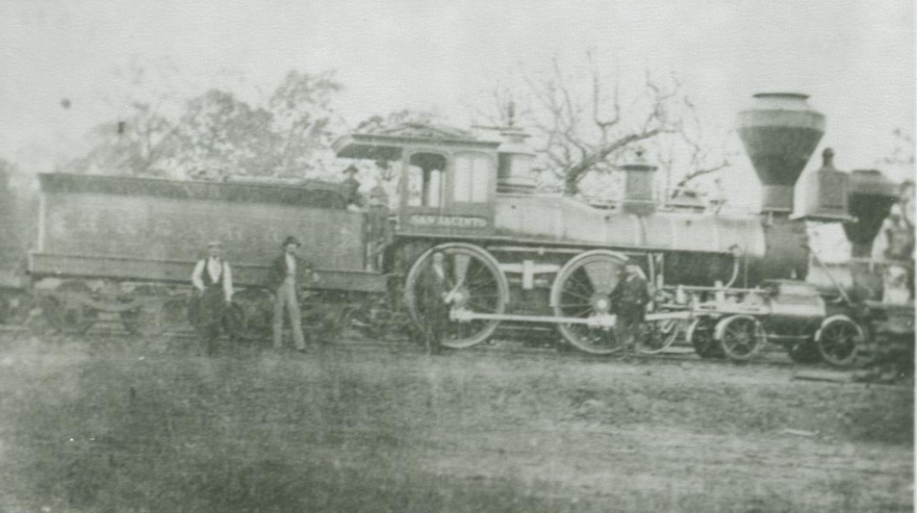  Figure 1: A railroad in Longview, Texas. 1870.  The Portal to Texas History.

From 1870 to 1900, railroads were expanding rapidly across Texas. Many farmers in east Texas were using the railroads to ship their cotton crops to market. In many places, in fact, railroads were the only available transportation to ship crops. As a result, railroad companies were able to charge whatever they wanted. High railroad rates made it very difficult for many farmers who were already struggling due to falling cotton prices.
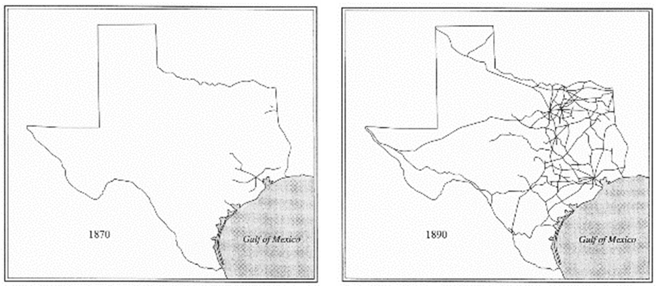
Farmers faced many additional economic challenges at this time. Cotton prices fell dramatically, meaning farmers were paid less for their crops.  As a result, farmers grew more cotton hoping to increase their profit. This became a problem, however, because there was too much cotton available and not enough people buying it, and prices fell even lower. | 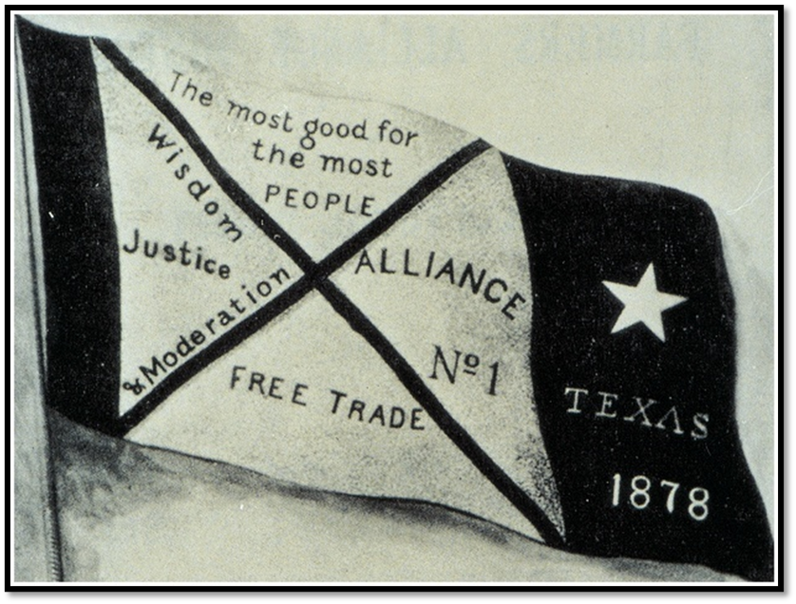  Figure 2: The banner of the Farmer's Alliance.
Many farmers went into debt, unable to afford their basic expenses. Nearly half of all Texas farmers during this era turned to tenant farming, which means they were renting land for farming and paying a portion of their crop as rent to their landlord. Often, the small income from farming cotton was not enough to cover rent and expenses like railroad rates. This led farmers into cycles of increasing debt.
During this period, farmers organized groups like the Grange and the Farmer’s Alliance to provide support for struggling farmers and work for political reforms that would benefit farmers. One reform these organizations wanted was government regulation of railroads to prevent them from charging excessive fees to transport cotton crops.
In 1891, a man named James Hogg ran for governor of Texas. In order to gain the support of farmers across the state, Hogg promised to establish a state agency to regulate the railroads and prevent price gouging. Hogg was elected governor in 1891 with the support of most Texas farmers as well as the Farmer’s Alliance. He established the Railroad Commission to fulfill his campaign promise to the farmers. Despite Hogg’s establishment of the Railroad Commission, most farmers felt the commission did not do enough to regulate railroads and protect the farmers. Many Texas farmers continued to struggle.
In the early 1900s, oil was discovered in larger quantities than ever before in Texas. The responsibilities of the Railroad Commission expanded to include regulation of the oil industry in Texas. Later, its responsibilities expanded again to include the regulation of natural gas. With these new responsibilities, the Railroad Commission has held enormous influence over the supply and price of oil and natural gas throughout the United States, making one of the most important regulatory agencies in the nation.
Part II: Comprehension Questions
Quick Facts

- Why was the Texas Railroad Commission established? | To __________________ railroads as they expanded across the state
- When was it established? | 1890 1891 1892 1893
- Which Texas governor’s administration established the Commission? | Sam Houston Richard Coke  James Hogg Elisha M. Pease

- Why did farmers want an organization like the Railroad Commission to be established? Choose TWO.
  - Farmers were struggling financially due to falling cotton prices.
  - Farmers wanted easier access to railroads that were often far from their farms.
  - Farmers sought jobs with the railroads to avoid tenant farming.
  - Farmers wanted organizations like the Grange to have more say over railroad practices.
  - Farmers couldn’t afford to pay the high shipping rates railroads charged.

- In addition to advocating for railroad regulations, what other steps did farmers take to address the many challenges they faced? Choose THREE.
Refusing to grow cotton until prices increased. | Forming organizations like the Farmer’s Alliance. | Running for high offices like governor and president.
Taking part in organizations like the Grange. | Boycotting railroad companies with high rates. | Putting pressure on Texas political leaders.

- How did the responsibilities of the Railroad Commission change over time and what is its significance today?
Originally, the responsibilities of the Railroad Commission were (A) to establish new railroads to transport farmer crops (B) regulate how much railroads could charge.
Over time, however, new responsibilities included (C) regulating the oil and gas industries (D) regulating other forms of transportation like planes and automobiles.
Today, the Railroad Commission is significant because (E) it is one of the most powerful regulating bodies in the U.S. (F) it controls the global oil and gas market.

Price Gouging: Charging much more than is considered reasonable or fair for a product or service.

