The Big Picture Advanced
Unit 10: Cotton, Cattle, & Railroads

Name: |  | Date: |  | Period:

Part I: Analyze an Image

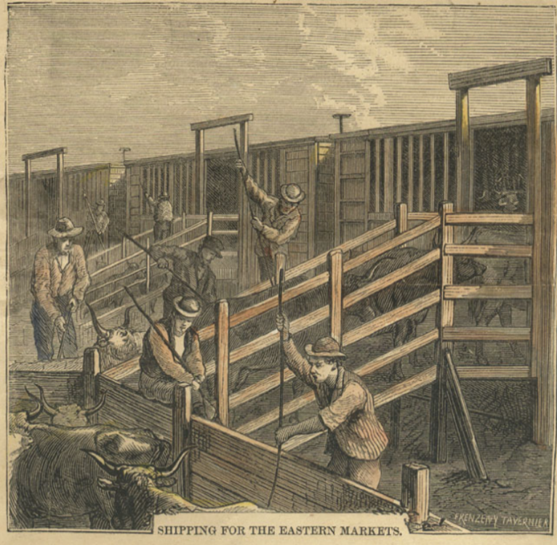  Figure 1: "The Texas Cattle Trade" Harper's Weekly, May 2, 1874. The Portal to Texas History | - What are three things you observe about the image?

- What are two things you can infer about this era of Texas history based on the image?

- What do you predict we will see in this unit based on the image?

Part II: Essential Ideas Reading Passage

In the previous unit on Reconstruction, the United States faced the challenge of reuniting the country after the deadly and divisive Civil War. The decades that followed Reconstruction brought significant economic, social, and political changes to Texas. The population of Texas grew tremendously, expanding from 800,000 people in 1870 to more than 3 million people by 1900. The rise of industry throughout the U.S. led to the expansion of railroads throughout the state, which aided in Texas’s rapid population increase.
As the population of Texas increased, many Texans also began moving west toward the Great Plains. At the same time, professional hunters flocked to the Plains to hunt bison for their profitable hides. The increase of Anglo settlers and the rapid depletion of bison herds caused conflicts between the Anglos and Plains Indians. These conflicts would ultimately result in the forced removal of Indian tribes from the Texas Plains.
The forced removal of American Indians from the Plains opened the region to Anglo settlers and industry. Some Texas cowboys began gathering large herds of wild cattle and driving them through the Plains to major railroads in Kansas and Missouri to be shipped to Northern markets, where high prices for cattle meant large profits for cattle drivers. Soon, cattlemen began establishing large ranches in the Great Plains, using new innovations like barbed wire to more easily enclose their land and windmills to bring water to their livestock. The growth of large ranches and the expansion of railroads in Texas eventually led to the end of cattle drives, although the image of Texas cowboys continued to be an iconic symbol of Texas’s western culture.
Despite the enduring popular image of Texas as a western cowboy state, the majority of Texans at the time still lived in the eastern part of the state and worked as farmers, often cultivating cotton. Economic challenges related to falling cotton prices caused many farmers and their families to face severe financial struggles. The struggles of farmers and other laborers during this era would ultimately lead to the creation of organizations like the Grange and the Farmer’s Alliance to protect and advocate for farmers.
Laborers would also create a short-lived, though powerful third political party called the Populist Party, which would have a significant effect on the government of Texas and the nation as a whole and bring awareness to the needs of laborers across the country. At the same time, Southern state governments began passing new laws known as “Jim Crow laws,” which restricted many of the rights of African Americans in the South.
In this unit, we will examine how cotton, cattle, and railroads played a significant role in the development of Texas and the many changes Texans experienced in the late 19th century.

Part III: Cause and Effect
Directions: Read each statement in the middle column of the chart below. Then, write the cause(s) and effect(s) of each statement in the appropriate boxes. Each statement may have more than one cause and/or effect. List as many as possible.
Cause | Statement | Effect
 | The population of Texas increased from 800,000 in 1870 to 3 million by 1900.
 | More railroads were built in Texas throughout the era.
 | American Indians were forcefully removed from the Texas Plains.
 | Cotton farmers in Texas and the nation struggled financially.

