The Big Picture Grade Level
Unit 10: Cotton, Cattle, & Railroads

Name: |  | Date: |  | Period:

Part I: Analyze an Image
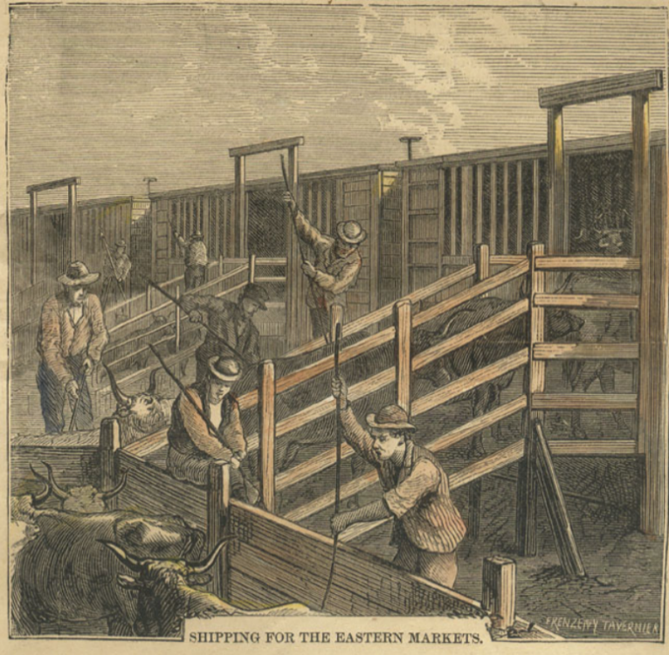  Figure 1: "The Texas Cattle Trade" Harper's Weekly, May 2, 1874. The Portal to Texas History | - What are two things you observe about the image?

- What is one thing you can infer about this era of Texas history based on the image?

- What do you predict we will see in this unit based on the image?

Part II: Essential Ideas Reading Passage

In the previous unit on Reconstruction, the United States faced the challenge of reuniting the country after the Civil War. The decades after Reconstruction brought significant economic, social, and political changes to Texas. The population of Texas increased rapidly during this era. In 1870, the Texas population was 800,000 people. By the end of the era, it had grown to more than 3 million people. This was also a period of rapid industrialization, which meant significant growth in business and manufacturing. As a result, railroads expanded throughout the state, helping the rapid population increase during this time.
As the population of Texas increased, many Texans began moving west toward the Great Plains. At the same time, professional hunters also traveled to the Texas Plains to hunt bison for their profitable hides. The increase of Anglo settlers and the overhunting of bison caused many conflicts between Anglos and Plains Indians. As a result of these conflicts, the Plains Indians tribes would be forced out of the Plains and onto reservations in Oklahoma.
After the Indian tribes were forcefully removed from the Plains, the region was open to more Anglo settlers and industry. Some Texas cowboys gathered large herds of wild cattle and drove them through the Plains to major railroads in northern states like Kansas and Missouri, where high cattle prices meant greater profit. Soon, cattlemen established large ranches in the Great Plains. They used new innovations like barbed wire to fence in their land and windmills to pump water to their livestock. Large fenced in ranches closed off the Plains and brought cattle drives to an end, though cowboys and cattle drives would remain a popular image in Texas culture.
Despite the image of Texas as a western state of cowboys, the majority of Texans at the time still lived in the eastern part of the state working as cotton farmers. During this era, the price of cotton dropped significantly, so cotton farmers were paid less for their crop. Struggling farmers formed organizations like the Grange and the Farmer’s Alliance to support farm workers.
Farmers and other struggling laborers would go on to establish a political organization called the Populist Party to advocate for all workers in the United States. The Populist Party was short-lived, but it brought attention to the needs of farmers and other workers and influenced state and national politics. At the same time, Southern state governments began passing new laws known as “Jim Crow laws,” which restricted many of the rights and freedoms of African Americans in the South.
In this unit, we will examine how cotton, cattle, and railroads played a significant role in the development of Texas and the many changes Texans experienced in the late 19th century.

Part III: Cause and Effect
Directions: Read each statement in the middle column of the chart below. Then, write the cause(s) or effect(s) of each statement in the appropriate boxes. Each statement may have more than one cause and/or effect. List as many as possible.
Cause | Statement | Effect
The expansion of railroads allowed people to travel more easily. | People moved into Texas is large numbers after Reconstruction.
 | More railroads were built in Texas throughout the era. | People could travel more easily to Texas and within Texas into cities and toward the western frontier.
Professional bison hunters overhunted Plains buffalo, and more Anglo settlers moved into the region. | American Indians were forcefully removed from the Texas Plains.
 | Cotton farmers in Texas and the nation struggled financially. | Struggling farmers and laborers organized the Grange, the Farmer’s Alliance, and the Populist Party to support workers.

