The Problem with Cotton Foundations
Unit 10: Cotton, Cattle, & Railroads

Name: |  | Date: |  | Period:

The Problem with Cotton, 1870 - 1900

- Cotton prices fell steadily.  - Farmers received less money for their crop.  - Farmers grew MUCH MORE cotton to try to make up for lost profits.  - Too much cotton flooded the market, causing prices to drop lower. | What was the primary problem with cotton from 1870 to 1900, and what were the effects of this problem? Use the graphic organizer below to answer the question. Information in each box should be no more than six words.  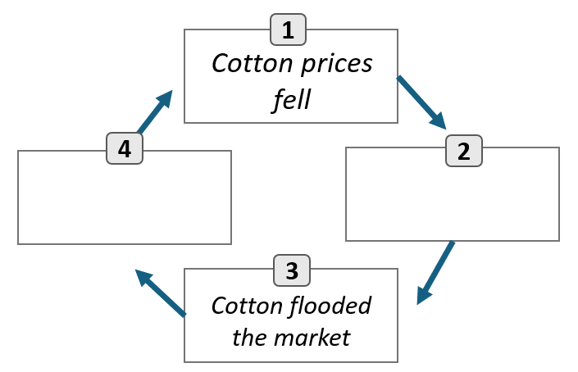

The Effects of Falling Cotton Prices

- Many farmers could not afford supplies, equipment, shipping, or property costs.  - Farmers often borrowed to pay for expenses, causing many to go into debt.  - 30,000 farmers turned to tenant farming during this period.  - By 1890, 42% of all Texas farms worked by tenants. | Circle or highlight THREE statements that most accurately relate to tenant farming.  - Tenant farming allowed farmers more freedom over their own farming practices.  - Tenant farmers rented land and paid in cash or a portion of their crops.  - Tenant farmers often borrowed money to cover expenses, going into debt.  - Tenant farming was a way for struggling farmers to save money and pay off debts.  - Tenant farming kept many farmers in a cycle of poverty.

Farmer’s Organize
The Grange

What  Established 1867 by the U.S. Dept. of Agriculture to support struggling farmers.  1873 – First Texas chapter established in Salado. | Platform  1)Limit government spending and taxes.  2) Government regulation of railroad rates.  3) Establish non-profit cooperative groups to sell crops for farmers without a fee. | Write the correct number of the platform next to the letter that best explains how it would benefit farmers.  - Farmers could ship their crops more cheaply.  - Farmers would owe less money to the government.  - Farmers could receive more profit from the sale of their crops.

The Farmer’s Alliance

What  Established in 1876 in Lampasas, TX to support struggling farmers. | How were the Grange and the Farmer’s Alliance similar?  The Grange and the Farmer’s Alliance were similar because  _____________________________________________________________________

The Farmer’s Alliance Platform

- Establish non-profit cooperative groups to sell crops for farmers without a fee.  - Promote government regulation of railroad rates.  - Abandon the gold standard and include “Free Silver” to expand the money supply.  - Subtreasury Plan: Government should establish warehouses to store surplus cotton to prevent flooding the market. | Choose ONE item listed in the platform and explain how it would support the goal of the Farmer’s Alliance.  Platform letter A / B / C / D would support struggling farmers by (E) reducing the cost of shipping crops (F) reducing the amount farmers had to pay to sell their crops (G) having more money in the economy (H) making sure there wasn’t too much cotton available.

The Populist Party

- Officially established in Omaha, Nebraska, 1892.  - “The People’s Party”  - Formed to support laborers across the U.S. | What is one similarity and one difference between the Populist Party and the Grange and Farmer’s Alliance.  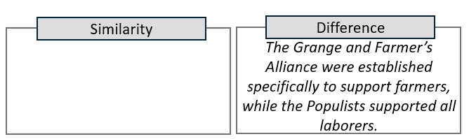

The Populist Party Platform

- Abolish national banks.  - Establish an income tax which taxes wealthier people at a higher rate than poorer people.  - Direct election of senators.  - Government control of transportation and communication companies.  - “Free Silver” – abandon gold standard.  - Government regulation of the economy. | Consider the Redeemer government’s push for limited government at the end of Reconstruction. Was the Populist Party platform in line with limited government? Explain.  The Populist Party platform was / was not in line with the Redeemer’s support of limited government because ______________________________ _______________________________________________________ _______________________________________________________

The Effects of Labor Organizing

- Labor organizations were short-lived and never as strong as existing political parties, BUT . . .  - They highlighted issues important to farmers and laborers.  - They encouraged the creation of the Texas Railroad Commission to regulate railroads. | What were some of the significant effects of labor organizations like the Grange, the Farmer’s Alliance, and the Populist Party? Check all that apply.  - They achieved some regulation of transportation and commerce.  - They made people aware of challenges facing farmers and workers.  - They became more powerful than the Democratic and Republican Parties.  - They are political organizations that are still active in government today.

