Vocabulary Quiz Advanced
Unit 10: Cotton, Cattle, & Railroads

Name: |  | Date: |  | Period:

Part I: Key Terms
Directions: Match the vocabulary term with its correct definition
Industrialization | Tenant Farming | Urbanization

A ranch | Innovation | To reform | Segregation

The process of coming up with new ideas, creating new methods for doing things or new products. During this period barbed wire was created, and windmills were used in new ways on farms and ranches.

The process of people moving from rural areas in the countryside to larger cities. During this era, some Texans began moving to cities like Fort Worth and Galveston.

Cultivating crops on land that is rented from a landlord. Often this type of crop cultivation leads to cycles of debt because the profit from crops was very low and rent payments were very high.

To institute change to a system in order to improve it. Farmers worked for changes to protect farm workers, limit rents on property, and reduce costs like shipping crops by train.

Separation based on race. During this era, laws were passed called Jim Crow laws that restricted the rights and liberties of Black Southerners. This included requiring railroad cars and other public spaces to be separated by race.

The process of developing business and manufacturing. During this era, this increased in Texas in lumber, coal, and cattle.

A large type of farm that raises livestock like cattle. During this era, these large livestock farms increased in the Texas Plains.

Part II: Fill in the Blank
Directions: Use the vocabulary terms to fill in the blanks on the following statements.
Industrialization | Tenant Farmers | Urbanization

Ranches | Innovations | Reform | Segregate

- During the era of Cotton, Cattle, and Railroads, the beef industry in Texas grew as cowboys moved cattle to Northern states on cattle drives and large ____________________ were established in the Great Plains region of Texas to raise livestock.
- During this period, cotton prices dropped drastically, causing many agricultural workers in Texas to struggle. Many of these workers had to become ___________________ _____________________ because they could not afford to buy or maintain their own property. This often led to cycles of debt and poverty for many Texans.
- During the late 1800s, manufacturing increased throughout the United States. Factories churned out man-made items and there were many innovations in transportation, communication, agriculture, and business. This was a period of significant _______________________________ for the U.S. and Texas.
- While the majority of Texans continued to live in rural areas in the countryside, some began moving into larger cities in Texas. The expansion of railroads made transportation easier, aiding in the process of ___________________________________ in Texas.
- Railroad companies were able to charge any price they chose, and in places where railroads were the only means of transporting crops to market, farmers often struggled to pay the high cost of shipping their cotton. Many farmers worked to _______________________ business practices and government laws to provide them more support as they took part in the agriculture industry.
- As a result of Jim Crow laws, railroad companies were required to _____________________________ their cars so that white and Black passengers did not ride in the same cars.
- Many ____________________________________ in agriculture allowed farmers to complete farm work more easily by using wind energy powered by windmills to grind grain or move water. They also allowed ranchers to protect their water resources and livestock by fencing in their land with barbed wire.

Part III: Comprehension Questions

- Use the information in the graphic below to answer the question that follows.
Year | Rural Population | Urban Population | Total Population
1870 | 95% | 5% | 818,579
1880 | 90% | 10% | 1,591,749
1890 | 86% | 14% | 2,235,527
1900 | 82% | 18% | 3,048,710

What does the information in this chart tell us about Texas during the era of Cotton, Cattle, and Railroads? Choose TWO correct answers.
- Texas experienced a small, though steady decline in its population during the last four decades of the 19th century.
- The population of Texas steadily increased in the final four decades of the 19th century.
- Texas was slowly becoming more rural, despite the fact that the majority of Texans still lived in cities.
- Texas was slowly becoming more urbanized, despite the fact that the majority of Texans still lived in the countryside.
- The population of Texas played a significant role in the rise of the cattle, cotton, and railroad industries in the state.

- Which response best completes the missing information in the chart below?

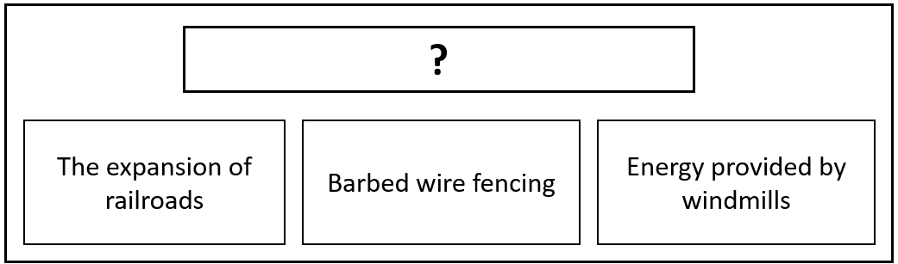

  - The Effects of Segregation
  - Innovations of the 1800s
  - Agricultural Challenges
  - Benefits of Urbanization

- Read the primary source excerpt from a newspaper article below, then choose the response that best summarizes how the topic in the source relates to our vocabulary terms.

“THE GAZETTE would appeal to the farmers of this section not to stake their all on cotton. Cotton is not only ‘a credit crop’ that peons the farmer to the merchant and the merchant to the factor, but it is a proverb in Mississippi, where men raise cotton, get deeper in debt and have naught to look forward to except the chance of going in debt to make another crop, that ‘it takes thirteen months in the year to raise cotton.’”

- “Fort Worth Weekly Gazette. (Fort Worth, Tex.) Thursday, September 5, 1889.” The Portal to Texas History.

  - The excerpt accurately describes the circumstances that led many agricultural workers to turn to tenant farming.
  - The excerpt accurately explains the goals of farmer’s organizations like the Grange and the Farmer’s Alliance.
  - The excerpt describes the grievances farmers had against railroad companies for the high fees they charged to transport cotton.
  - The excerpt demonstrates why many farmers moved into Texas cities as part of the process of urbanization.

- Read the primary source excerpt from a newspaper article below, then choose the response that best summarizes how the topic in the source relates to our vocabulary terms.
“Mr. Greer called up the house bill to require railroad companies to provide separate rooms in passenger depots for white and colored persons. Mr. Feagin of Polk offered an amendment extending the time to 100 days within which railroads must provide separate rooms. Adopted.”

- The Weekly Republic. (Weatherford, Tex.) Friday, March 24, 1893. The Portal to Texas History

  - The excerpt demonstrates one example of segregation during this era.
  - The excerpt demonstrates the rise of urbanization during this era.
  - This excerpt demonstrates various innovations during this era.
  - This excerpt demonstrates challenges facing tenant farmers during the era.

