Vocabulary Quiz Foundations
Unit 10: Cotton, Cattle, & Railroads

Name: |  | Date: |  | Period:

Part I: Key Terms

Directions: Choose the correct term for each definition and description.
- (a) Urbanization  (b) Innovation  (c) Segregation | The process of coming up with new ideas, creating new methods for doing things or new products. Examples: Barbed wire, windmills, and railroads.
- (a) To reform  (b) Tenant farming  (c) Urbanization | The process of people moving from rural areas in the countryside to larger cities. Example: Some Texans moving to Fort Worth or Galveston.
- (a) Tenant farming  (b) Industrialization  (c) Innovation | Renting land from a landlord in order to grow crops and paying rent in money or a portion of crops.
- (a) Innovation  (b) A ranch  (c) To reform | To change something to improve it. Example: Groups like the Farmer’s Alliance worked to make changes to improve life for poor farmers.
- (a) Innovation  (b) To reform  (c) Segregation | Separation based on race. Example: A Texas law required railroad companies to provide separate cars to white and Black passengers.
- (a) Tenant Farming  (b) Urbanization  (c) Industrialization | The process of developing business and manufacturing. Examples: The growth in cattle, cotton, and lumber in Texas.
- (a) To reform  (b) A ranch  (c) Industrialization | A large type of farm that raises livestock like cattle. Example: During this era, these large livestock farms increased in the Texas Plains.

Part II: Fill in the Blank

Directions: Circle or highlight the term that best completes each sentence.
- Large (a) reforms (b) ranches (c) industries were established in the Texas Plains to raise livestock for the beef industry.
- Farmers who couldn’t afford to buy or pay for their own land had to become (a) urbanized (b) innovations (c) tenant farmers, renting land from a landowner and paying rent to the owner.
- During the late 1800s, manufacturing increased throughout the United States, turning natural resources into man-made goods in a process called (a) industrialization (b) urbanization (c) segregation.
- Most Texans continued to live in rural areas in the countryside, however, during this era some Texans moved to bigger cities in a process called (a) industrialization (b) urbanization (c) reform
- Railroad companies often charged high prices to transport crops. This was a challenge to struggling farmers, who worked to (a) reform (b) ranch (c) urbanize railroad pricing to make it better for farmers.
- As a result of Jim Crow laws, railroad companies were required to (a) industrialize (b) reform (c) segregate their cars so that white and Black passengers did not ride in the same cars.
- (a) Innovations (b) reforms (c) ranches like the windmill and barbed wire helped make farming and ranching easier.

Part III: Comprehension Questions

- Use the information in the graphic below to answer the question that follows.
Year | Rural Population | Urban Population | Total Population
1870 | 95% | 5% | 818,579
1880 | 90% | 10% | 1,591,749
1890 | 86% | 14% | 2,235,527
1900 | 82% | 18% | 3,048,710

What does the information in this chart tell us about Texas during the era of Cotton, Cattle, and Railroads? Choose TWO correct answers.
- Texas experienced a small, though steady decline in its population during the last four decades of the 19th century.
- The population of Texas steadily increased in the final four decades of the 19th century.
- Texas was slowly becoming more rural, despite the fact that the majority of Texans still lived in cities.
- Texas was slowly becoming more urbanized, despite the fact that the majority of Texans still lived in the countryside.
- The population of Texas played a significant role in the rise of the cattle, cotton, and railroad industries in the state.

- Which response best completes the missing information in the chart below?

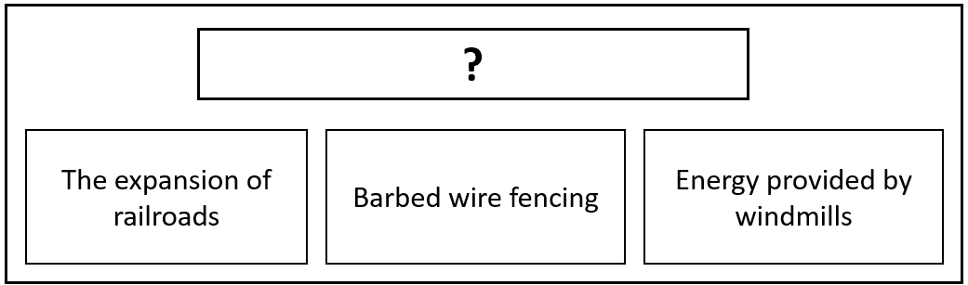

  - The Effects of Segregation
  - Innovations of the 1800s
  - Agricultural Challenges
  - Benefits of Urbanization

