Vocabulary Quiz Grade Level
Unit 10: Cotton, Cattle, & Railroads

Name: |  | Date: |  | Period:

Part I: Key Terms
Directions: Match the vocabulary term with its correct definition
Industrialization | Tenant Farming | Urbanization

A ranch | Innovation | To reform | Segregation

The process of coming up with new ideas, creating new methods for doing things or new products. Examples: Barbed wire, windmills, and railroads.

The process of people moving from rural areas in the countryside to larger cities. Example: Some Texans moving to Fort Worth or Galveston.

Renting land from a landlord in order to grow crops and paying rent in money or a portion of crops.

To change something to improve it. Example: Groups like the Farmer’s Alliance worked to make changes to improve life for poor farmers.

Separation based on race. Example: A Texas law required railroad companies to provide separate cars to white and Black passengers.

The process of developing business and manufacturing. Examples: The growth in cattle, cotton, and lumber in Texas.

A large type of farm that raises livestock like cattle. Example: During this era, these large livestock farms increased in the Texas Plains.

Part II: Fill in the Blank
Directions: Use the vocabulary terms to fill in the blanks on the following statements.
Industrialization | Tenant Farmers | Urbanization

Ranches | Innovations | Reform | Segregate

- Large _________________________ were established in the Texas Plains to raise livestock for the beef industry.
- Farmers who couldn’t afford to buy or pay for their own land had to become _______________________________________, renting land from a landowner and paying rent to the owner.
- During the late 1800s, manufacturing increased throughout the United States, turning natural resources into man-made goods in a process called ________________________________________.
- Most Texans continued to live in rural areas in the countryside, however, during this era some Texans moved to bigger cities in a process called _____________________________.
- Railroad companies often charged high prices to transport crops. This was a challenge to struggling farmers, who worked to ____________________________ railroad pricing to make it better for farmers.
- As a result of Jim Crow laws, railroad companies were required to _____________________________ their cars so that white and Black passengers did not ride in the same cars.
- ________________________________ like the windmill and barbed wire helped make farming and ranching easier.

Part III: Comprehension Questions

- Use the information in the graphic below to answer the question that follows.
Year | Rural Population | Urban Population | Total Population
1870 | 95% | 5% | 818,579
1880 | 90% | 10% | 1,591,749
1890 | 86% | 14% | 2,235,527
1900 | 82% | 18% | 3,048,710

What does the information in this chart tell us about Texas during the era of Cotton, Cattle, and Railroads? Choose TWO correct answers.
- Texas experienced a small, though steady decline in its population during the last four decades of the 19th century.
- The population of Texas steadily increased in the final four decades of the 19th century.
- Texas was slowly becoming more rural, despite the fact that the majority of Texans still lived in cities.
- Texas was slowly becoming more urbanized, despite the fact that the majority of Texans still lived in the countryside.
- The population of Texas played a significant role in the rise of the cattle, cotton, and railroad industries in the state.

- Which response best completes the missing information in the chart below?

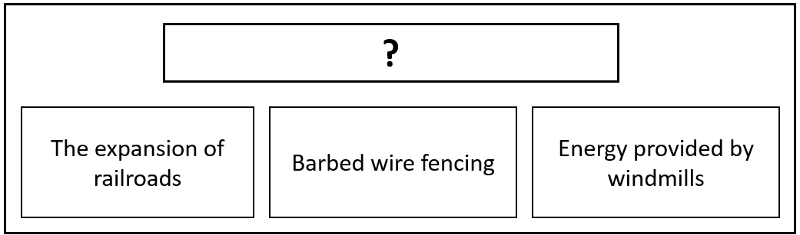

  - The Effects of Segregation
  - Innovations of the 1800s
  - Agricultural Challenges
  - Benefits of Urbanization

