Vocabulary Advanced
Unit 10: Cotton, Cattle, & Railroads

Name: |  | Date: |  | Period:

Directions: Use the vocabulary readings on the slideshow presentation to complete the chart below.
Industrialization (n)
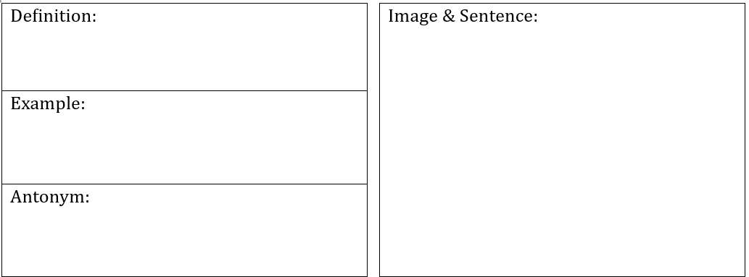

Innovation (n)

Urbanization (n)

A ranch (n)

Tenant Farming (n, v)

To reform (v)

Segregation (n)

