Vocabulary Grade Level
Unit 10: Cotton, Cattle, & Railroads

Name: |  | Date: |  | Period:

Directions: Use the vocabulary readings on the slideshow presentation to complete the chart below.
Industrialization (n)
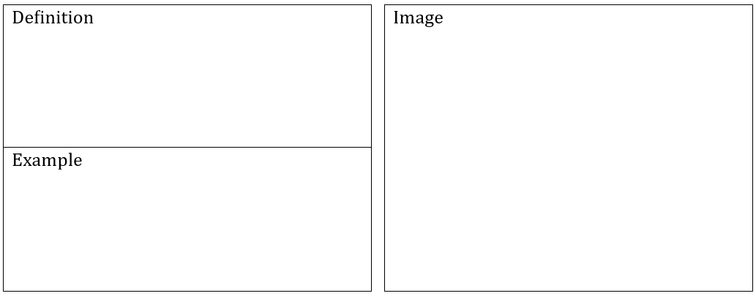

Innovation (n)

Urbanization (n)
A ranch (n)
Tenant Farming (n, v)
To reform (v)

Segregation (n)

