 Warm-up: The Compromise of 1850 Extension
Unit 7: Early Statehood
Name: |  | Date: |  | Period:

What do you notice or observe about this map? How do you think this map relates to slavery in the United States during this era? | 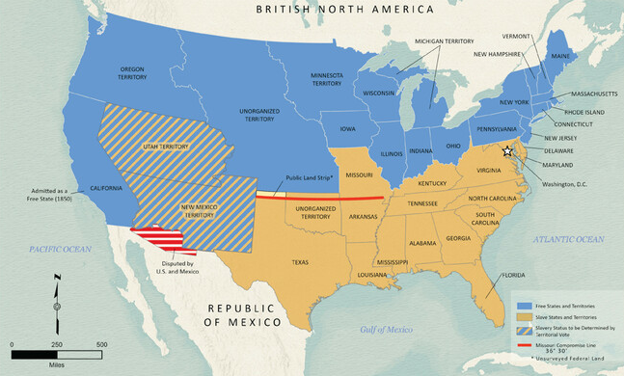

Warm-up: The Compromise of 1850 Extension
Unit 7: Early Statehood
Name: |  | Date: |  | Period:

What do you notice or observe about this map? How do you think this map relates to slavery in the United States during this era?

The Compromise of 1850 Exit Ticket

Determine which description listed below best explains the significance of the events shown in the chart.
Write the letter of the correct description below the name of the event it describes in the boxes provided.
- The U.S. fought and won this conflict over the border between Texas and Mexico.
- This document ended the war mentioned in the previous statement.
- Mexico was required to cede to the U.S. this territory from Texas west to California.
- In 1848, people flooded into California hoping to get rich in this event.
- When California applied for statehood, the North and the South argued over this significant issue.
The westward expansion of slavery | The U.S.-Mexico War | The Gold Rush | The Mexican Cession | The Treaty of Guadalupe Hidalgo

The Compromise of 1850 Exit Ticket

Determine which description listed below best explains the significance of the events shown in the chart.
Write the letter of the correct description below the name of the event it describes in the boxes provided.
- The U.S. fought and won this conflict over the border between Texas and Mexico.
- This document ended the war mentioned in the previous statement.
- Mexico was required to cede to the U.S. this territory from Texas west to California.
- In 1848, people flooded into California hoping to get rich in this event.
- When California applied for statehood, the North and the South argued over this significant issue.
The westward expansion of slavery | The U.S.-Mexico War | The Gold Rush | The Mexican Cession | The Treaty of Guadalupe Hidalgo

