The Compromise of 1850 Extension Advanced
Unit 7: Early Statehood

Name: |  | Date: |  | Period:

The Road to the Compromise of 1850
The U.S.-Mexico War

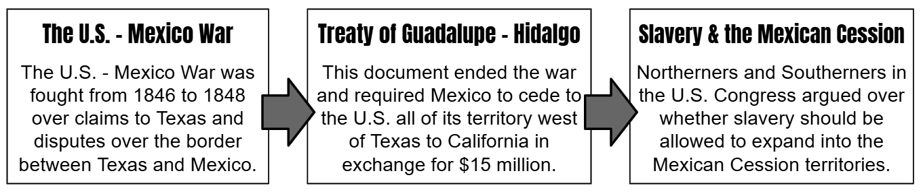
- What caused the conflict between the United States and Mexico that led to the U.S.-Mexico War?

- What was the outcome of the U.S.-Mexico War?

- How did this outcome influence sectional division in the United States?

The Road to the Compromise of 1850
The California Gold Rush

On January 24, 1848, gold was discovered at a place called Sutter’s Mill in northern California, near present-day Sacramento. With this discovery, people began flooding into California, hoping to strike it rich. One month later, the Treaty of Guadalupe Hidalgo was finalized, and California became a territory in the United States.
In order to apply for statehood, a United States territory was required to have a population of at least 60,000 free people. Population growth of that magnitude would have typically taken a long time in the 1800s, but the flood of migrants pouring into the territory as part of the Gold Rush quickly made California eligible to apply for statehood.
As California prepared to apply for statehood, there was one major question on the minds of Northerners and Southerners alike: would slavery be permitted to expand into western territories like California or would it be prohibited? This was an important question because every new state that came into the U.S. had two members of the Senate and at least one member of the House of Representatives. If those new states were slave states, Southerners would get more power in Congress. If those new states were free states, Northerners would get more power. Fierce debates raged in Congress over this issue as the anti-slavery North and the pro-slavery South both hoped to protect their region’s interests.
- Cause and Effect: Use the graphic organizer below to create a visual representation of the cause-and-effect relationship between three significant events explained in the reading above.

In the boxes below, create a three-to-five word title for each event and provide a brief description of the facts and significance of the event in the space provided.

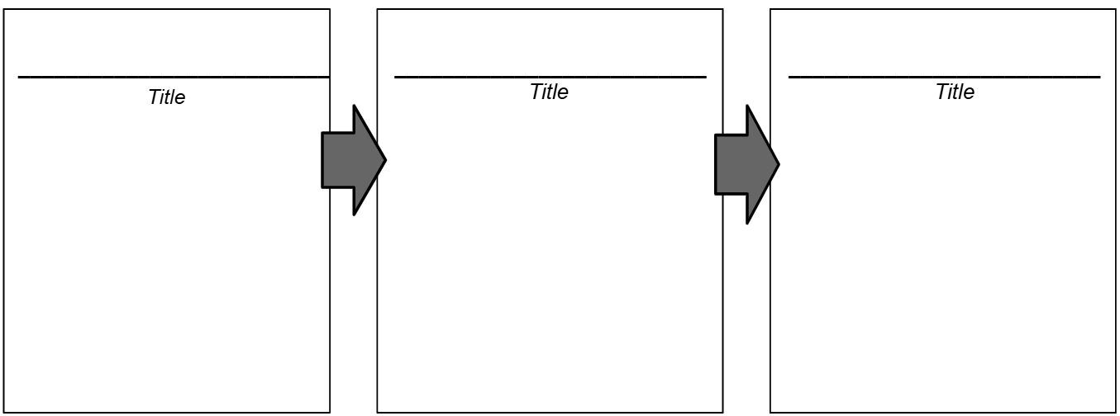

The Compromise of 1850

In order to appease both the anti-slavery North and the pro-slavery South, a congressman named Henry Clay authored the Compromise of 1850 which contained the following terms:
- California would be admitted to the Union as a free state.
- The territories of Utah and New Mexico were created, and each would be allowed to determine the issue of slavery within their own borders by popular sovereignty.
- The Fugitive Slave Act required Northerners in free states to assist in the capture and return of escaped slaves to their masters in the South.
- Slavery would remain legal in Washington D.C., however the sale or purchase of slaves in Washington D.C. was now illegal.
- Texas would cede much of its western land to the federal government in exchange for $10 million. The land included parts of modern-day New Mexico, Colorado, and Wyoming.
Which part or parts of the Compromise of 1850 would have likely appeased many opponents of the expansion of slavery?  Write your answer as a bulleted list. Provide an explanation to support your claims. | Which part or parts of the Compromise of 1850 would have likely appeased many supporters of the expansion of slavery?  Write your answer as a bulleted list. Provide an explanation to support your claims.

Short Answer Response Writing Activity

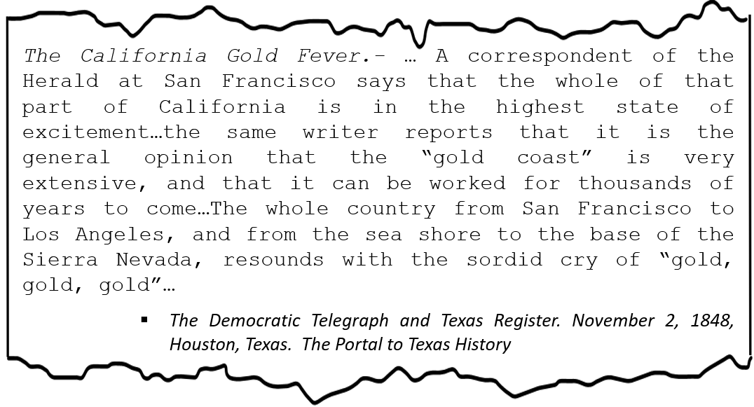
Prompt: Consider the information provided in the primary source excerpt above. How did the event or events discussed in the source contribute to the growing sectional tension in the United States during the era of Early Texas Statehood?

Your response should be detailed, organized, and composed of five to eight complete sentences. Include examples when possible.

Appease: To satisfy or calm someone by meeting their requirements or demands.

