The Compromise of 1850 Extension Foundations
Unit 7: Early Statehood

Name: |  | Date: |  | Period:

The Road to the Compromise of 1850
The U.S.-Mexico War

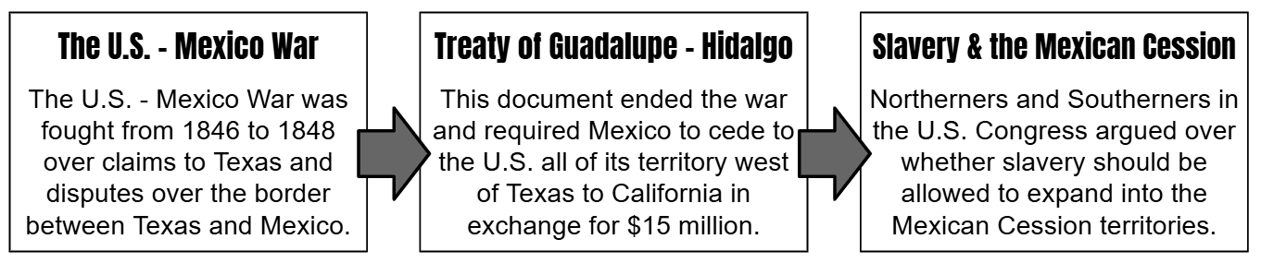
- What caused the conflict between the United States and Mexico that led to the U.S. – Mexico War? Choose TWO correct answers.
  - Arguments over the westward expansion of slavery
  - Debates over the amount of money the U.S. offered for the Mexican Cession
  - Dissatisfaction with the terms of the Treaty of Guadalupe Hidalgo
  - Disagreements over claims to Texas after its 1845 annexation
  - Disputes over the border between Texas and Mexico

- What was the outcome of the U.S.-Mexico War?
  - Mexico won the war, regaining Texas in the Treaty of Guadalupe Hidalgo and forcing the United States to cede its western territory.
  - The United States won the war, forcing Mexico to cede all its territory west of Texas in the terms of the Treaty of Guadalupe Hidalgo.
  - The United States and Mexico established the Mexican Cession as territory designated to remain free from slavery in the Treaty of Guadalupe Hidalgo.
  - All answers are correct.

- How did this outcome influence sectional division in the United States?
One way that this outcome influenced sectional division in the United States was (A) it created border disputes between eastern and western states (B) it increased debates between the North and South over slavery. (C) it caused diplomatic tension between the United States and Mexico.

The Road to the Compromise of 1850
The California Gold Rush

On January 24, 1848, gold was discovered at a place called Sutter’s Mill in northern California, near present-day Sacramento. With this discovery, people began flooding into California, hoping to strike it rich. One month later, the Treaty of Guadalupe Hidalgo was finalized, and California became a territory in the United States.
In order to apply for statehood, a United States territory was required to have a population of at least 60,000 free people. Population growth of that size would have typically taken a long time in the 1800s, but the flood of migrants pouring into the territory as part of the Gold Rush quickly made California eligible to apply for statehood.
As California prepared to apply for statehood, there was one major question on the minds of Northerners and Southerners alike: would slavery be permitted to expand into western territories like California or would it be prohibited? This was an important question because every new state that came into the U.S. had two members of the Senate and at least one member of the House of Representatives. If those new states were slave states, Southerners would get more power in Congress. If those new states were free states, Northerners would get more power. Fierce debates raged in Congress over this issue as the anti-slavery North and the pro-slavery South both hoped to protect their region’s interests.
- Cause and Effect: Use the graphic organizer below to create a visual representation of the cause-and-effect relationship between three significant events explained in the reading above.

You will either write a brief description to accompany the title of the event in the box, or you will create a title to accompany the description provided.
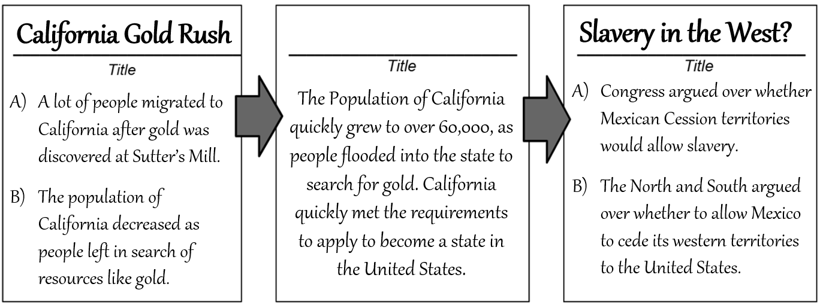

The Compromise of 1850

In order to appease both the anti-slavery North and the pro-slavery South, a congressman named Henry Clay authored the Compromise of 1850.
Read each term of the Compromise below, then determine if the term would have been more beneficial to the North, South, or both regions. Place a checkmark in the correct box. Then, in the space provided, explain the reasoning for your choice.
Terms of the Compromise of 1850 | North | South | Explain
California would be admitted to the Union as a free state. |  |  | - California joining as a free state would give more political power to the North.  - California joining as a free state would give more political power to the South.
The territories of Utah and New Mexico were created, and each would be allowed to determine the issue of slavery within their own borders by popular sovereignty. |  |  | - Popular sovereignty could benefit the South if people voted to prohibit slavery.  - Popular sovereignty could benefit the North or South, depending on how people vote
The Fugitive Slave Act required Northerners in free states to assist in the capture and return of escaped slaves to their masters in the South. |  |  | - The North and South would both benefit because this act helps enslaved people.  - The South would benefit because it would make it harder for escaped slaves to stay free.
Slavery would remain legal in Washington D.C., however the sale or purchase of slaves in Washington D.C. was now illegal. |  |  | - Stopping the slave trade would make the North happy, but allowing slavery to continue in D.C. would satisfy the South.  - This primarily benefits the South by making the slave trade in D.C. illegal.
Texas would cede much of its western land to the federal government in exchange for $10 million. The land included parts of modern-day New Mexico, Colorado, and Wyoming. |  |  | - The South would be happy because the size of a western slave state – Texas – was increased.  - The North would be happy that the size of a western slave state – Texas – was reduced.

Appease: To satisfy or calm someone by meeting their requirements or demands.

