Primary Source Material 1 | Vocabulary
“For a long time a great many people have been passing through my country; they kill all the game, and burn the country, and trouble me very much. The commissioners of our Great Father promised to keep these people out of our country. I believe our white brothers do not wish to run a line between us, because they wish to settle in this country. I object to any more settlements.”  - A Quote from Chief Buffalo Hump of the Penateka Comanche Tribe. Account provided by Robert S. Neighbours, Special Indian Agent of the United States, in a letter to Colonel Medill, Commissioner of Indian Affairs, Washington, D.C. Printed in the Telegraph and Texas Register, Houston, Monday, September 13, 1847. The Portal to Texas History | Game: Wild animals that are hunted for food  Commissioners of our Great Father: people from the American government  To run a line: To create a boundary  Object to: oppose

Primary Source Material #2 | Vocabulary
“We unhesitatingly say that no spot in America offers such inducements to capitalists, or affords such local and general advantages for manufacturers of all sorts as San Antonio de Bexar. With the most enchanting country around it, and the most salubrious climate in the world – the finest cotton and wheat district on earth, with myriads of fine cattle and sheep grazing upon the hills, nothing, we say, can surpass it.”  - A book titled, “Rambles and Scrambles in Texas” which documents the experiences of a man named Frederic Benjamin Page as he traveled through Texas in 1846. The Portal to Texas History. | Inducements: something good to persuade people  Capitalists: Wealthy people who take part in business  Salubrious: Healthy  Myriads: A lot

Primary Source Material # 3 | Vocabulary
“I have always believed, Mr. President, that Congress does not possess the power to interfere with the subject of slavery, and I further believe that, so far as any expectation or hope of compromise is involved in this matter, the only method for the attainment of that object is for the North to abstain from all encroachments upon Southern rights.”  - A speech from Sam Houston to the United States’ Senate in February, 1850. Published in an article in The Democratic Telegraph and Texas Register of Houston on March 14, 1850. The Portal to Texas History | Congress: The people elected to create laws in the government  Attainment: The act of achieving something you want  Object: Goal  Abstain: To not do something  Encroachments: To take over the property or rights of others

Primary Source Material # 4 | Vocabulary
“The present laws of Texas do not acknowledge that the Indians have any right of soil; and those persons holding land claims contend that they have the privilege of locating wherever they choose.”  - A letter from Special Indian Agent Robert S. Neighbours to Colonel W. Medill, Commissioner Indian Affairs, Washington, D.C. Printed in the Telegraph and Texas Register, Houston, Monday, September 13, 1847. The Portal to Texas History | Acknowledge: Recognize  Those persons holding land claims: Anglos moving west  Privilege: A special right

Primary Source Material # 5 | Vocabulary
“It will be remembered by our readers that the Legislature at its last session donated twelve leagues of land as a reserve, within those limits the different tribes of Indians in Texas were to be settled . . . The policy of the government is to confine them to this narrow space and feed them. They are gradually to be taught the arts of civilized life, particularly farming. Their wild nomadic habits and tastes are to be uprooted, and thus, in a few years, they are to become a self-supporting machine, making their daily bread “in the sweat of their brow...” — This policy doubtless sounds very well to philanthropic theorists, but when applied to the Southern Comanches will prove a miserable failure.”  - An article titled “The Indian Reservation” printed in The Texas Monument newspaper of La Grange, Texas, Tuesday, October 10, 1854. The Portal to Texas History | Legislature: Another word for Congress, or the people who are elected to make laws.  Reserve: Land set aside where the U.S. government wanted Indians to live.  Confine: Limit or keep in a certain place  Uprooted: Taken away  Philanthropic Theorists: People who have ideas about how to help

Primary Source Material # 6 | Vocabulary
“When Texas shall become densely settled, and the resources of the country brought out, Galveston will enjoy a richer commerce, and ship a larger amount of cotton than any other city in America.”  - A book titled, “Rambles and Scrambles in Texas” which documents the experiences of a man named Frederic Benjamin Page as he traveled through Texas in 1846. The Portal to Texas History. | Densely settled: A lot of people settled closely together  Commerce: Trade

Primary Source Material # 7 | Vocabulary
“Democrats of Texas, let me say one word to you – let me urge you to shake off the apathy and indifference you have hitherto manifested, and to rise in your might and majesty in defense of the Constitution and of Southern institutions. Slavery and the Mexican war are the great leading questions upon which you are called to decide in the canvass this summer. You know that the Whig party will make a tremendous effort to . . . brand the war as unnecessary, unconstitutional, and unjust – to give up all the advantages we have already gained in Mexico . . . and withdraw our troops.”  “Are you willing to submit to such degradation as this? No, is the answer from the Red River to the Rio Grande. Then now is your time to act: be prompt, vigilant and active, and the country is safe.”  - From a letter to the editor of The Democratic Telegraph and Texas Register of Houston, written on May 24, 1848 under the name “Young Hickory.” The Portal to Texas History | Apathy: Not being interested in something  Indifference: Not caring about something  Hitherto manifested: Shown or displayed so far  Unconstitutional: Not following the constitution, against the law  Degradation: (In this context) Disrespected  Vigilant: Watchful and alert

Primary Source Material # 8 | Vocabulary
“In the numbers of the Galveston News, which we received by Monday’s mail, we find some letters from the editor who is traveling in the west and has already furnished descriptions of the appearance and prospects of Victoria, Gonzales, Seguin, and New Braunfels, a new German town on the west bank of the Guadalupe, which already contains a population of 1,500. We found these letters very interesting, particularly the one describing New Braunfels and the country around and the contemplated improvements of the Germans, who it seems propose to build up immediately three more.”  - A newspaper article from The Northern Standard, from Clarksville, Texas, published Wednesday, February 4, 1846. The Portal to Texas History. | Furnished: Given or provided  Prospects: Possibilities  Contemplated: Being considered or thought about

Primary Source Material # 9 | Vocabulary
My dear Father,  You see I am at present in that city that has been rendered somewhat celebrated as the prison of the Santa Fe traders and others of our countrymen…Santa Anna is on our flank and will endeavor to cut off our communications, and the extreme sickliness of the season will prevent our sending down to Vera Cruz, but we will endeavor to subsist on the country that we pass through. I do not see that we are a bit nearer a peace now than when we first started – we have had victory after victory and seem to gain nothing by it. Will we be any nearer when we have taken the city of Mexico? I rather doubt it.  Yours Affectionately, Theodore  - A letter from American soldier, Lieutenant Theodore Laidley to his father in Virginia. The letter is dated May 3, 1847 in Perote, Mexico. The Portal to Texas History | Rendered: Become  Flank: A military position meaning next to or beside  Endeavor: Try  Subsist: Survive

Primary Source Material # 10 | Vocabulary
“The German people and Colonists for the Grant between the waters of the Llano and San Saba shall be allowed to visit any part of said country, and be protected by the Comanche Nation and the Chiefs thereof in Consideration of which agreement the Comanche may likewise come to the German colonies towns and settlements, and shall have no cause to fear, but shall go wherever they please—if not counselled otherwise by the especial agent of our great father—and have protection, as long as they walk in the white path.”  - A portion of the “Meusebach Treaty” established on May 9, 1847 between the German settlers in Fredericksburg and the Comanche Nation. The Texas State Library and Archives Commission. | Thereof: related to the topic that was just mentioned. Here, it shows that the chiefs are from the Comanche Nation.  Counselled: Informed  Great father: A term used by some Indian tribes to refer to the U.S. government

Primary Source Material # 11

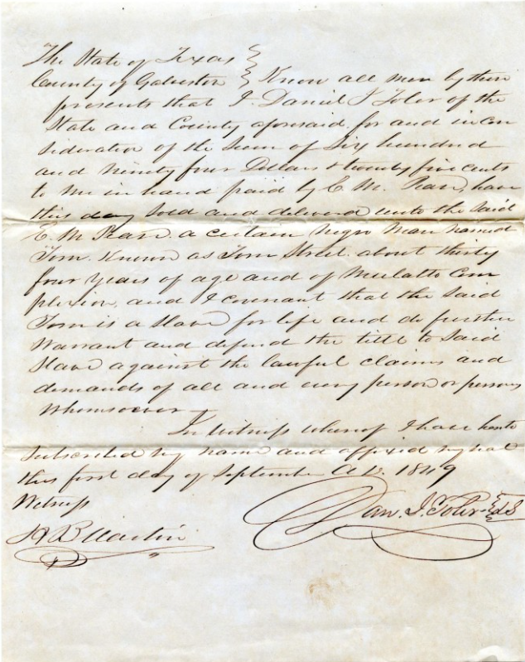 | This document is a bill of sale (or receipt) recording the sale of an enslaved man named Tim, “known as Tim Street” to a plantation owner named E. M. Pease.  Pease purchased the enslaved man for $694.25 (approximately $27,000 today.)  The enslaved man was described as being about 34 years old and of a light complexion.  The receipt declares that the enslaved man was a “slave for life.”  - Bill of sale for purchase of slave by E.M. Pease], text, September 1, 1849  The Portal to Texas History

