
Warm-up: Looking Ahead
Unit 7: Early Statehood
Name: |  | Date: |  | Period:

- What can this map tell us about the United States during this era? Explain. | 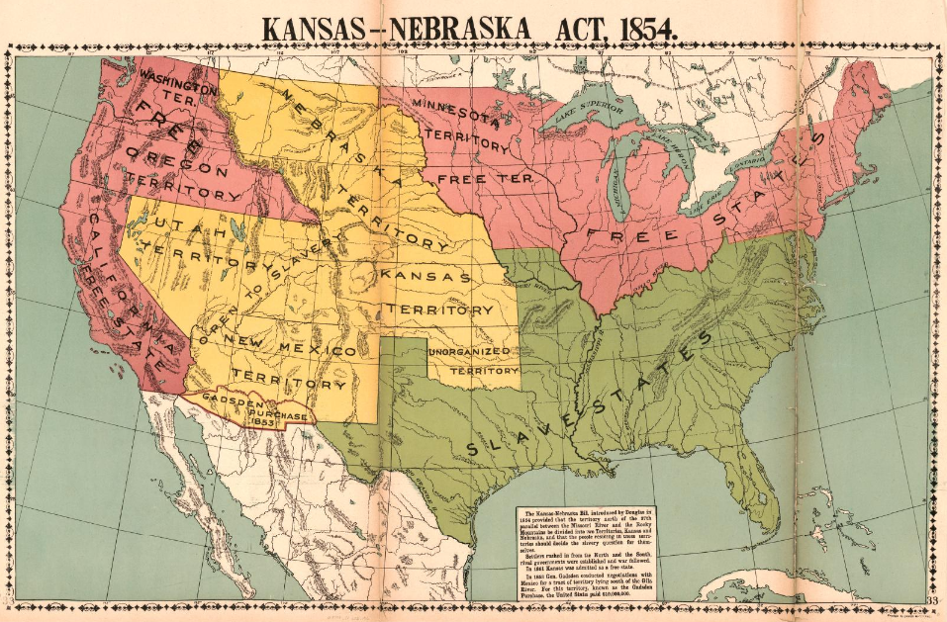

Warm-up: Looking Ahead
Unit 7: Early Statehood
Name: |  | Date: |  | Period:

- What can this map tell us about the United States during this era? Explain.


Looking Ahead Exit Ticket

Directions: Complete the activity below by circling a topic of your choice and finishing the sentence stems related to your chosen topic.
One of the topics presented in the primary source materials today was (choose one below)
Secession the Union Abolition Slavery

One point of view about this topic was ___________________________________________________________________
while, a different point of view on this topic was _________________________________________________________

Looking Ahead Exit Ticket

Directions: Complete the activity below by circling a topic of your choice and finishing the sentence stems related to your chosen topic.
One of the topics presented in the primary source materials today was (choose one below)
Secession the Union Abolition Slavery

One point of view about this topic was ___________________________________________________________________
while, a different point of view on this topic was _________________________________________________________

