Station 1

Notes:
Data for this chart only includes the top 10 demographic groups that lived in Texas in 1850. There were more groups of people from other states in the United States and from other countries, though these groups represented a smaller portion of the Texas population in 1850.
Data is limited for the birth records of American Indians and enslaved African Americans in Texas during the Early Texas Statehood era from 1845 to 1860. As a result, information for those demographic groups is not included in this chart.

Station 2

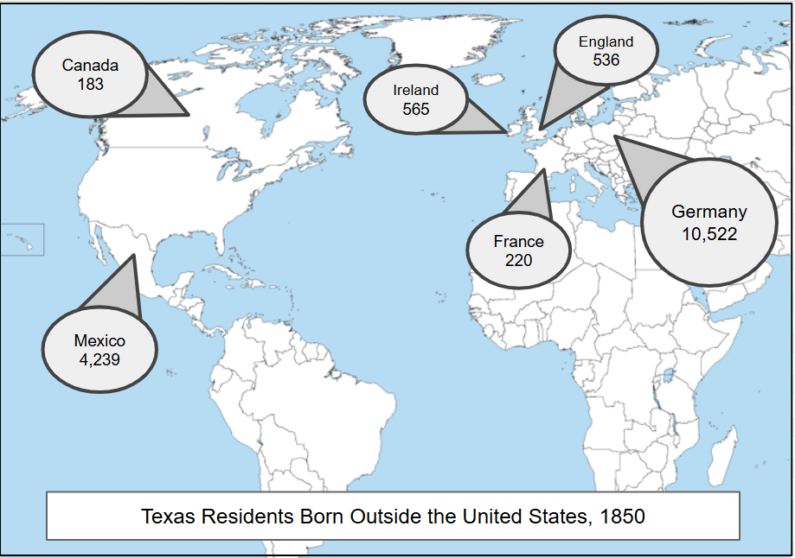
Note: This graphic shows information related to the country of origin for only the top six countries where immigrants to Texas immigrated from in 1850.

Station 3

Notes:
The non-Indian population of Texas for the years 1800 – 1820 was approximately 4,000 Tejanos. On the chart the number appears to be close to zero because of the wide scope of the data presented on the chart.
Exact numbers for the Texas Indian population during the Early Texas Statehood era are not known, though estimates indicate that there were approximately 20,000 American Indians living in Texas in 1820. Similarly, the number of enslaved people in Texas is an estimation before Texas joined the U.S. in 1845.

Station 4

Enslaved Population in the Southern United States, 1860
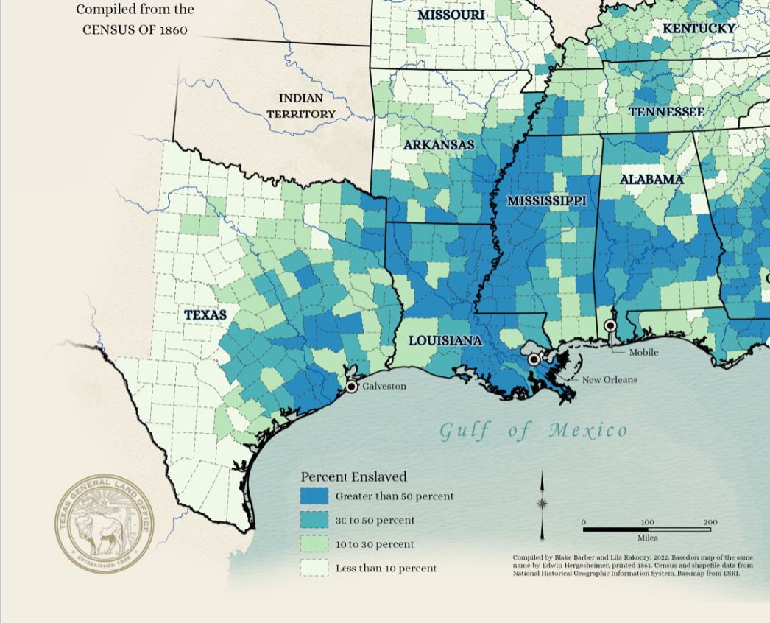
Note: This chart represents what percentage of the overall population was comprised of enslaved people for the locations shown.

Station 5



An infographic using information from the following source: Birthplace of Texas residents 1850-2022. Texas Migration History 1850-2022. America’s Great Migration Project. University of Washington. Accessed on July 22, 2025. Texas Migration History 1850-2022 - America's Great Migrations
Demographic: Related to the different groups of people within a larger population
An infographic using information from the following source: Birthplace of Texas Residents, 1850. Texas Migration History 1850-2022. America’s Great Migration Project. University of Washington. Accessed on July 22, 2025. TexasMigration History 1850-2022 - America's Great Migrations. Data placed on a map from Wikimedia Commons: A large blank world map with oceans marked in blue. Accessed on July 22, 2025. https://commons.wikimedia.org/wiki/File:20230519193449!A_large_blank_world_map_with_oceans_marked_in_blue_(1).png
An infographic using information from the following source: Population Growth from Early Texas Settlers, 1800 – 1850. Accessed on July 22, 2025. Population Growth from Early Texas Settlers - Texas Proud
Map Showing the Distribution of the Slave Population of the Southern States of the United States. Compiled from the Census of 1860. GIS Educational Maps. Texas General Land Office. Accessed on July 22, 2025. GIS Educational Maps | GIS Educational Maps | GIS Educational Maps | Showcase | Texas GLO
German-Texan Heritage Society. German-Texan Heritage Society, The Journal, Volume 36, Number 3, Fall 2014, periodical, Autumn 2014; Austin, Texas. (https://texashistory.unt.edu/ark:/67531/metapth1507496/: accessed July 22, 2025), University of North Texas Libraries, The Portal to Texas History, https://texashistory.unt.edu; crediting German-Texan Heritage Society.

