 Warm-up: Mind Map Review
Unit 7: Early Statehood
Name: |  | Date: |  | Period:

Look at the word bank below. Complete the mind map diagram by putting each term where you think it fits best.

- Early Statehood  - U.S.-Mexico War  - Disputes over slavery  - Treaty of Guadalupe Hidalgo  - Westward Expansion | 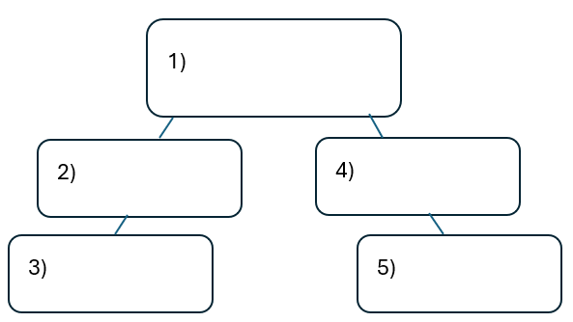

Warm-up: Mind Map Review
Unit 7: Early Statehood
Name: |  | Date: |  | Period:

Look at the word bank below. Complete the mind map diagram by putting each term where you think it fits best.

- Early Statehood
- U.S.-Mexico War
- Disputes over slavery
- Treaty of Guadalupe Hidalgo
- Westward Expansion

Exit Ticket: Mind Map Review
Unit 7: Early Statehood
Name: |  | Date: |  | Period:

Directions: Complete the sentence by choosing the best answer for each blank from the chart below.
The (1)____________ is primarily characterized by (2)____________

Answer choices for blank (1)  Circle the best answer | Answer choices for blank (2)  Circle the best answer
- Early Statehood era  - U.S.-Mexico War  - Compromise of 1850  - Treaty of Guadalupe Hidalgo | - … migration and immigration from Texas into other Southern states and central European countries in search of new economic opportunities.  - … rising sectionalism in the U.S. over the issue of slavery, which increased after gaining the Mexican Cession.  - … arguments between the North and South over claims to Texas and its southern border with Mexico.  - … the development of a strong abolitionist party in Texas and the rest of the South.

Exit Ticket: Mind Map Review
Unit 7: Early Statehood
Name: |  | Date: |  | Period:

Directions: Complete the sentence by choosing the best answer for each blank from the chart below.
The (1)____________ is primarily characterized by (2)____________

Answer choices for blank (1)  Circle the best answer | Answer choices for blank (2)  Circle the best answer
- Early Statehood era  - U.S.-Mexico War  - Compromise of 1850  - Treaty of Guadalupe Hidalgo | - … migration and immigration from Texas into other Southern states and central European countries in search of new economic opportunities.  - … rising sectionalism in the U.S. over the issue of slavery, which increased after gaining the Mexican Cession.  - … arguments between the North and South over claims to Texas and its southern border with Mexico.  - … the development of a strong abolitionist party in Texas and the rest of the South.

