Study Guide Review Grade Level
Unit 7: Early Statehood

Name: |  | Date: |  | Period:

Part I: Significant Terms
Write the term from the word-bank below in the numbered box next to the best definition or description in the chart below.
The Mexican Cession | The Compromise of 1850 | The U.S.-Mexico War
Frontier | Sectionalism | The Treaty of Guadalupe Hidalgo
Slavery | Plantation Agriculture | Manifest Destiny

This was the primary economic activity of southern states like Texas, Mississippi, and Alabama. This economic activity focused on cultivating, or growing, the cash crop, cotton, using slave labor.
This conflict was fought over claims to Texas and disputes, or arguments, over the southern border of Texas.
This document ended the conflict in the previous question. The terms of this document required Mexico to cede, or give up, to the United States all of its land west of Texas to California in exchange for $15 million.
Conflicts regularly occurred between prominent Indian tribes like the Comanche and Anglo settlers who migrated into this area in west Texas. One result of these conflicts was the forced removal of Texas Indians into present-day Oklahoma.
This was a belief that some Americans held that the United States was destined to expand all the way to the west coast of North America.
This was the name given to all the lands that Mexico ceded to the United States as part of the terms of the Treaty of Guadalupe Hidalgo. It included lands from Texas to California. The addition of this land to the U.S. sparked intense arguments over whether or not slavery should be permitted in the new territories.
A U.S. Senator named Henry Clay authored this law to satisfy both the anti-slavery North and the pro-slavery South. The law admitted California to the Union as a free state, strengthened laws about capturing and returning runaway slaves, and reduced the size of Texas.
This was the term for the growing division between the North and the South, primarily over the issue of slavery. This term meant that these different regions were more focused on their own interests and more loyal to their region over their country.
This was the primary issue which caused division between the North, which opposed this issue, and the South, which supported it. Northerners and Southerners argued over whether this issue should be allowed in new states in the west.

Part II: Cause-and-Effect Matching
The left column contains significant events of the Early Texas Statehood era. The right column provides the effect of each event. Match each cause on the left with its correct effect on the right.

- The United States annexed Texas and supported the state’s claim that its southern border was the Rio Grande, rather than the Nueces River.

- The Treaty of Guadalupe Hidalgo ended the war with an American victory and set the terms of peace.

- The California Gold Rush brought a flood of migrants into the territory, quickly making California eligible for statehood.

- Disputes over the westward expansion of slavery increased between Northern and Southern congressmen.

- People from the United States and other countries flooded into Texas, and many of those people began settling along the western frontier.

- Most of the people migrating into Texas from the U.S. came from states in the South like Mississippi, Alabama, and South Carolina.

- This event caused intense debates between Northern and Southern politicians over the expansion of slavery into the new western state.

- Conflicts increased between Great Plains tribes like the Comanche and Anglo settlers, leading to military action and eventually the forced removal of many Indian tribes from Texas into Oklahoma.

- Mexico was required to cede to the United States all Mexican territory west of Texas to California in exchange for $15 million.

- The Compromise of 1850 was passed to appease both Northerners and Southerners. It admitted California as a free state, passed stricter requirements for returning runaway slaves, and reduced the size of Texas.

- These new arrivals increased Texas’ connection to other agricultural slave states, leading Texas to side firmly with the South on the issue of sectionalism that was rapidly growing in the country.

- Mexico viewed these actions as an act of war. These actions led to the outbreak of the U.S.-Mexico War from 1846 to 1848.

Part III: Practice Test Questions
Answer the following practice test questions about Early Statehood. Questions are based on the 8th grade Social Studies STAAR question types.

- The map below shows the political boundaries and regions of the United States in 1848 – 1850. Label the map by writing the correct letter of each location with its corresponding description.
_______ Slave states  _______ The Mexican Cession  _______ Territory ceded to  the U.S. in the  Compromise of 1850.  _______ Free States | 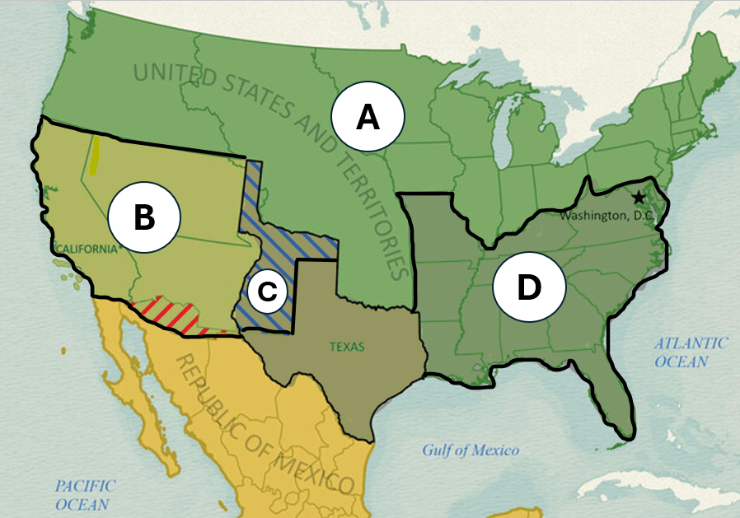

- View the graphic organizer below and answer the question that follows.

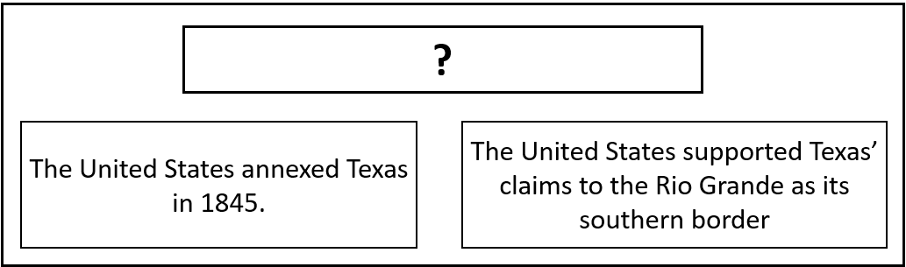

Which of the following titles best completes the information provided in the chart?

- Terms of the Treaty of Guadalupe Hidalgo
- Causes of the U.S.-Mexico War
- Conditions of the Compromise of 1850
- Reasons for increasing sectionalism in the United States

- Read the items in the graphic organizer below. Which items were terms of the Compromise of 1850? Circle or highlight THREE correct answers.

California joined the Union as a free state. | Mexico was required to cede to the U.S. all its territory from Texas to California. | Texas ceded some of its western territory for $10 million.
The Fugitive Slave law was passed requiring Northerners to return runaway slaves. | Texas was opened to international immigration from countries like Germany. | Slavery was abolished in all Southern states.

- This question has two parts. Read the following primary source excerpt and answer the questions that follow.

“California, of all the recent territorial acquisitions from Mexico, was that in which, if anywhere within them, the introduction of slavery was most likely to take place; and the constitution of California, by the unanimous vote of her convention, has expressly interdicted it.”

- The Texas State Gazette of Austin, June 8, 1850. The Portal to Texas History

PART A:
Which political principle is best exemplified in the excerpt above?
- Federalism
- Republicanism
- Unionism
- Popular Sovereignty
PART B:
Which excerpt from the passage provides the best example of your answer to the previous question?
- “ … by the unanimous vote of her convention …”
- “ … and the constitution of California…”
- “ … of all the recent territorial acquisitions from Mexico …”
- “ … has expressly interdicted it.”

