Preserving German Heritage

Today, German culture and heritage can be observed in Texas in a number of ways. Many towns founded by German immigrants are thriving Texas cities today, including Fredericksburg, Gruene, and New Braunfels. | 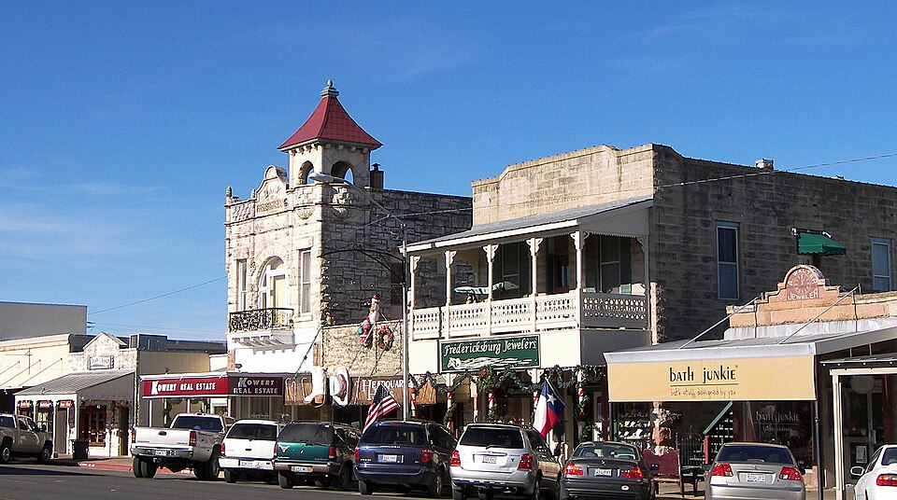  Figure 1: The Fredericksburg Historic District

The German – Texan Heritage Society was founded in 1978, to promote and preserve German culture in Texas. The Society sponsors traditional German events, like Christmas markets where visitors can sample mulled wine, stollen (bread filled with dried fruit and nuts, and bratwurst (a traditional German sausage.)
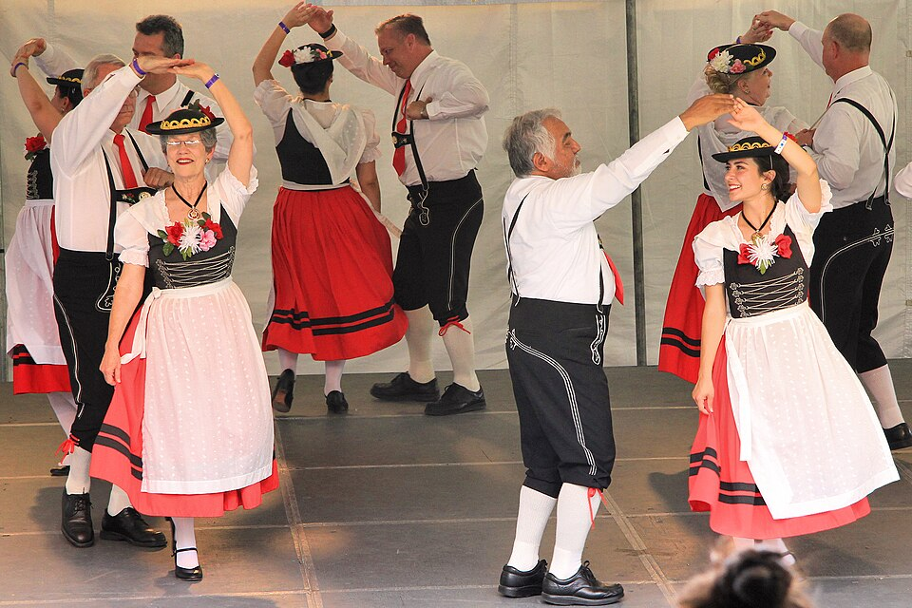  Figure 2: German Folk dancers of San Antonio at the 42nd annual Texas Folklife Festival. | Another traditional German celebration that is held in various cities across Texas is called Oktoberfest. This event includes German food and drinks, live music performed by “oompah” bands, and German dancing. Performers and attendees at these events often wear traditional German clothes like lederhosen.

New Braunfels hosts a celebration related to Oktoberfest called Wurst Fest, which is considered one of the largest Oktoberfest celebrations in Texas.  The German – Texas Heritage Society also holds educational programs including language classes to teach children and adults the German language as well as traditional German cooking classes. The Society also maintains resources to help people who want to learn more about their German ancestors who immigrated to Texas. | 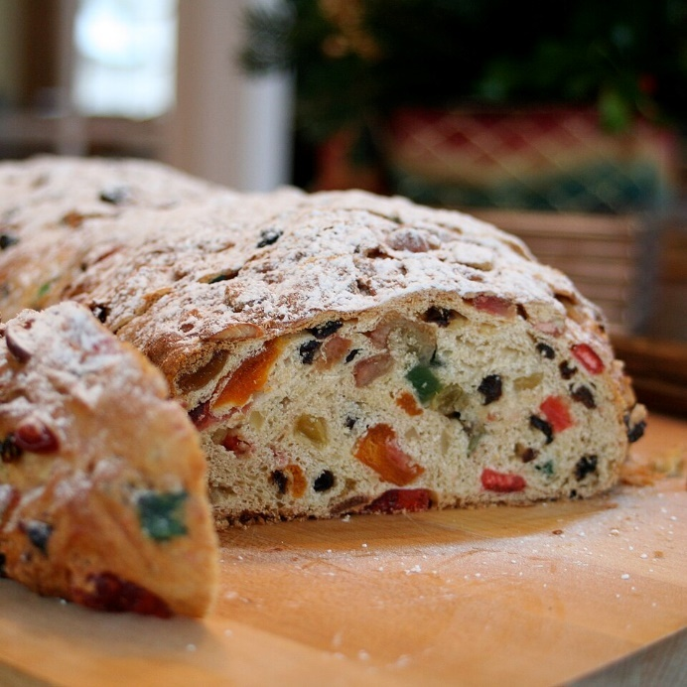  Figure 3: Stollen, German bread filled with nuts and dried fruits

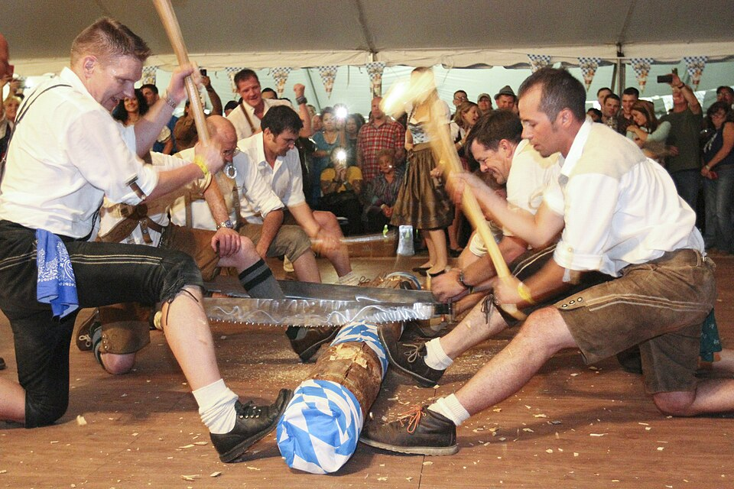  Figure 4: A wood-chopping competition at an Oktoberfest Celebration at Fort Bliss, Texas. | Many German towns and communities across Texas also hold their own cultural events. Near Houston, the town of Tomball hosts an annual German Christmas festival called the Tomball German Fest.  Texas’ rich history of German culture and heritage is preserved, honored, and celebrated in many ways throughout the Lonestar State today.

Preserving Polish Heritage

Polish immigrants began settling in Texas in the early 1800s. Like many other immigrants at the time, Poles were drawn to Texas for the inexpensive land and economic opportunities the region offered.  Today, Polish culture and heritage in Texas is honored and preserved in a number of ways. The Polish Heritage Center at Panna Maria works to educate the public about the history and culture of Polish people at Panna Maria – the oldest Polish settlement in the United States. | 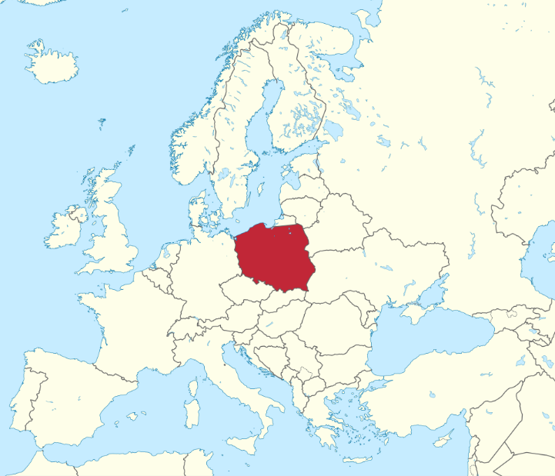  Figure 5: A map of Europe with the location of Poland highlighted.

The Polish Heritage Center at Panna Maria also hosts educational events, runs a Polish cooking school, maintains a library on Polish history, promotes the Polish language by offering language classes, and hosts an annual Polish Youth Day in Panna Maria.
  Figure 6: Traditional Polish food, including sausage and cabbage rolls. | Another way that Polish culture is preserved in Texas today is through various Polish celebrations. The Houston Polish Festival has been held every year since 2006 at a Polish church called Our Lady of Czestochowa Roman Catholic Church. The event includes traditional Polish music, dancing, and foods like cabbage rolls, blintzes (a dessert pastry similar to a crepe filled with sweet cream), and kiszka (Polish sausage). Performers and participants often wear traditional Polish clothing. The event includes a Catholic mass, which is a religious service in the Catholic faith.

Another organization called the Polish American Council of Texas was established in 2011 to promote and preserve Polish culture and heritage in Texas. This organization maintains resources for Polish Texans throughout the state and keeps a directory of significant Polish historic sites in Texas. Many of these sites are Catholic churches, like Saint Michael Catholic Church, which was the third oldest church in San Antonio. The Polish – American Council of Texas also offers scholarships to Polish – American high school and university students. | 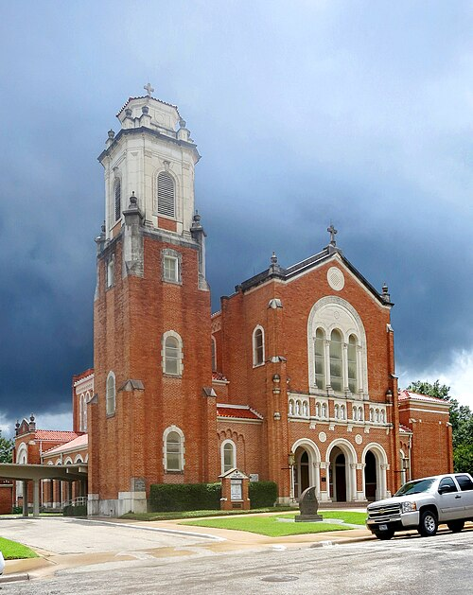  Figure 7: St. Mary's Catholic Church, established in 1870 in Brenham, Texas by Irish, German, and Polish Families.

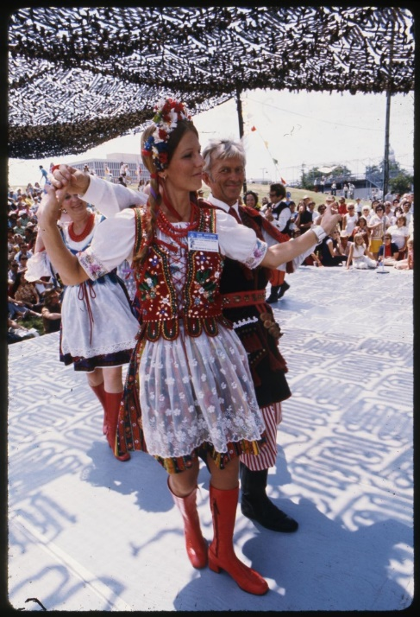  Figure 8: Dancers at the Texas Folk Life Festival in 1975. | There are also Polish schools and educational programs in Texas like the Jan Karski Polish School of Dallas and the Szkola Polska im Mikolaja Kopernika school in Houston. These schools seek to promote Polish cultural awareness and teach Polish language classes to youth and adults.  There are also a number of Polish dance groups in Texas that learn traditional Polish dances and give performances around the state, like the Jagoda Polish Dance Ensemble in Plano and the Wawel Dance Group in Houston.

Texas’ rich history of Polish culture and heritage is preserved, honored, and celebrated in many ways throughout the Lonestar State today.

Preserving Mexican Heritage

Texas’ rich history is closely tied with the history of Mexico, and there are many examples of that close connection throughout Texas today. Many important cities in Texas have Spanish names, like El Paso, San Antonio, Corpus Christi, Amarillo, Laredo, and Del Río. |   Figure 9: Guadalupe Peak, in the Guadalupe Mountains. The Portal to Texas History.

Many geographic landforms also have Spanish names like the Llano Estacado in the Great Plains, the Guadalupe Mountains in the Mountains and Basins, Padre Island, the Rio Grande, and the Balcones Escarpment in the Coastal Plains.
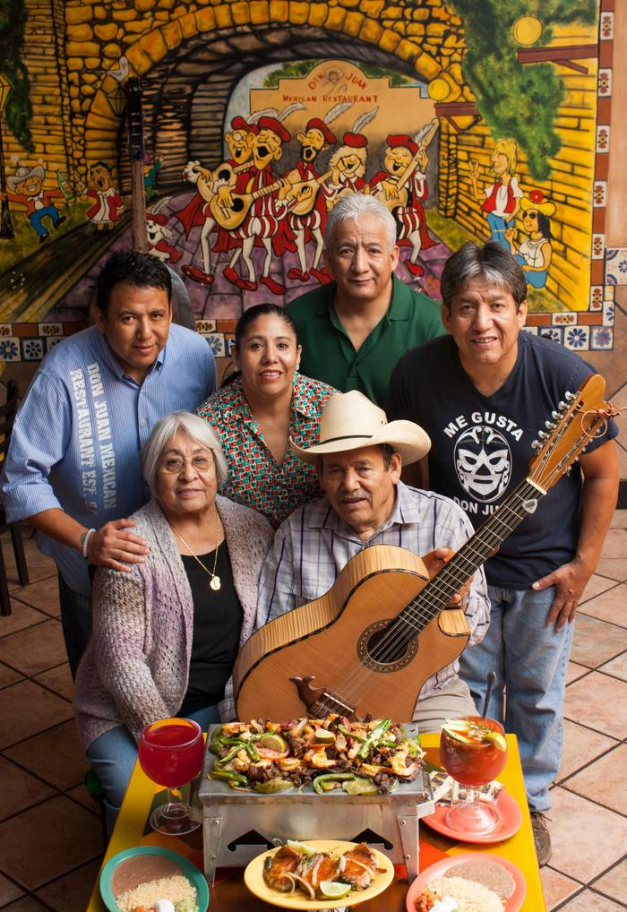  Figure 10: Don Juan Mexican Restaurant in Tyler, Texas. The Portal to Texas History. | Additionally, the Spanish language is still used for more than just significant Texas cities and landforms. Spanish is the second-most spoken language in Texas today, with nearly 30% of Texans, or 7.8 million people, speaking Spanish throughout the Lone Star State. In fact, approximately 40% of Texas’ total population is Hispanic, with the large majority of the Hispanic population having Mexican heritage.  Another way in which Mexican culture and heritage is preserved in Texas today is through food. Mexican food is incredibly popular in Texas, with nearly 20% of all restaurants in the state being Mexican restaurants.

Over time, traditional Mexican food has been combined with Texan foods to create a type of food called Tex-Mex, which adds ingredients like yellow cheeses, flour tortillas, and cumin to the more traditional Mexican ingredients of white cheeses, corn tortillas, and a wider variety of chili peppers and spices.
There are many ways that people across Texas work to preserve, maintain, and celebrate Mexican heritage and culture throughout the state. In San Antonio, the Guadalupe Cultural Arts Center holds educational events to teach different styles of Spanish dance including flamenco and folklorico. The organization also provides music classes to teach the popular Mexican style of music called mariachi.  The Guadalupe Cultural Arts Center also hosts cultural events including the Tejano Conjunto Festival which includes traditional Mexican art, music, dancing, and food; the Noche de Romance mariachi concert; the Cinefestival which highlights Mexican and Spanish-language films; and the Teatro Salon which highlights Spanish literature. | 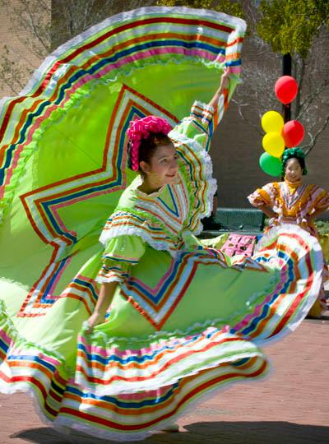  Figure 11:A folklorico dancer in green at Carnaval, which was hosted by the UNT Multicultural Center. The Portal to Texas History.
Additionally, the city of San Antonio has held celebrations for more than 167 years to commemorate Mexican Independence, which is celebrated on September 16 each year. Houston holds the annual Fiestas Patrias International Parade to celebrate a number of patriotic Mexican holidays. Mexican Independence celebrations have also been held at the Texas state capitol in Austin, as well as other locations across the state.
Texas’ rich history of Mexican culture and heritage is preserved, honored, and celebrated in many ways throughout the Lone Star State today.

Preserving American Indian Heritage

Long before the first Spanish explorers or Anglo empresarios arrived in Texas, the region was home to numerous American Indian tribes with their own unique cultures, traditions, languages, and religious beliefs.
Today, there are many ways that people and organizations in Texas work to preserve and honor various American Indian tribes and their unique cultures, and heritage.
The Intertribal Community Council of Texas is an organization based in the Dallas – Fort Work Metroplex that advocates for the American Indian community in north Texas. In addition to providing community resources for the DFW American Indian population, the organization also holds meetings of tribal elders from the Comanche and Cherokee tribes, and hosts activities like the traditional American Indian game of stickball. | 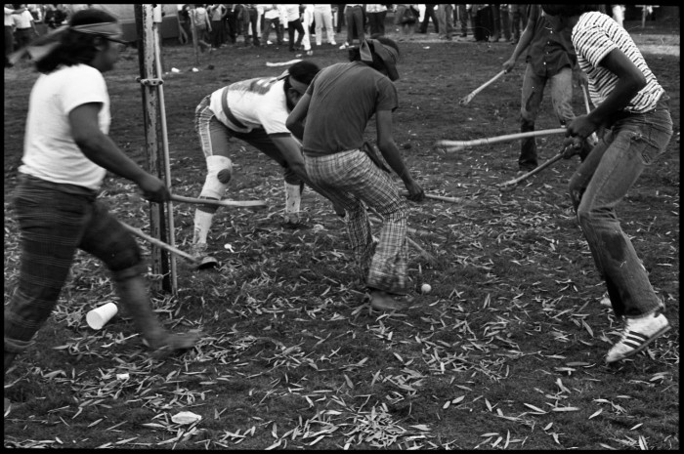  Figure 12: The Alabama-Coushatta and Tigua tribes play a game of stickball at the Texas Folk Life Festival. The Portal to Texas History.

The Indigenous Cultures Institute is another organization that works to promote and preserve American Indian heritage in Texas and northern Mexico and highlight the connection between Indigenous and Mexican heritage and ancestry. The institute hosts events like the Sacred Springs Powwow in San Marcos, as well as religious events including ceremonies for the Coahuiltecan Paxē Pilam Church of Tejas.  Additionally, the Indigenous Cultures Institute works to preserve sacred sites like the White Shaman Rock Shelter near Comstock, Texas, along the Rio Grande. This site contains American Indian cave art from approximately 4,000 years ago. The Institute also offers classes on the Coahuiltecan language, Indigenous arts and theatre, and American Indian history and culture. | 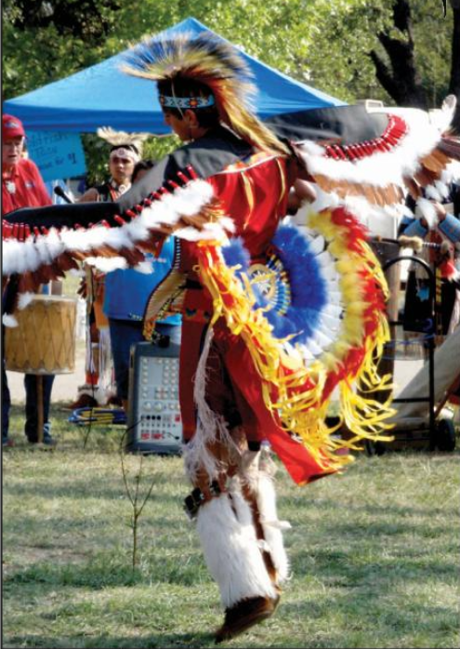  Figure 13: A dancer performs at a Powwow in Comanche County. The Portal to Texas History.

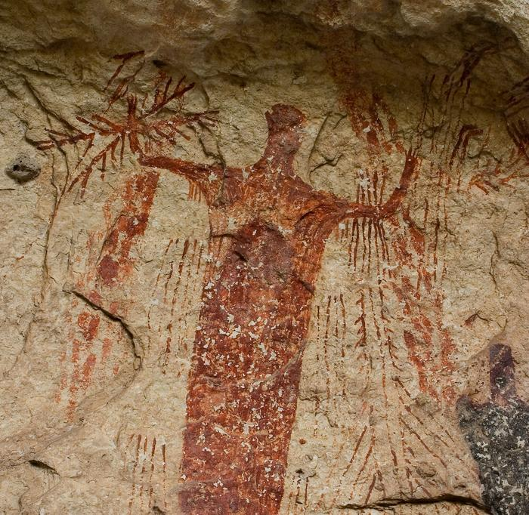  Figure 14: A cave painting at the White Shaman Rock Shelter. The Portal to Texas History. | The Texas Historical Commission (THC) is an organization that works to preserve Texas history and educate the public about important topics and sites in Texas.  The THC maintains the Caddo Mounds State Historic Site, which was the location of a prominent Hasinai Caddo village that was established more than 1,000 years ago in east Texas. The Caddo built large earth mounds for religious ceremonies, and three of those mounds are preserved at this location today. Artifacts from the site like Caddo pottery, tools, and weapons are on display at the Caddo Mounds museum.

The Texas Tribal Buffalo Project is a woman-led, Lipan Apache organization in the Texas Great Plains that works to preserve the Apache culture and heritage, with a specific focus on the tribe’s historic connection to the American buffalo in the region. This organization’s goal is to preserve and care for the natural environment of American buffalo herds in the Plains. The organization also hosts a farmers market where people can buy buffalo meat as well as items made by tribal members.
Texas’ rich history of American Indian culture and heritage is preserved, honored, and celebrated in many ways throughout the Lone Star State today.

