Texas Today Advanced
Unit 7: Early Statehood

Name: |  | Date: |  | Period:

Preserving Cultural Heritage in Texas Today
Increased immigration to Texas from 1845 to 1860 brought many people from different countries to Texas. As Germans, Czechs, Irish, French, Canadians, Poles and others immigrated to Texas, they brought their own languages, food, traditions, customs, and heritage with them. While they often worked to assimilate into American and Texan culture, it was also important to many of them that they preserve their own heritage as they began their new lives in Texas.
In addition to newly arrived groups of immigrants, there were also Mexican Texans, or Tejanos, and American Indians already living in Texas during early statehood. These groups have also worked to preserve and maintain their cultural traditions and heritage over time.
Today, many Tejanos, American Indians, and descendants of immigrants in Texas still honor their own unique cultures and heritage in a variety of ways. In this assignment, you will choose one group of people from the options in the map below and learn about how people preserve the culture and heritage of this group in Texas today.
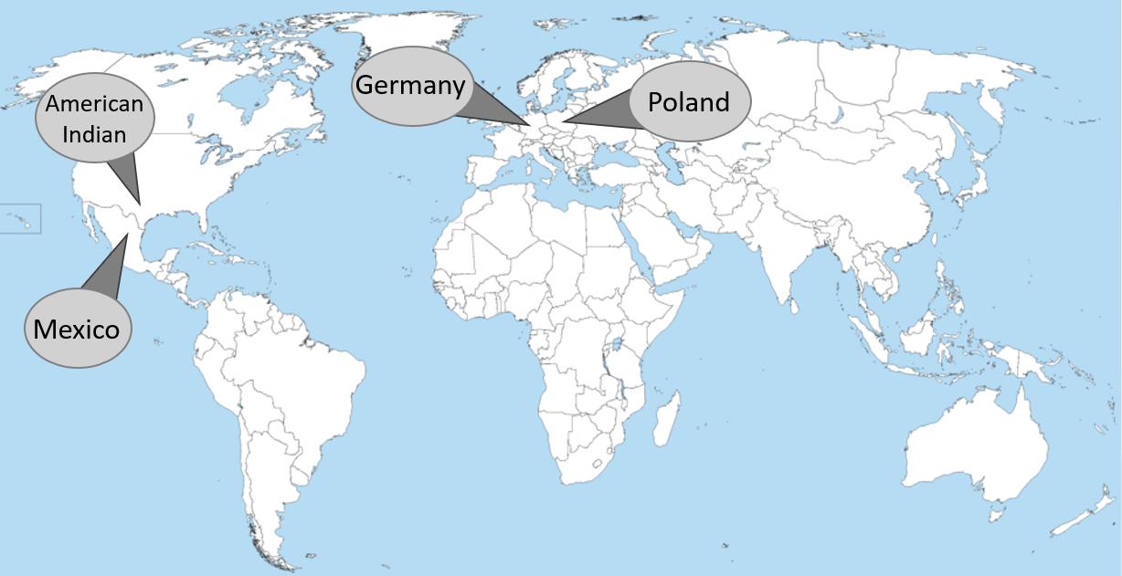
I chose to learn about (which people group?)

How do people in Texas today work to preserve the culture and heritage of this group?

One question I have about what I learned in the reading is . . . | I would like to know more about . . .

Use the internet to research at least ONE interesting thing you learned in the reading about this group of people. Provide more information about your chosen topic here:

Directions: Now learn about the other people groups from your classmates. Record information about their groups below. Record at least five pieces of information about each group. Talk to at least three classmates to acquire this information.
People Group #2:

How do people in Texas today work to preserve the culture and heritage of this group?

People Group #3:

How do people in Texas today work to preserve the culture and heritage of this group?

People Group #4:

How do people in Texas today work to preserve the culture and heritage of this group?

