Texas Today Foundations
Unit 7: Early Statehood

Name: |  | Date: |  | Period:

Preserving Cultural Heritage in Texas Today
From 1845 to 1860, immigration to Texas increased significantly. Germans, Czechs, Irish, French, Canadians, Poles and others immigrated to Texas, bringing their own languages, food, traditions, customs, and heritage with them. While they often worked to assimilate into American and Texan culture, they often also preserved their own heritage as they began their new lives in Texas.
In addition to the different immigrant groups who came to Texas, there were also Mexican Texans, or Tejanos, and American Indians already living in Texas. These groups have also worked to preserve and maintain their cultural traditions and heritage over time.
Today, many Tejanos, American Indians, and descendants of immigrants in Texas still honor their own unique cultures and heritage in a variety of ways. In this assignment, you will choose one group of people from the options in the map below and learn about how people preserve the culture and heritage of this group in Texas today.
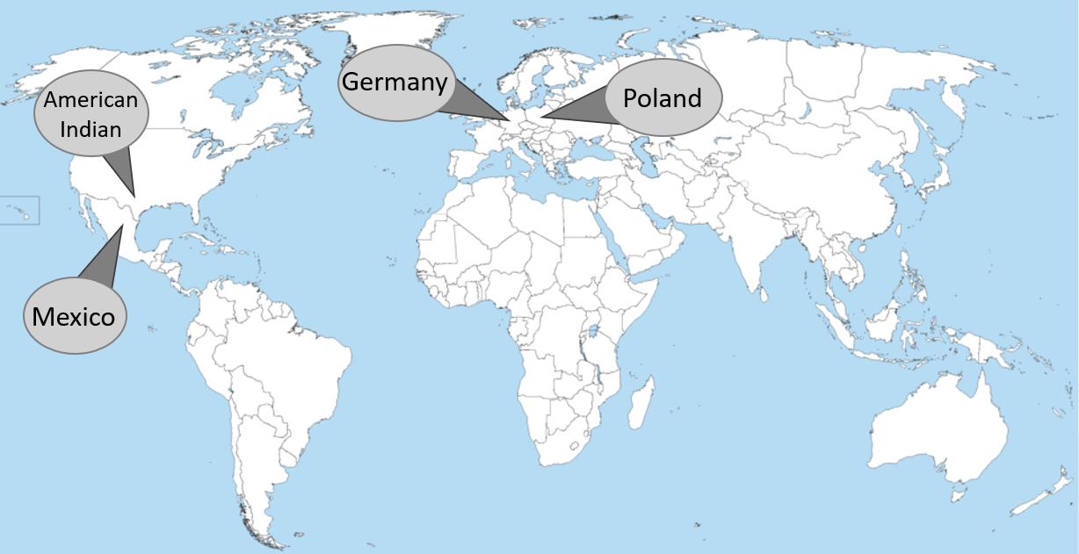
I chose to learn about . . .  (Circle or Highlight) | Germans Poles American Indians Tejanos

How do people in Texas today work to preserve the culture and heritage of this group?
(Complete at least 3 of the options offered in the box below.)
- Events like ____________________________________________________________________________
- Offering classes: ____ language ____ cooking _____ the arts _____ other
- Preserving special places like _________________________________________________________
- Holding meetings like _________________________________________________________________
- Making traditional foods like _________________________________________________________
- Other (explain) _________________________________________________________________________

One question I have about what I learned in the reading is . . . | I would like to know more about . . .

BONUS: Use the internet to research at least ONE interesting thing you learned in the reading about this group of people.
Provide more information about your chosen topic here:

(This portion is not required. It is worth up to 10 additional points.)

Directions: Now learn about the TWO other people groups from your classmates. Record information about their groups below.
People Group #2: | Germans Poles American Indians Tejanos

How do people in Texas today work to preserve the culture and heritage of this group?
- Events like ____________________________________________________________________________
- Offering classes ____ language ____ cooking _____ the arts _____ other
- Preserving special places like _________________________________________________________
- Holding meetings like _________________________________________________________________
- Making traditional foods like _________________________________________________________
- Other (explain) _________________________________________________________________________

People Group #3: | Germans Poles American Indians Tejanos

How do people in Texas today work to preserve the culture and heritage of this group?
- Events like ____________________________________________________________________________
- Offering classes ____ language ____ cooking _____ the arts _____ other
- Preserving special places like _________________________________________________________
- Holding meetings like _________________________________________________________________
- Making traditional foods like _________________________________________________________
- Other (explain) _________________________________________________________________________

Assimilate: totally adopt a new culture and way of life
Descendant: A person in a family tree who came after the people before. A grandchild is a descendant of a grandparent, for example.

