 Warm-up: Texas Today
Unit 7: Early Statehood
Name: |  | Date: |  | Period:

- What observations can you make about how people preserve their culture based on the image?  - What are other ways people can preserve their culture? | 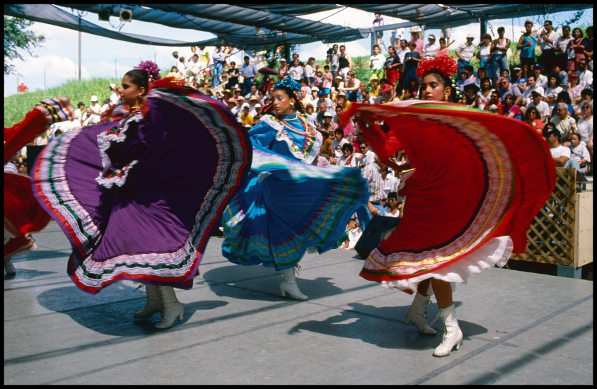  Figure 1: Ballet Folklorico Dancers at the Texas Folk Life Festival in San Antonio

Warm-up: Texas Today
Unit 7: Early Statehood
Name: |  | Date: |  | Period:

- What observations can you make about how people preserve their culture based on the image?  - What are other ways people can preserve their culture? | 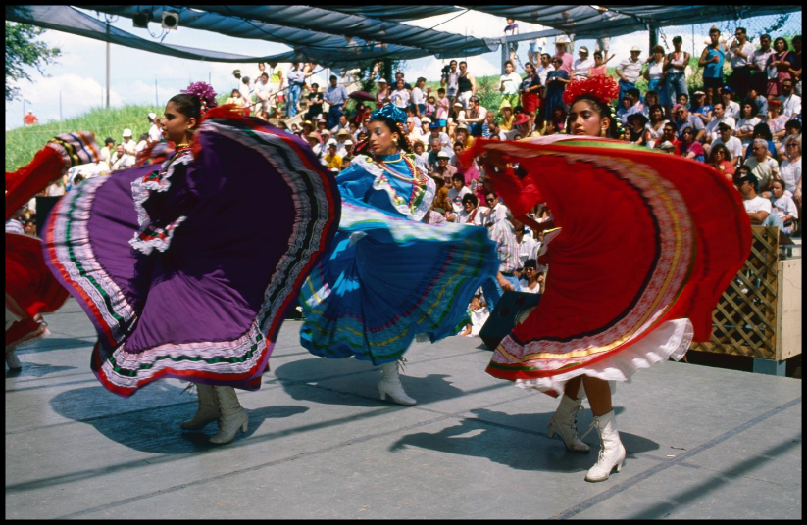  Figure 2: : Ballet Folklorico Dancers at the Texas Folk Life Festival in San Antonio

Texas Today Exit Ticket

Directions: Fill in the blanks with the appropriate information. Circle or highlight your choice from the options provided.
People from various cultural groups in Texas today work to preserve their cultures and heritage in a number of ways, like ______________________________________________________ , ___________________________________ ____________________________________, and __________________________________________________________________________.
For example, many / German / Polish / Tejano / American Indian people preserve their culture by __________________________________________________________________________________________________________________.

Texas Today Exit Ticket

Directions: Fill in the blanks with the appropriate information. Circle or highlight your choice from the options provided.
People from various cultural groups in Texas today work to preserve their cultures and heritage in a number of ways, like ______________________________________________________ , ___________________________________ ____________________________________, and __________________________________________________________________________.
For example, many / German / Polish / Tejano / American Indian people preserve their culture by __________________________________________________________________________________________________________________

