The Big Picture Advanced
Unit 7: Early Statehood

Name: |  | Date: |  | Period:

Part I: Analyze an Image

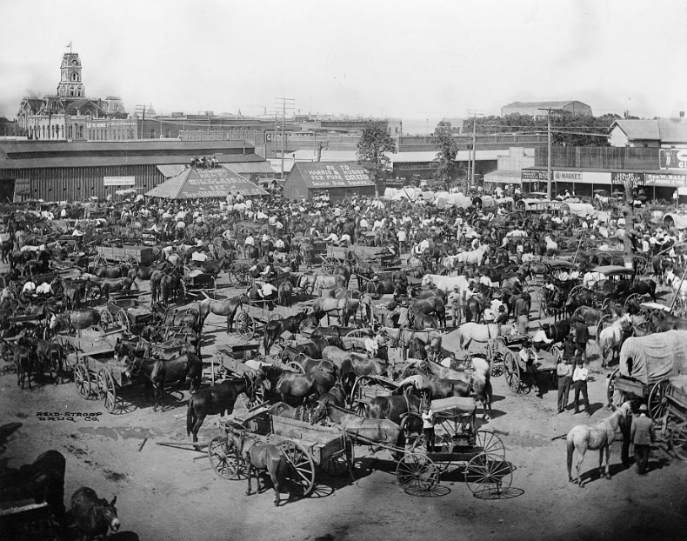  Figure 1 The Market at the town square of Cleburne, Texas. 1850. Library of Congress | - What are three things you observe about the image?
- What are two things you can infer about this era of Texas history based on your observations?

- What do you predict we will see in this unit based on the image?

Part II: Essential Ideas Reading Passage

In our previous unit on the Republic of Texas, we learned about the many challenges Texas faced as an independent nation. The Republic had struggled to address numerous issues including its mounting debt, protecting its borders and territory from invasions by the Mexican army, difficulty establishing foreign trade, and two failed attempts at annexation to the United States. Then, in 1845, the Republic of Texas finally succeeded in joining the United States as the 28th state in the Union. The annexation of Texas to the U.S. would have a significant effect on Texas, Mexico, and the United States during in the decades that followed.
Almost immediately after Texas’ annexation, the United States and Mexico fought a war over claims to Texas and disputes over the border between Texas and Mexico. The U.S.-Mexico War lasted from 1846 to 1848. The U.S. army took control of Mexico City in September 1847, ending the war five months later with the Treaty of Guadalupe Hidalgo in February, 1848. According to the terms of the treaty, the United States gained a large portion of Mexico’s territory including modern-day California, Nevada, Utah, Arizona, New Mexico, and parts of Colorado and Wyoming. With the acquisition of all this territory, the United States extended all the way to the Pacific Ocean.
The acquisition of all of this land reignited arguments within the United States government between northern and southern politicians over whether the new territories would enter the Union as slave states or free states. Southern slave states argued that slavery should be allowed to expand west. Most northerners opposed the expansion of slavery, arguing that it was not fair to white workers whose wages would then be kept low to compete with slave labor. The annexation of Texas and the addition of the new territories in the southwest caused a significant increase in arguments over slavery in the United States. During this era, these arguments would even lead to violence.
Throughout the era of early Texas statehood from 1845 to 1860, Texas would grow and develop in numerous ways. The population of Texas exploded during this era as hundreds of thousands of people migrated to Texas. Many of these people came from the American South, often bringing enslaved people with them to work on Texas plantations. Immigration from other countries also increased as German, Czech, Polish, and Irish immigrants came to Texas in search of new opportunities. As settlements expanded west into Indian territory, conflicts often broke out between the Anglo settlers and the U.S. military against Texas Indian tribes like the Comanche. All of these new developments in Texas were taking place as arguments over slavery intensified between the North and South. These arguments would have a profound impact on Texas with its predominantly southern population in control of the state government and its plantation-based economy.
Part III: Cause and Effect
Directions: Use the information from the reading on the previous page to complete the chart below demonstrating cause and effect based on events from the reading.
Cause | Effect
The Republic of Texas struggled to establish commercial and diplomatic relationships, faced increasing debt, and was unable to protect its borders from incursions by the Mexican army.
 | The U.S.-Mexico War broke out and was fought from 1846 to 1848.
The United States won the U.S.-Mexico War. The Treaty of Guadalupe Hidalgo ended the war and set the terms for peace.
 | Plantation agriculture cultivating cotton using enslaved labor increased significantly in Texas.
As the population of Texas grew, Anglo settlers migrated into the western frontier of Texas.
Write your own cause | Explain the effect

