The Big Picture Foundations
Unit 7: Early Statehood

Name: |  | Date: |  | Period:

Part I: Analyze an Image

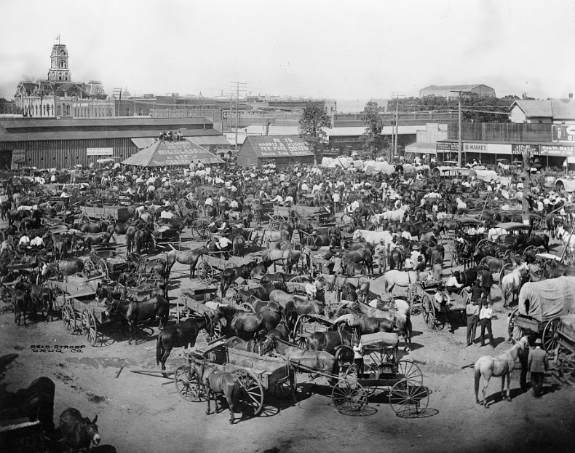  Figure 1 The Market at the town square of Cleburne, Texas. 1850. Library of Congress | - What is one thing you observe about the image?
- What is one thing you can infer about this era of Texas history based on your observations? Choose TWO.
  - Slavery will probably be abolished in Texas
  - The population of Texas will probably increase significantly
  - Texas will probably try to rejoin Mexico
  - The economy of Texas will probably improve
  - The people of Texas will probably vote to leave the United States

- What do you predict we will see in this unit based on the image? Circle or highlight THREE options that you think are likely to happen in this unit.

A decrease in Texas’ population | More plantation agriculture in the state | More conflict between Anglos and Indians
The end of slavery in Texas | An increase in Texas’ population | An alliance with Mexico

Part II: Essential Ideas Reading Passage

Directions: The following reading passage has been divided into separate sections. After each section, you will complete a “Cause and Effect” chart. You will circle or highlight the BEST answer choice demonstrating the correct CAUSE or EFFECT.
In our previous unit on the Republic of Texas, we learned about the many challenges Texas faced as an independent nation. The Republic of Texas struggled with economic issues including increasing debt and difficulty establishing commercial relationships with other countries. Texas was also unable to protect its borders from invasions by the Mexican army, while powerful Indian tribes like the Comanche dominated its western frontier. After two failed attempts at annexation to the United States, Texas finally succeeded at joining the U.S. in 1845. The annexation of Texas to the U.S. would have a significant effect on Texas, Mexico, and the United States during in the decades that followed.
Cause | Effect
- Texas faced problems with debt, commercial partnerships, and instability as a country.  - Texas needed economic and military protection from western Indian tribes. | The Republic of Texas was officially annexed to the U.S. in 1845.

Almost immediately after Texas’ annexation, the United States and Mexico fought a war over claims to Texas and disputes over the border between Texas and Mexico. The U.S.-Mexico War lasted from 1846 to 1848. The Treaty of Guadalupe Hidalgo officially ended the war in February 1848. According to the terms of the treaty, the United States gained a large part of Mexico’s territory including modern-day California, Nevada, Utah, Arizona, New Mexico, and parts of Colorado and Wyoming. With the addition of this new territory, the United States extended all the way west to the Pacific Ocean.
Cause | Effect
- The U.S. and Mexico did not agree on the border between Texas and Mexico.  - The U.S. invaded Mexican territories like California and New Mexico. | The U.S.-Mexico War broke out in 1846. It ended in 1848.
The United States won the U.S.-Mexico War. The Treaty of Guadalupe Hidalgo ended the war and set the terms for peace. | - Mexico was able to regain control of Texas.  - The U.S. gained Mexico’s lands in the southwest.

Gaining this new land in the west increased arguments between the North and the South over slavery. Most southerners argued that slavery should be allowed to expand west, so that plantation agriculture could spread into the new land. Most northerners, however, opposed the westward expansion of slavery. They argued slavery was not fair because it kept White wages low to compete with slave labor. The annexation of Texas and the addition of the new territories caused a significant increase in arguments over slavery in the United States. During this era, these arguments would even lead to violence.
Cause | Effect
Most northerners opposed the expansion of slavery, while most southerners supported it. | - Northerners and southerners argued over whether slavery should expand into the new western lands.  - Northerners and southerners tried to extend slavery west to make more money in agriculture.

Throughout the era of early Texas statehood from 1845 to 1860, Texas grew and developed in numerous ways. The population of Texas exploded during this era as hundreds of thousands of people migrated to the new state. Many of these people came from agricultural states in the South. These southerners often brought enslaved people with them to work on Texas plantations. Immigration from other countries also increased as German, Czech, Polish, and Irish immigrants came to Texas in search of new opportunities. As settlements expanded west into Indian territory, conflicts often broke out between the Anglos and Indian tribes like the Comanche.
All of these new developments in Texas were taking place as arguments over slavery grew stronger between the North and South.
Cause | Effect
After Texas was annexed to the United States in 1845, hundreds of thousands of people started moving into Texas. | - The new people coming to the state were mostly abolitionists who wanted to end slavery in Texas.  - Most people came from southern states, so Texas became very closely connected to the South.

