The U.S.-Mexico War Advanced
Unit 7: Early Statehood

Name: |  | Date: |  | Period:

James Polk

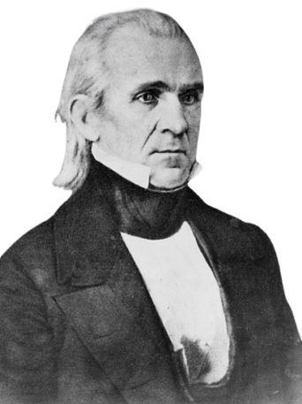

The U.S.-Mexico War

The Causes of the U.S.-Mexico War

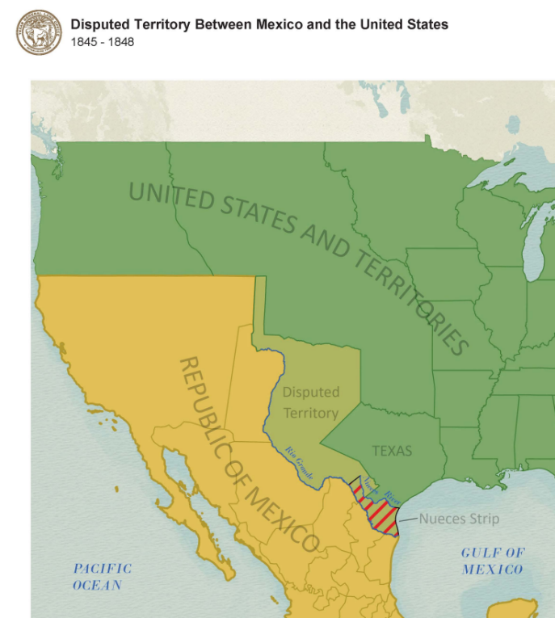

Notable Battles

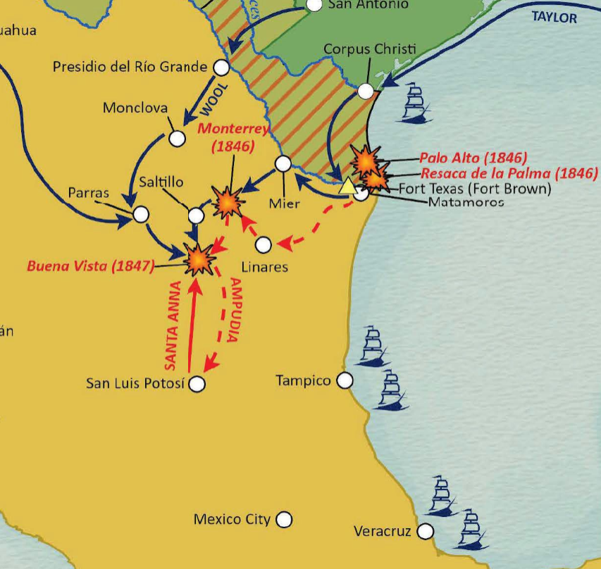

The Treaty of Guadalupe Hidalgo
February 1848

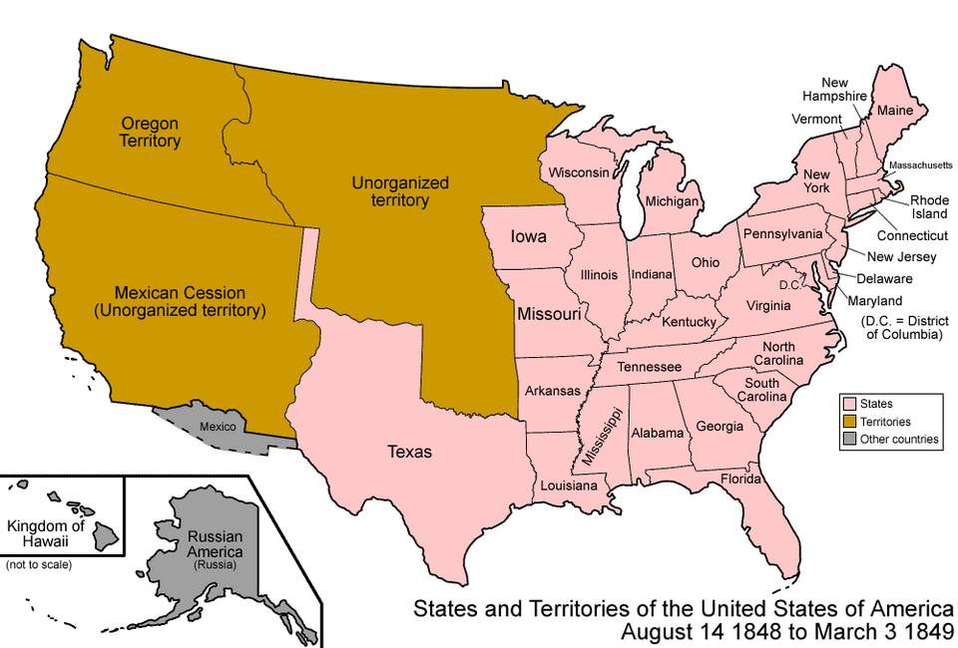

Texas & the U.S.-Mexico War

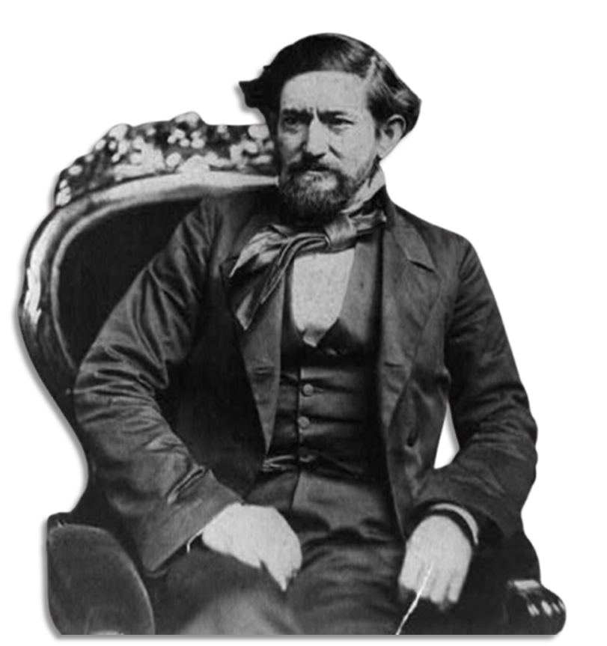

Significance of the U.S.-Mexico War

