The U.S.-Mexico War Foundations
Unit 7: Early Statehood

Name: |  | Date: |  | Period:

James Polk

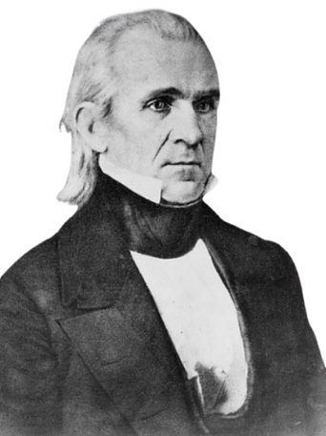 | Write the correct word(s) from the slide  - U.S. President 1845 – 1849  - Goal: Westward expansion of the U.S. to the Pacific Ocean.  - Why?  - Better access to profitable markets with Asia  - “___________________________________________”

The U.S.-Mexico War

The Causes of the U.S.-Mexico War  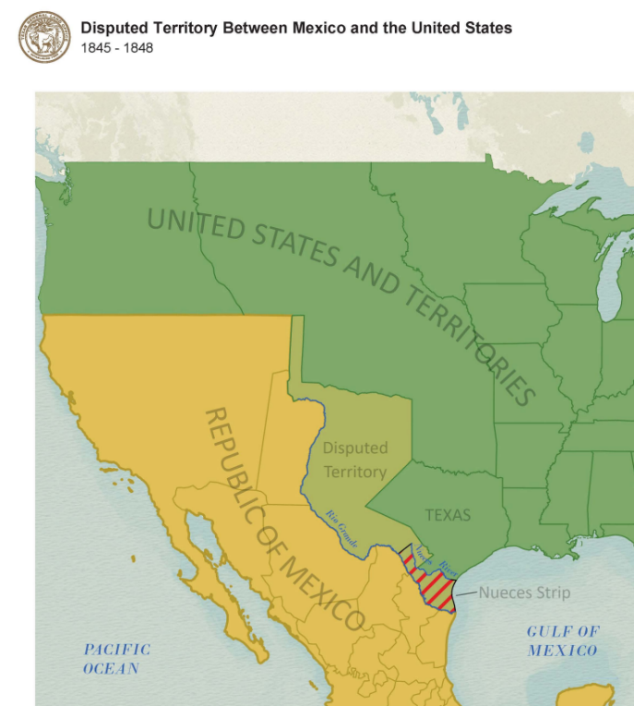 | Circle the correct word  Cross out the incorrect words  - Mexico opposed the U.S. annexation / cession / expansion of Texas  - Disputes between the U.S. and Mexico over the southern territory / settlements / border / of Texas

Notable Battles  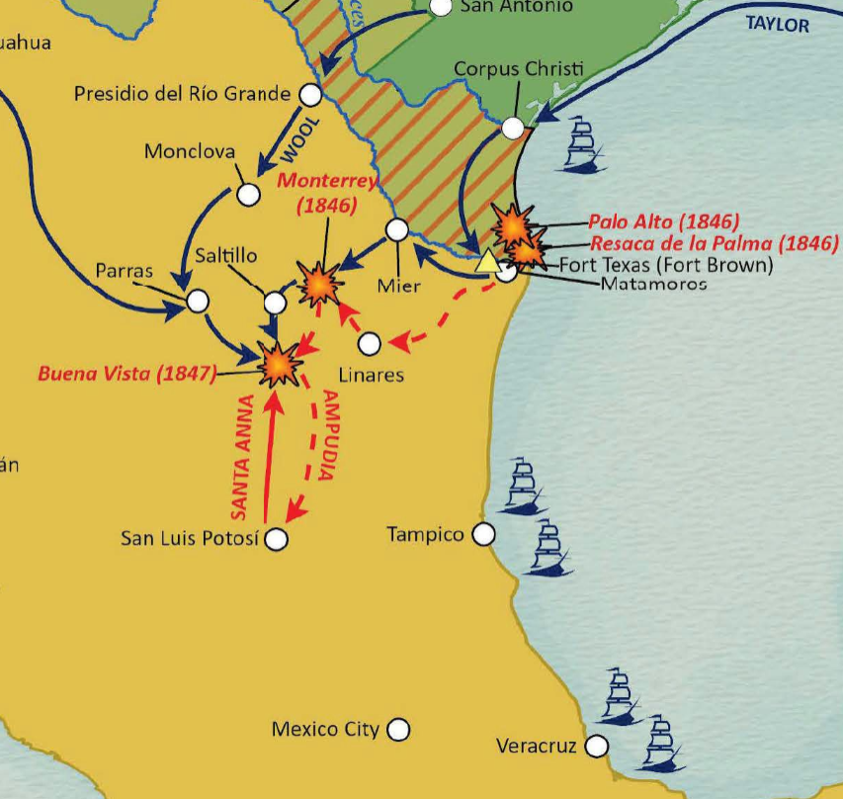 | Circle the correct word  Cross out the incorrect words  Write the correct word(s)  - Battle of Palo Alto: (May 1846) The bloodiest / first / final battle of the war  - Battle of Buena Vista: (February 1847) American General Zachary ________________ defeated Santa Anna in one of the largest battles of the war.  - Capture of Mexico City: (September 1847) Leads to the beginning / turning point / end of the war.

The Treaty of Guadalupe Hidalgo  February 1848  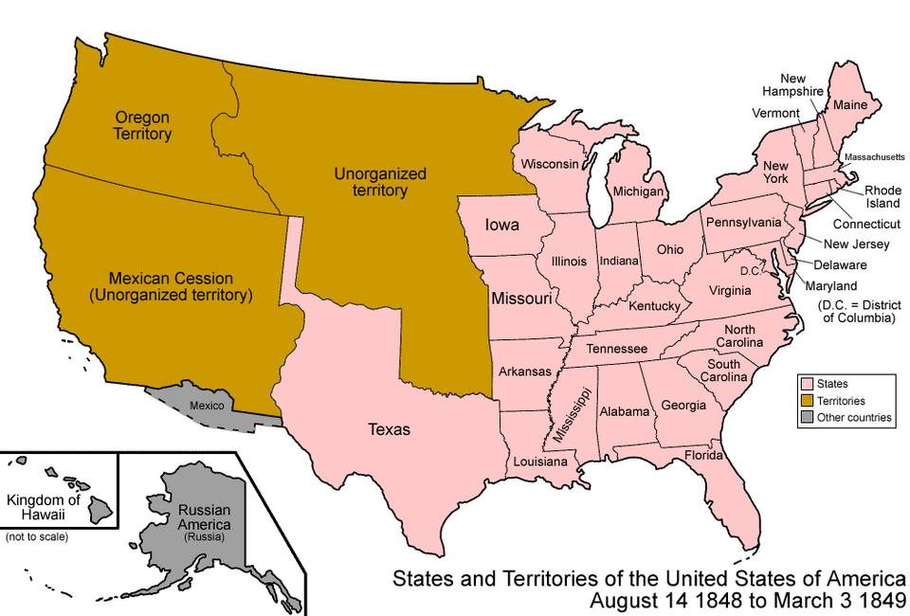 | Circle the correct word  Cross out the incorrect words  Write the correct word(s)  - Mexico annexed / ceded / cession all its land from Texas west to California.  - The U.S. paid Mexico $________ million for the land.  - Mexican citizens in the ceded territory could automatically become U.S. citizens / immigrants / rich

Texas & the U.S.-Mexico War  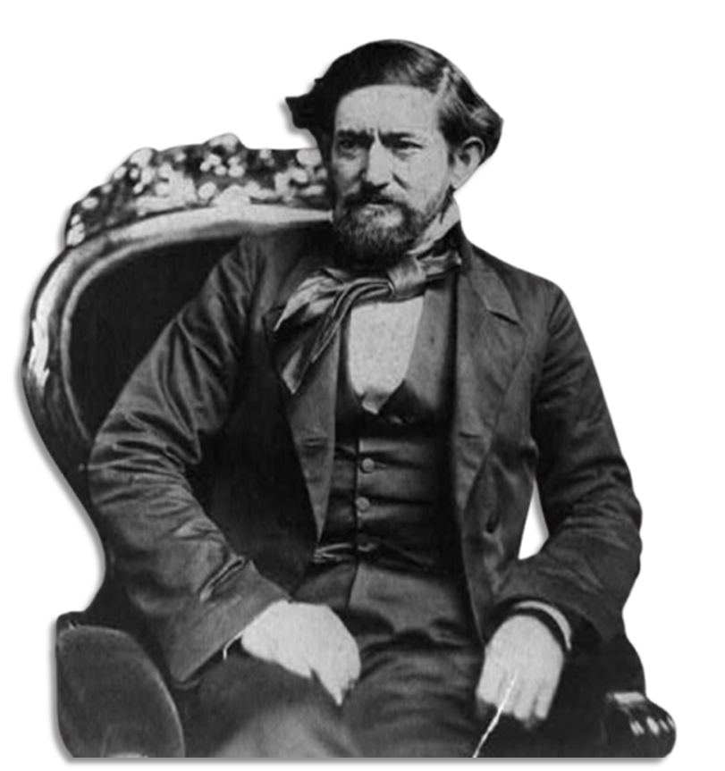 | Circle the correct word  Cross out the incorrect words  Write the correct word(s)  - Approximately 10,000 / 8,000 / 18,000 Texans fought in the U.S.-Mexico War.  - The Texas _________________________ fought alongside the regular U.S. Army.  - New army settlements / forts / missions were built in Texas during the war.

Significance of the U.S.-Mexico War  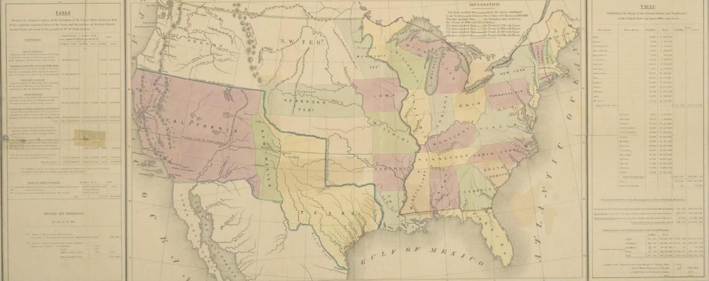 | Circle the correct word  Cross out the incorrect words  Write the correct word(s)  - The Nueces River / Red River / Rio Grande is solidified as Texas’ southern border.  - The U.S. now extends fully to the south / west / east coast.  - The new lands of the Mexican Cession start new arguments about the expansion of slavery in the U.S.

