The U.S.-Mexico War Grade Level
Unit 7: Early Statehood

Name: |  | Date: |  | Period:

James Polk

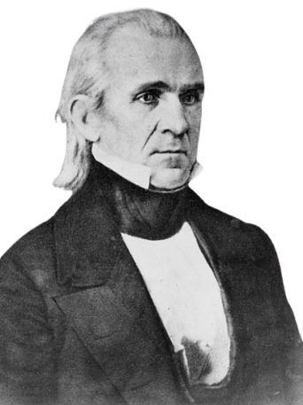 | - U.S. President 1845 – 1849  - Goal: ______________________________________________ _____________________________________________________  - Why?  - Better access to ____________________________________ _______________________________________________________  - “_________________________________________”

The U.S.-Mexico War

The Causes of the U.S.-Mexico War  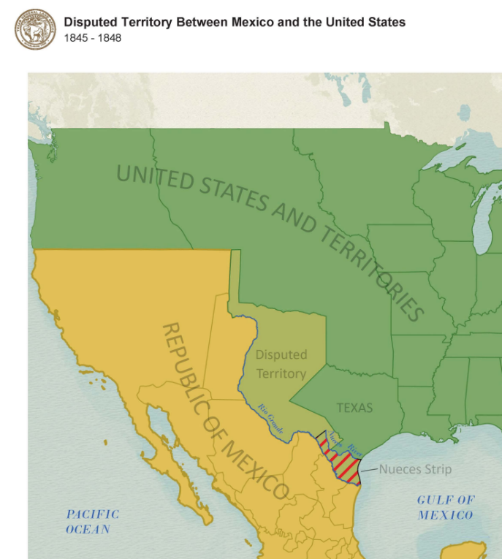 | - Mexico opposed __________________ _____________________________________ _____________________________________  - Disputes between the ___________ and __________________________ over _____________________________________ _____________________________________ _____________________________________

Notable Battles  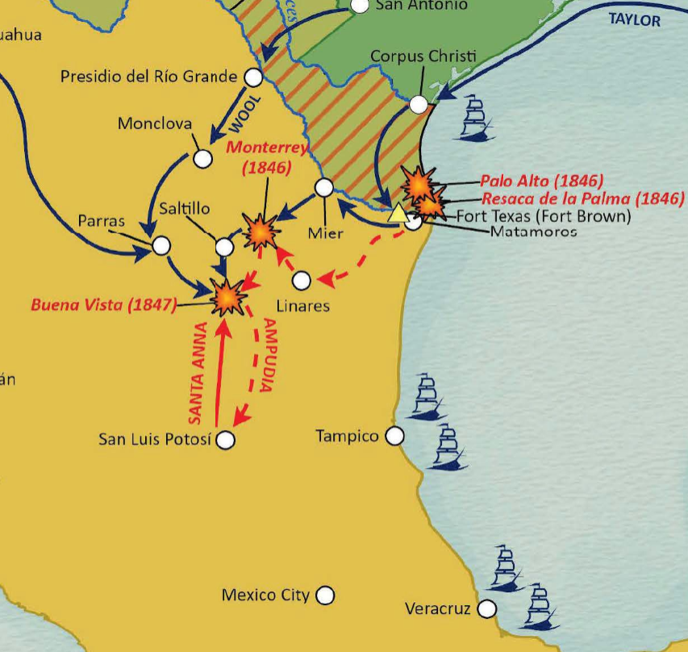 | - The Battle of ____________________ (May, 1846) The _______________ battle of the war.  - The Battle of ____________________ _______________ (Feb. 1847) American General _____________ _________________ defeated ___________________________ in one of the largest battles of the war.  - The Capture of __________________ ____________ (Sept. 1847) leads to the _______________________________

The Treaty of Guadalupe Hidalgo  February 1848  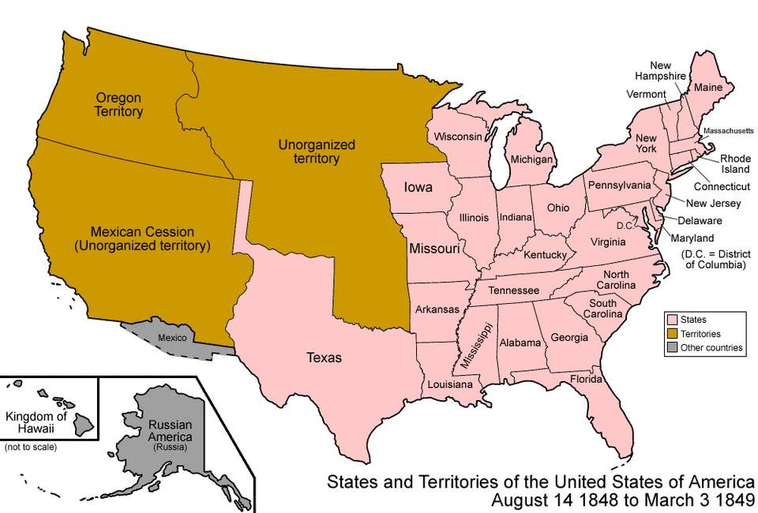 | - Mexico _______________ all its land from ______________________________ ____________________________________.  - The U.S. paid Mexico ____________ ____________________________________ ____________________________________  - Mexican citizens in the ceded territory could automatically ___________________________________ ___________________________________

Texas & the U.S.-Mexico War  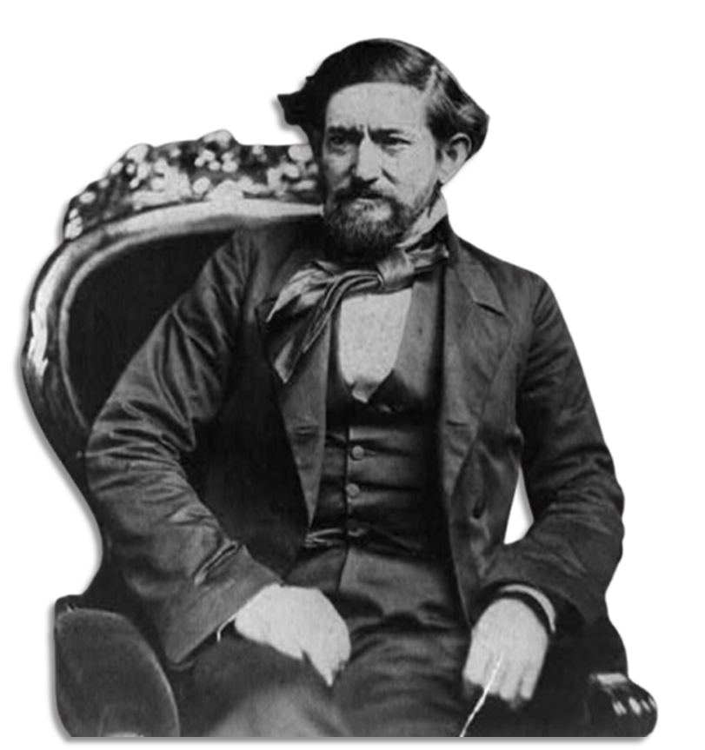 | - Approximately ____________________ Texans fought in the U.S.-Mexico War.  - ______________________________________ fought alongside the ______________ ______________________________________  - New ________________________________ were built in Texas during the war.

Significance of the U.S.-Mexico War  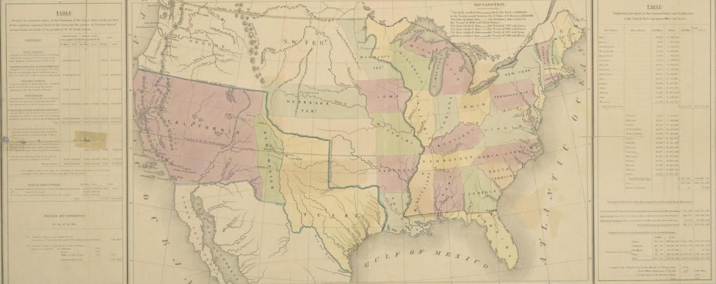 | - The __________________________________ is solidified as ______________________ _______________________________________  - The U.S. now _______________________ _______________________________________  - The new lands of the _____________ __________________________ start new arguments about the ______________ ______________________________________ __________________________ in the U.S.

