Warm-up
- Responses will vary

Lesson
Guides Notes fill-in-the-blank responses for Foundations level work provided below.
James Polk

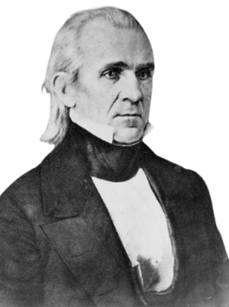 | Write the correct word(s) from the slide  - U.S. President 1845 – 1849  - Goal: Westward expansion of the U.S. to the Pacific Ocean.  - Why?  - Better access to profitable markets with Asia  - “Manifest Destiny”

The U.S.-Mexico War

The Causes of the U.S.-Mexico War  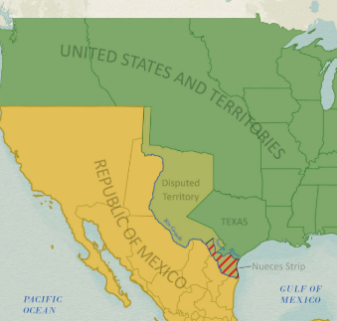 | Circle the correct word  Cross out the incorrect words  - Mexico opposed the U.S. annexation / cession / expansion of Texas  - Disputes between the U.S. and Mexico over the southern territory / settlements / border / of Texas

Notable Battles  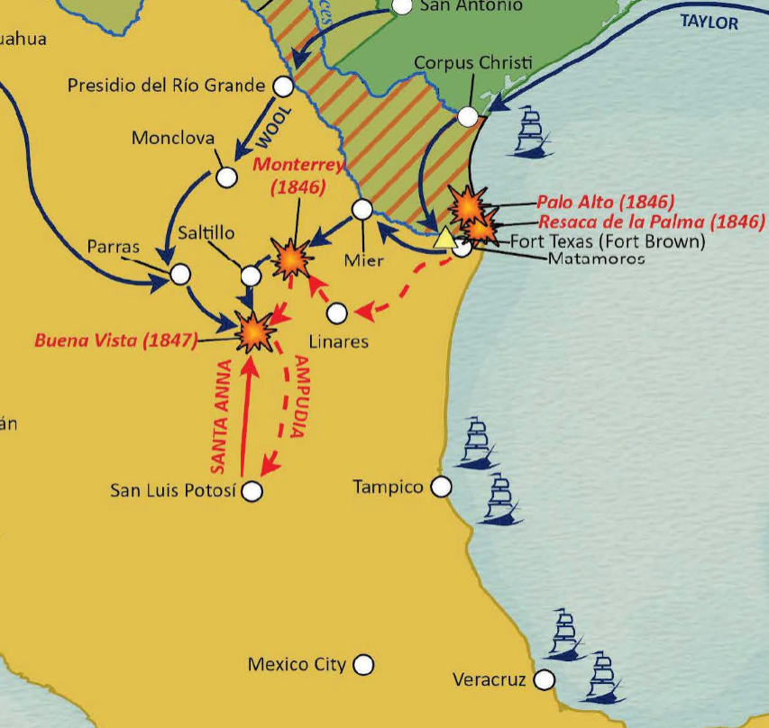 | Circle the correct word  Cross out the incorrect words  Write the correct word(s)  - Battle of Palo Alto: (May 1846) The bloodiest / first / final battle of the war  - Battle of Buena Vista: (February 1847) American General Zachary Taylor defeated Santa Anna in one of the largest battles of the war.  - Capture of Mexico City: (September 1847) Leads to the beginning / turning point / end of the war.

The Treaty of Guadalupe Hidalgo  February 1848  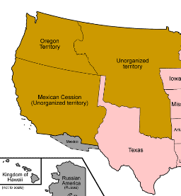 | Circle the correct word  Cross out the incorrect words  Write the correct word(s)  - Mexico annexed / ceded / cession all its land from Texas west to California.  - The U.S. paid Mexico $15 million for the land.  - Mexican citizens in the ceded territory could automatically become U.S. citizens / immigrants / rich

Texas & the U.S.-Mexico War  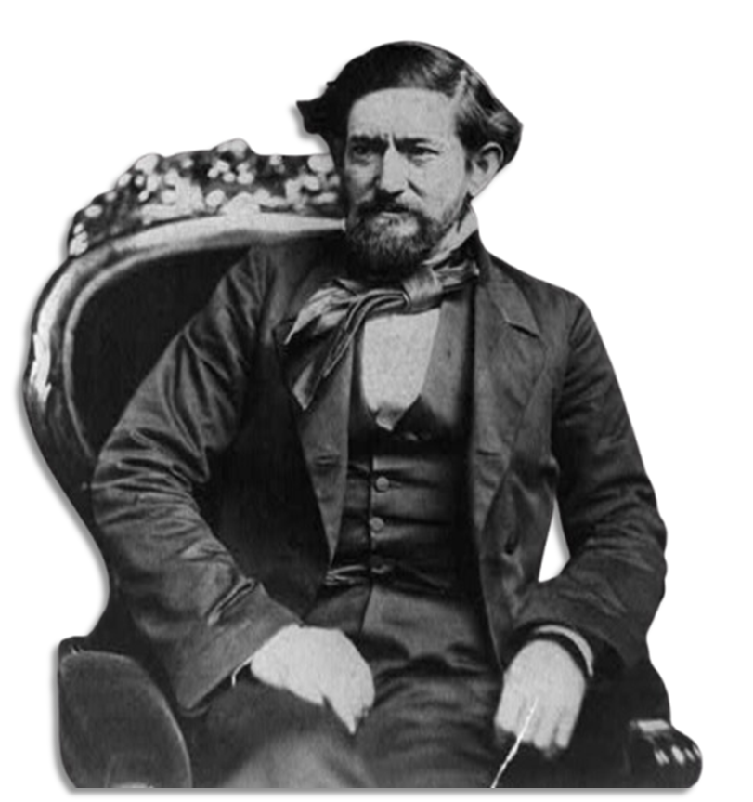 | Circle the correct word  Cross out the incorrect words  Write the correct word(s)  - Approximately 10,000 / 8,000 / 18,000 Texans fought in the U.S.-Mexico War.  - The Texas Rangers fought alongside the regular U.S. Army.  - New army settlements / forts / missions were built in Texas during the war.

Significance of the U.S.-Mexico War  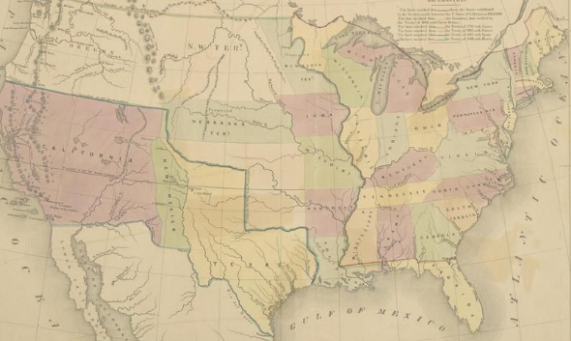 | Circle the correct word  Cross out the incorrect words  Write the correct word(s)  - The Nueces River / Red River / Rio Grande is solidified as Texas’ southern border.  - The U.S. now extends fully to the south / west / east coast.  - The new lands of the Mexican Cession start new arguments about the expansion of slavery in the U.S.

Exit Ticket
Responses will vary but should include any of the information in the chart below.
Cause | Significant Event | Effect
- Disputes between Mexico and the U.S. over the Texas border.  - Disputes between the U.S. and Mexico over ownership of Texas  - Disputes between Mexico and the U.S. over the annexation of Texas | The United States and Mexico fought a war from 1846 to 1848. | - The U.S. won the war and gained all Mexican territory west of Texas including California, New Mexico, Utah, Nevada, Colorado, and Wyoming.  - The addition of new western territories caused disagreements between the North and South over slavery

