 Warm-up: The U.S.-Mexico War
Unit 7: Early Statehood
Name: |  | Date: |  | Period:

What inferences can you make about the events in this lesson based on the lesson title and your observations of the artwork here? | 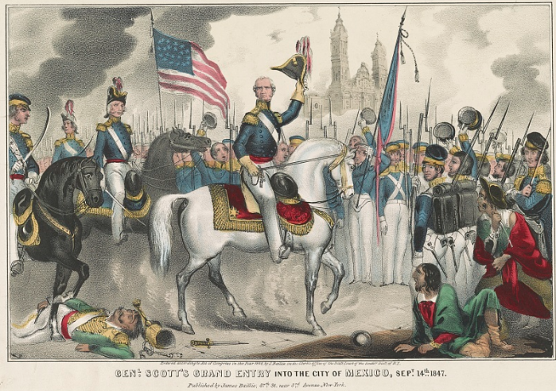

Warm-up: The U.S.-Mexico War
Unit 7: Early Statehood
Name: |  | Date: |  | Period:

What inferences can you make about the events in this lesson based on the lesson title and your observations of the artwork here?


The U.S.-Mexico War Exit Ticket

Directions: In the spaces provided, write at least ONE cause and ONE effect of the significant event in the middle of the graphic organizer.
Cause | Significant Event | Effect
 | The United States and Mexico fought a war from 1846 to 1848.

The U.S.-Mexico War Exit Ticket

Directions: In the spaces provided, write at least ONE cause and ONE effect of the significant event in the middle of the graphic organizer
Cause | Significant Event | Effect
 | The United States and Mexico fought a war from 1846 to 1848.

