 Warm-up: What’s the story?
Unit 7: Early Statehood
Name: |  | Date: |  | Period:

What do you observe about the map to the right? What are the similarities and differences between this map and a current map of the U.S.? | 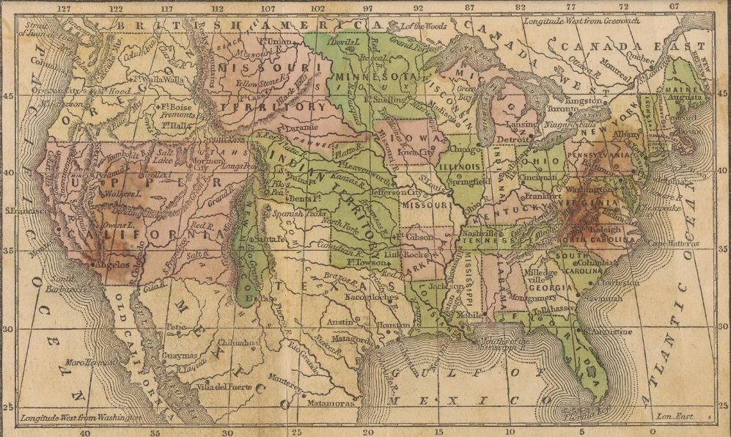

Warm-up: What’s the story?
Unit 7: Early Statehood
Name: |  | Date: |  | Period:

What do you observe about the map to the right? What are the similarities and differences between this map and a current map of the U.S.? | 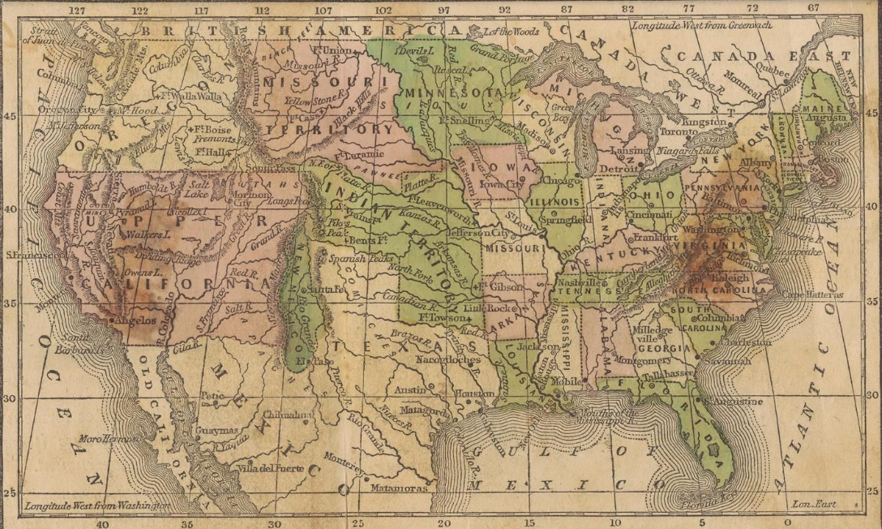


What’s the story? Exit Ticket

Directions: Write the letter of the location on the map beside the correct description of the location.
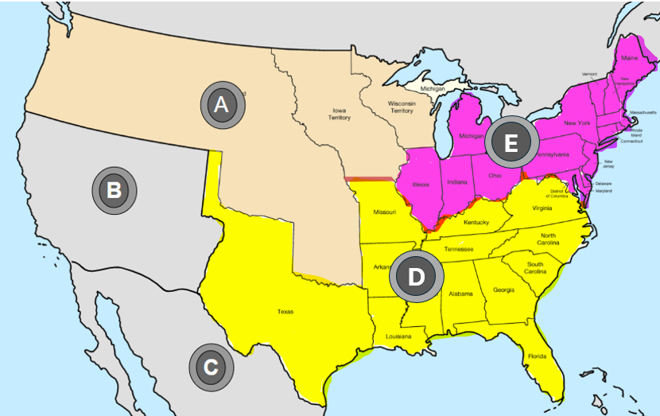 | - Slave states  - The Mexican Cession  - Unorganized U.S. territory  - Mexico  - Free states

What’s the story? Exit Ticket

Directions: Write the letter of the location on the map beside the correct description of the location.
- Slave states
- The Mexican Cession
- Unorganized U.S. territory
- Mexico
- Free states

