The Dust Bowl Advanced
Unit 12: The Great Depression

Name: |  | Date: |  | Period:

Part I: What was the Dust Bowl?
During the decade of the 1930s, the Great Plains region of the United States experienced a combination of extreme drought and massive dust storms that swept across the region, kicking up dry soil hundreds or thousands of feet into the air and carrying it for miles. The dust then fell back to earth blanketing towns and burying houses, farms, and entire communities in soil. This phenomenon came to be known as the Dust Bowl, and it had a severe impact on states of the Great Plains, including the Panhandle region of Texas. | 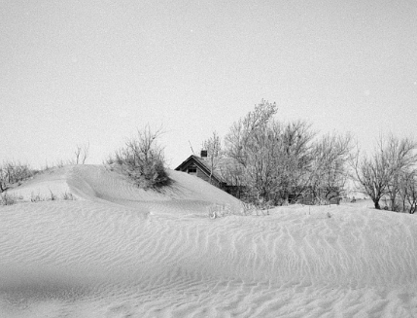  Figure 1: Severe wind erosion made this farm uninhabitable. Cimarron County, Oklahoma. April 1936. The Library of Congress

In this activity, you will examine the causes, effects, and attempts to address the Dust Bowl during the Great Depression.

What was the Dust Bowl and what were its primary causes? How do you think this ecological disaster affected people in Texas and across the U.S.?

Part II: Primary Source Analysis
Directions: Use the primary source excerpts provided to complete your work.
Causes of the Dust Bowl

Primary Source Excerpt Title and Number | Explain three causes  Provide examples and details when possible

Effects of the Dust Bowl

Primary Source Excerpt Title and Number | Explain three effects  Provide examples and details when possible

New Deal Programs & Steps Taken to Address the Dust Bowl

Primary Source Excerpt Title and Number | Describe three New Deal Programs and the purpose or goals of each.

Personal Experiences of the Dust Bowl

Primary Source Excerpt Title and Number | Describe the personal experiences of people who survived the Dust Bowl (this includes what you can infer or observe from primary source images)

Part III: In Their Shoes – A Writing Activity
Directions: Based on what you have learned about the Dust Bowl and how it affected people in the Panhandle of Texas and across the Midwest, write a journal entry from the point of view of a person who experienced the Dust Bowl.
You may choose to present your journal entry from any point of view, including men, women, children, farmers, people working in soil conservation in the CCC, etc. Your entry may span one or more days.


