The Dust Bowl Grade Level
Unit 12: The Great Depression

Name: |  | Date: |  | Period:

Part I: What was the Dust Bowl?
During the decade of the 1930s, the Great Plains region of the United States experienced a prolonged period of drought. The lack of water made the soil incredibly dry. When strong winds blew through the region, the dry dirt flew thousands of feet into the air causing intense dust storms. These storms came to be known as the Dust Bowl.  When the dust fell back to earth, it often covered houses, farms, and entire communities in the dry, dusty soil. | 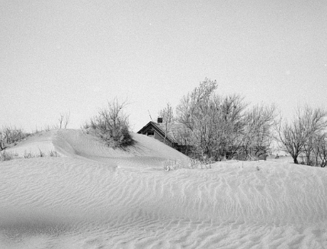  Figure 1: Severe wind erosion made this farm uninhabitable. Cimarron County, Oklahoma. April 1936. The Library of Congress
The Dust Bowl lasted throughout the entire 1930s, and it had a severe impact on states of the Great Plains, including the Panhandle region of Texas.
In this activity, you will examine the causes, effects, and attempts to address the Dust Bowl during the Great Depression.
What was the Dust Bowl and what were its primary causes? How do you think this ecological disaster affected people in Texas and across the U.S.?
The Dust Bowl was ________________________________________________________________________________ ______________________________________________________________________________________________________It was caused by ___________________________________________________________________________________ ______________________________________________________________________________________________________One effect I think it had on people in Texas was ________________________________________________ ______________________________________________________________________________________________________

Part II: Primary Source Analysis
Directions: Use the primary source excerpts provided to complete your work.
Causes of the Dust Bowl

Primary Source Excerpt Title and Number | Explain two causes  Provide examples and details when possible

Effects of the Dust Bowl

Primary Source Excerpt Title and Number | Explain two effects  Provide examples and details when possible

New Deal Programs & Steps Taken to Address the Dust Bowl

Primary Source Excerpt Title and Number | Describe two New Deal Programs and the purposes or goals of each.

Personal Experiences of the Dust Bowl

Primary Source Excerpt Title and Number | Describe the personal experiences of people who survived the Dust Bowl (this includes what you can infer or observe from primary source images)

Part III: In Their Shoes – A Writing Activity
Directions: Based on what you have learned about the Dust Bowl and how it affected people in the Panhandle of Texas and across the Midwest, write a journal entry from the point of view of a person who experienced the Dust Bowl.
You may choose to present your journal entry from any point of view, including men, women, children, farmers, people working in soil conservation in the CCC, etc. Your entry may span one or more days.


