Excerpt 1: The Beginning of the Great Depression  “Southland Life Insurance Company business and crop reports for the month of January strongly indicate a ‘watchful waiting’ attitude over the entire state. In the main, business conditions are reported around normal, with some exceptions on the optimistic side and others pessimistic. Answering the question: ‘Have recent financial developments had any effect on business conditions in your community?,’ most are inclined to believe that the effects of the stock market crash in Texas are over-estimated.”  - “The Caldwell News and the Burleson County Ledger (Caldwell, Tex.) Friday, February 14, 1930.The Portal to Texas History. | Indicate: Show; Point out.  Exceptions: Something that does not follow the general trend or rule.  Optimistic: A positive outlook  Pessimistic: A negative outlook  Inclined: Likely  Over-estimated: Not as bad as it seems

Excerpt 2: Bill Oakley’s First-Hand Account of the Great Depression  “Well, the Depression was equal to war, as I look back on it, in my younger life. By that, I mean it was very hard on family. Though we were not losing loved ones, many people did not have the bare necessities of life and not the proper food. We did have food because we were on an East Texas farm where we could…raise ours. We had our own milk, eggs, and that type of thing, but some of our very close friends were not that fortunate. It was almost equal to war, I would say.”  - Oral History Interview with Bill Oakley about his experience during the Great Depression, February 6, 1991, The Portal to Texas History. | Bare necessities: The most basic things needed to survive.  Fortunate: Lucky  Oral History Interview: A primary source record of history in which someone interviews a person who lived through a particular period of time. The interview often takes place after the time occurred.

Excerpt 3: George Riley’s First-Hand Account of the Great Depression  “My mother decided to move out and come to Dallas. Boy, I didn’t want that! I’d lived on a farm all my life. My brothers, though, were a lot older than I was, and they said, ‘c’mon, we’ll go get a job up there.’  It was in that time that Mother had done spent all her money before I even got out of school. She didn’t have nothing. She didn’t have no job. Didn’t none of the boys have no job. We was poor as rats, you might say. We had to move to another house…. It had a dry toilet. It didn’t have no bathrooms, no nothing. We done like we did in the country – washed in the washtub. After I got out of school, we was still in the rat race. My mother went to work for the WPA. I know you’ve heard of that.”  - Oral History Interview with George Riley, February 3, 1994, The Portal to Texas History. | A dry toilet: Usually a bench or seat positioned over a bucket, without plumbing. You would have to toss the waste from the bucket outside.  The rat race: A term that means an exhausting, repetitive lifestyle focused solely on working long hours, often without getting anywhere.  WPA: Works Progress Administration. A New Deal program that hired unskilled workers to do jobs around the community.

Excerpt 4: Requirements of the Civilian Conservation Corps  “Enrollees work 8 hours a day, 5 days a week (except in emergencies). Enrollees receive $30 per month, minimum cash allowance. Some of the jobs in which CCC enrollees receive instruction include: auto mechanics, bridge construction, bulldozer operation, cabin construction, carpentry, concrete construction, diesel engine operation, drafting, jackhammer operation, landscaping, large scale cooking, logging, office work, road and trail construction, road grader operation, sawmill operation, sign painting and sign making, small dam construction, steam-shovel operation, stone masonry, surveying, telephone line construction, tool sharpening, tractor operation, tree nursery work, truck driving, welding, wildlife management.”  - “The Lampasas Leader (Lampasas, Tex.), Friday, March 31, 1939.” The Portal to Texas History. | Civilian Conservation Corps: A New Deal program that provided job training and opportunities.  Enrollees: People enrolled in a program.  Drafting: Creating technical drawings and blueprints for architects and engineers to use.  Road grader: Making sure roads are level, flat, and smooth.  Stone masonry: Building structures with stones.  Welding: Using heat to bind metals together

Excerpt 5: The Dust Bowl  “Clouds of dust rode a raging norther which struck Shamrock about 9 o’clock last night, driving low temperatures still lower and contracting visibility to a few yards. It was the worst dust storm of the season….”  “The entire Panhandle Plains was included in the dust choked area. At Amarillo the wind began picking up a powdery dust shortly after 9 am. By 11 o’clock the sun was wholly obscured and did not shine through the dust clouds until after 2:30 pm.”  - “The Shamrock Texan (Shamrock, Tex.) Friday, February 14, 1936.” The Portal to Texas History. | The Dust Bowl: A period of extreme drought and strong winds which created thick clouds of dirt and dust over the Great Plains from 1930 to 1940.  Norther: A fast-moving, intense cold front.  Contracting visibility: Limiting how far people can see.  Obscured: Hidden from view

Excerpt 6: The Exploitation of Soil  “Thousands of people in the Midwest and the Southwest today are suffering from coughs, sinus trouble, or other afflictions brought on or aggravated by the recent dust storms. Soil from the Great Plains is being blown away by hundreds of tons, some of it being carried clear to the Atlantic Ocean. This vast table land, east of the Rockies now could become what it was called in early days, the Great American Desert, if all its cover be ripped off.”  “Shortsighted land policies have allowed the exploitation of dust bowl soil, with the result that a large part of the essential topsoil has blown away and the remainder is likely to be so within a few years.”  - “The Denison Press (Denison, Tex.), Wednesday, May 12, 1937.” The Portal to Texas History. | Afflictions: Pain, distress, and physical illness  Aggravated: Made worse  A ton: 2,000 pounds  Shortsighted: Doing things without thinking about the long term effects.  Exploitation: Misuse; Using something for your own benefit, often in a harmful way.

Excerpt 7: The Rural Electrification Administration (REA)  “The entire purpose of the REA program is to raise the standard of living in the rural areas, and to improve the living conditions so that rural residents will remain on the farm. This is possible by the use of federal funds at a very low rate of interest, and with repayment of loans over a 20-year period.”  “The REA will loan 100% money necessary for wiring homes and barns or farm buildings, at a low interest with several years to pay. The electric Home and Farm Authority will finance the purchase of all refrigerators, water pumps and systems, ranges and all other electrical appliances.”  - “Rural Areas Will Share in REA Plan”. The Brady Standford, March 6, 1936. The Portal to Texas History. | Standard of Living: A measurement of wealth and comfort available to people in their communities.  Rural: Areas outside of cities and towns; The countryside.  Rate of interest: An additional amount of money you must add when you repay a loan.  Wiring: Connecting homes to electrical lines.  Ranges: Cooking stoves.  Appliances: Technology in the home, like washing machines and ovens.

Excerpt 8: Urbanization & the Decrease of Small Farms  “During 1936, the number of people living on Texas farms decreased 26,000 or a little more than one per cent of the farm population….Since 1930, therefore, the Texas farm population has decreased approximately 62,300 or 2.6 per cent, and since 1935 the decrease has been about 42,700 or 1.8 per cent….Since Texas farms lost 59,000 by migration to cities and to farms in other states, however, the total farm population decreased by 26,000….[Some] were enabled to stay with their farms with the help of government benefits, but in many cases, it is felt, the government benefits have increased large-scale farming and hence population displacement.”  - “The Dublin Progress (Dublin, Tex.), Vol. 49, No. 42, Ed. 1 Friday, November 26, 1937.” The Portal to Texas History. | Migration: The movement of people to new areas often in search of better work opportunities or living conditions  Large-scale farming: Larger farms that rely heavily on mechanization (machines)  Hence: Therefore; As a result  Displacement: Forced movement

Excerpt 9: A Political Cartoon  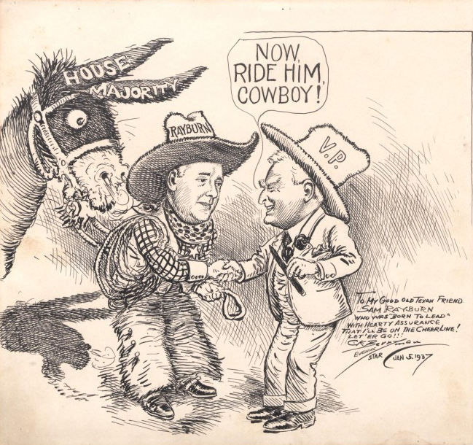  - “Political Cartoon by Clifford Berryman depicting Sam Rayburn and John Nance Garner, artwork, January 5, 1937. The Portal to Texas History. | In this image, a cartoon caricature of United States Vice President John Nance Garner (of Uvalde, Texas) shaking hands with U.S. Speaker of the House, Sam Rayburn (Tennessee-born Texan from Fannin County.)  The written note in the bottom right reads, “To my good old Texan friend Sam Rayburn who was “Born To Lead” with hearty assurance that I’ll be on the cheerline! Let ‘er go!!”  Evening Star  Jan. 5, 1937

Excerpt 10: The Rural Electrification Administration  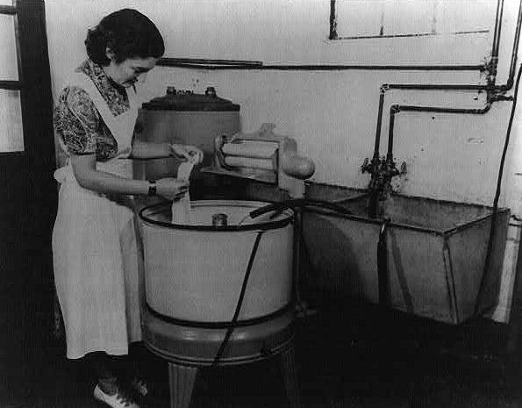  - “Portrait of America #36.” The Library of Congress. | “Rural electrification in the U.S. - Modern wash day on an electrified U.S. farm: This electric washer on a U.S. farm bears the brunt of the rubbing and scrubbing needed to clean the family clothes. With an electric water system as well as a water heater, the wash is out on the line by mid-morning, and the farm wife is still fresh for ironing and other tasks of the day. Power for these machines is supplied through a farmer's cooperative rural electrification project.”

