
Warm-up: Looking Ahead
Unit 12: The Great Depression
Name: |  | Date: |  | Period:

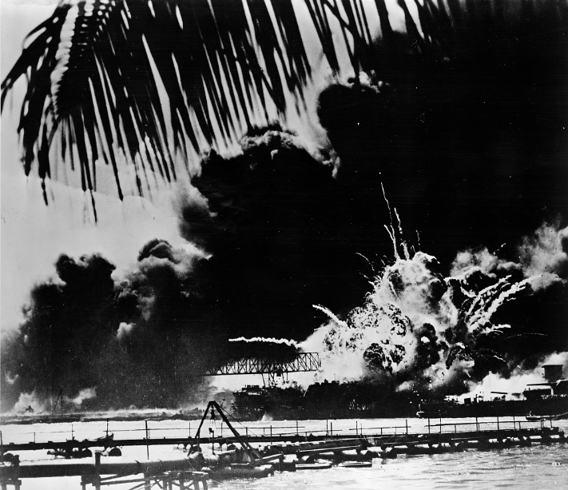 | What do you observe about the image to the left? What can you infer about the next unit based on your observations?

Warm-up: Looking Ahead
Unit 12: The Great Depression
Name: |  | Date: |  | Period:

What do you observe about the image to the left? What can you infer about the next unit based on your observations?


Looking Ahead Exit Ticket

“The National Broadcasting Company observer at Honolulu reported “untold” damage to the Pearl Harbor naval base and the city of Honolulu in a three-hour battle.”
“In Washington President Roosevelt summoned his cabinet and congressional leaders of both parties to meet with him.”
“Responsible British quarters said in London that Britain would declare war against Japan “within an hour” if the United States should proclaim a state of war.”
- “ Sweetwater Reporter” newspaper, Sunday, December 7, 1941. The Portal to Texas History

What do you think President Roosevelt and the U.S. Congress will decide to do? | How do you think this decision might influence Britain, the rest of Europe, and the war?

Looking Ahead Exit Ticket

“The National Broadcasting Company observer at Honolulu reported “untold” damage to the Pearl Harbor naval base and the city of Honolulu in a three-hour battle.”
“In Washington President Roosevelt summoned his cabinet and congressional leaders of both parties to meet with him.”
“Responsible British quarters said in London that Britain would declare war against Japan “within an hour” if the United States should proclaim a state of war.”
- “ Sweetwater Reporter” newspaper, Sunday, December 7, 1941. The Portal to Texas History

What do you think President Roosevelt and the U.S. Congress will decide to do? | How do you think this decision might influence Britain, the rest of Europe, and the war?

