Looking Ahead Advanced
Unit 12: The Great Depression

Name: |  | Date: |  | Period:

Part I: The World at War Again
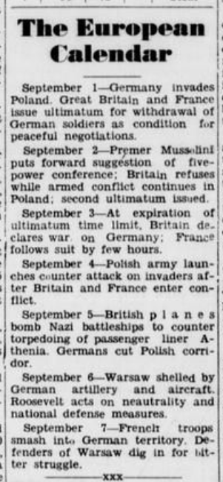  Figure 1: Falfurrias Facts, September 8, 1939.  The Portal to Texas History | - On what date did Germany invade Poland?  - How did Britain and France respond to the German invasion?  - What did Italian leader, Benito Mussolini, suggest?  - Did other countries agree to Mussolini’s suggestion? Why or why not?  - What happened when Germany refused to end its attack on Poland?  - How did the U.S. respond to the outbreak of war in Europe?

Part II: The United States – From Isolationist to Involved
“Washington, Dec. 9”  “Isolationist sentiment in congress disappeared today almost without a trace. The men who have fought President Roosevelt’s foreign policy joined his supporters in calling for war in answer to Japan’s attack.”  “Senator Burton K. Wheeler, Democrat, Montana, spearhead of congressional opposition to President Roosevelt, said the Japanese bombs dropped at Pearl Harbor ‘mean war and we’ll have to see it through.’”  - Sweetwater Reporter (Sweetwater, Tex.), December 8, 1941. The Portal to Texas History | Isolationist sentiment: The belief that the U.S. should stay isolated, or out of international affairs and issues.  Spearhead: A person or group who leads a campaign or movement to achieve something.  Pearl Harbor: An American military base in Hawaii.

- World War I began in Europe when Germany invaded Poland in 1939. According to both excerpts in this worksheet, what was the initial U.S. policy toward the war?

- What significant event caused many Americans to oppose this policy? What was the U.S. Congress considering as a result of this event?

- How do you think America’s entry into World War II in 1941 would affect Texas? Consider the role that World War I had on Texas when formulating your response.

