Looking Ahead Grade Level
Unit 12: The Great Depression

Name: |  | Date: |  | Period:

Part I: The World at War Again
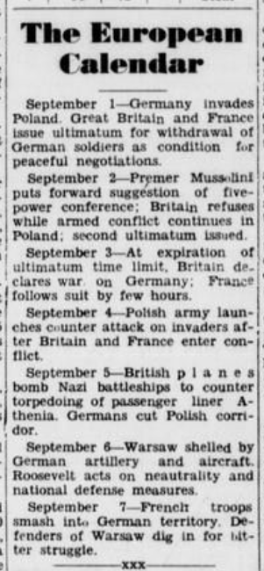  Figure 1: Falfurrias Facts, September 8, 1939.  The Portal to Texas History | - What significant event occurred on September 1, 1939??  - How did Britain and France respond to the German invasion of Poland?  - Britain declared war on Germany, but France remained neutral.  - France declared war on Germany, but Britain remained neutral.  - Britain and France both declared war on Germany.  - None of the above  - What was the U.S. government’s response to the outbreak of war in Europe?  - President Roosevelt asked Congress for a declaration of war against Germany.  - President Roosevelt’s administration remained neutral and focused on defending the U.S.  - President Roosevelt publicly supported the British and French war effort against Germany.  - President Roosevelt entered into peace talks with Germany.

Part II: The United States – From Isolationist to Involved
“Washington, Dec. 9”  “Isolationist sentiment in congress disappeared today almost without a trace. The men who have fought President Roosevelt’s foreign policy joined his supporters in calling for war in answer to Japan’s attack.”  “Senator Burton K. Wheeler, Democrat, Montana, spearhead of congressional opposition to President Roosevelt, said the Japanese bombs dropped at Pearl Harbor ‘mean war and we’ll have to see it through.’”  - Sweetwater Reporter (Sweetwater, Tex.), December 8, 1941. The Portal to Texas History | Isolationist sentiment: The belief that the U.S. should stay isolated, or out of international affairs and issues.  Spearhead: A person or group who leads a campaign or movement to achieve something.  Pearl Harbor: An American military base in Hawaii.

- World War I began in Europe when Germany invaded Poland in 1939. According to both excerpts in this worksheet, what was the initial U.S. policy toward the war?

The official U.S. policy toward the war in Europe was (a) to remain neutral (b) to enter the war on the side of the British and French (c) to guide peace talks as the spokesperson for Germany. Evidence of this fact appears in the excerpt with the phrase __________________________________________________________________________________________________ __________________________________________________________________________________________________
__________________________________________________________________________________________________

- What significant event caused many in the U.S. to oppose this policy? What was the U.S. Congress considering as a result of this event?
Many in the U.S. began to oppose this policy after ________________________________________ _________________________________________________________________________________________________ As a result of this event, the U.S. Congress decided to _____________________________________ __________________________________________________________________________________________________

