Study Guide Advanced
Unit 12: The Great Depression

Name: |  | Date: |  | Period:

Part I: Key Terms and Definitions
Write the term from the word-bank below in the numbered box next to the best definition or description in the chart below. You will not use every term.
New Deal | Dust Bowl | Economic Depression
Legislation | John Nance Garner | Relief
Sam Rayburn | Boom and Bust Cycles | Stock Market
Unemployment | Erosion | Ecology

A long period of financial decline characterized by business closures, increased unemployment, and hardship. During the 1930s, the U.S. experienced the worst of these financial declines in the country’s history.
This term is another way of saying “law.” During the Great Depression, Congress passed a number of laws to stabilize banks, regulate businesses, increase employment, and support people experiencing financial hardship.
This term refers to President Franklin D. Roosevelt’s programs to provide relief, recovery, and reform to the American people. Some of the programs that benefited Texas most were the Civilian Conservation Corps and the Rural Electrification Administration.
This is a financial system in New York that allows people to buy shares in different companies in order to profit from the success of the company. In 1929, this financial system crashed, millions of dollars were lost, and the U.S. was thrown into the Great Depression as a result.

A phenomenon in economics in which enormous economic growth leads to overproduction, which causes prices to drop dramatically. This in turn leads to economic decline. This phenomenon occurred in Texas during the Great Depression when east Texas oil wells overproduced oil, dropping the price of oil and significantly negatively influencing the oil industry.
Massive dirt storms that swept across the Great Plains for much of the 1930s. These storms were caused by a prolonged period of drought combined with a decade of harmful farming and ranching practices which depleted the natural grasses of the Plains and led to widespread erosion.
He was a Texan who served fifteen terms in the state and U.S. legislature before serving as Vice President to Franklin D. Roosevelt. As vice president, he was instrumental in pushing a lot of significant New Deal legislation.
This is an ecological process in which wind or water wears away materials of the earth like rock and soil. During the Great Depression, this process occurred on the Great Plains because drought made the soil very dry and dusty, and high winds blew a lot of the soil away.
This term refers to the number or percent of adults who are out of work at any given period of time. At the height of the Great Depression, 25% of Americans were out of work.
This prominent Texan was the longest-serving speaker of the House of Representatives in the U.S. Congress, serving 48 years. He helped pass a lot of significant New Deal legislation including the Rural Electrification Administration. He served as both the minority and majority leader in the House of Representatives.

Part III: Cause and Effect Matching
The left column contains significant events of the Great Depression. The right column provides the effect of each event. Match each cause on the left with its correct effect on the right.

- Many who took part in the stock market panicked when the market turned in 1929 and began selling all of their stocks.  - Decades of harmful farming and grazing practices depleted the natural grasses of the Great Plains.  - Millions of Americans faced severe financial hardships during the Great Depression and needed more assistance than organizations like churches or communities could provide.  - One New Deal program called the Rural Electrification Administration (REA) helped bring affordable electricity to rural areas.  - The Civilian Conservation Corps (CCC) was instituted as part of the New Deal to protect and preserve the environment.  - East Texas oil fields experienced massive oil strikes during the 1930s. | - As a result, President Roosevelt instituted the “New Deal” to provide relief, recovery, and reform to people facing financial hardship. New Deal programs helped stabilize the banks, regulate the markets, and provide jobs to millions.  - As a result, the price of stocks dropped and millions of dollars were lost, causing banks to fail, businesses to close, and millions to lose their jobs. This period was known as the Great Depression and lasted throughout the 1930s.  - As a result, the overproduction of oil flooded the market, dramatically reducing the value of oil and causing a crisis in the oil industry in Texas and the U.S.  - As a result, the number of Texas farms with access to electricity climbed from 2% in the 1930s to nearly 80% by the 1950s. This dramatically improved the standard of living in Texas farming communities.  - Thousands of young Texas men were employed replanting native grasses in the Great Plains, teaching farmers beneficial farming practices, taking part in reforestation, and constructing dozens of Texas state parks.  - As a result, high winds on the Plains caused erosion of the dry soil, which would be kicked up hundreds or thousands of feet into the air, causing dirt storms that came to be known as the Dust Bowl.

Part IV: Practice Test Questions
Directions: Answer the following practice test questions about the Great Depression

- Observe the information in the graphic below and answer the question that follows.
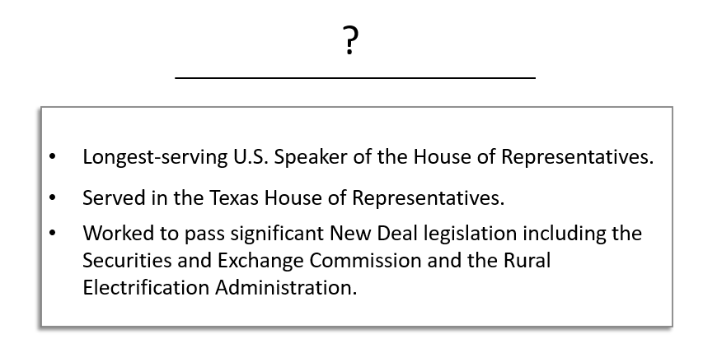
Which significant individual below correctly replaces the question mark for the list of accomplishments above?

  - Lyndon Baines Johnson
  - Sam Rayburn
  - John Nance Garner
  - Franklin Delano Roosevelt

- Which of the following headlines would you have been likely to find in a newspaper from October 29, 1929?

  - The Rural Electrification Administration Electrifies Texas Farms!
  - Franklin Delano Roosevelt Elected to His Second Term of Office!
  - Texas Panhandle Struck by Worst Dust Storm in History!
  - Stock Market Crash Causes the Loss of Millions of Dollars!

- Read each statement about the accomplishments of significant Texans of the Great Depression in the box below. Then write the letter of each accomplishment under the name of the person who achieved it.

- A prolific real estate developer in Houston who served on the Reconstruction Finance Corporation to stabilize banks as part of the New Deal.

- A young Texan leader who served as the director of the Texas National Youth Association and ensured that young Texans had access to work, including young Black Texans.

- The Vice President under Franklin D. Roosevelt’s first term in office, who helped pass significant pieces of New Deal legislation to reform the financial markets and protect against future economic disasters.

Lyndon B. Johnson | Jesse Holman Jones | John Nance Garner

- Which statements most accurately explain the causes of the Dust Bowl?
Select two correct answers.

  - Over-farming the land and over-grazing cattle depleted the native grasses of the Great Plains.
  - A prolonged period of drought caused extremely dry topsoil that could be easily carried away by high winds.
  - The demand for crops rose exponentially in the decades prior to the 1930s due to the growing population and the demands of World War I.
  - Farmers planted an abundance of crops to help feed the millions of struggling Americans without enough food to eat during the Great Depression.
  - New Deal programs like the Civilian Conservation Corps initiated programs to replant native grasses in order to provide an anchor to the soil.

- Read the primary source excerpt below and answer the question that follows.
“The Brenham soil conservation was established in Brenham because a large group of public spirited men saw the need for this work in this county and requested that a camp be established here. Since October the 15th, 1934 the camp has supervised the soil and water conservation on 28 different farms, protecting approximately 3500 acres…”

- “Brenham Banner-Press (Brenham, Tex.), October 7, 1935.” The Portal to Texas History.

Which statement below most accurately relates to the information provided in the primary source excerpt above?
  - The federal government during the Great Depression was heavily focused on economic recovery and reform efforts.
  - Harmful farming practices of the prior decades depleted the native grasses of the Plains, and a prolonged period of drought made the loose soil very dry.
  - Addressing the environmental challenges facing the Great Plains was not a priority for President Roosevelt’s administration or his New Deal agenda.
  - During the Great Depression, people adapted to changes in the environment caused by the Dust Bowl and worked to address those changes.

- What was President Franklin D. Roosevelt’s plan to address the challenges and hardship caused by the Great Depression? Provide examples to support your answer.

Your response should contain three to five complete sentences.

The following question has two parts.
By the 1930s, only about 2% of small farms in ____(7)_____ communities had access to _____(8)_____, which the New Deal sought to address with programs such as the REA.

Use the answer options below to fill in the blanks from the passage above.
- The best selection for the blank labeled number six is –
  - urban
  - industrial
  - rural
  - unemployed

- The best selection for the blank labeled number seven is –
  - public education
  - electricity
  - New Deal work programs
  - agricultural machinery

- Which answer option below best explains the process that is depicted in the infographic below?

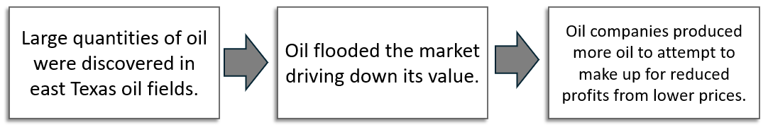

  - Boom and bust cycles in industry
  - The accumulation of debt due to buying stocks on margin
  - The harmful effects of over-farming and over-grazing cattle
  - Economic growth and development due to New Deal programs

