Study Guide Grade Level
Unit 12: The Great Depression

Name: |  | Date: |  | Period:

Part I: Key Terms and Definitions
Write the term from the word-bank below in the numbered box next to the best definition or description in the chart below.
New Deal | Dust Bowl | Economic Depression
Legislation | John Nance Garner | Unemployment
Sam Rayburn | Boom and Bust | Stock Market

- A long period of financial decline
- Causes businesses to close
- Increases unemployment
- Extreme financial hardship
- The Great Depression was the worst in U.S. history
- Another word for “law”
- There were many new laws passed as part of the New Deal
- These laws meant to stabilize banks, regulate business, and decrease unemployment.
- President Franklin D. Roosevelt’s plan to provide relief, recovery, and reform to the American people.
- In Texas:
- The Civilian Conservation worked to address challenges related to the Dust Bowl
- The Rural Electrification Administration provided affordable electricity to farming communities.

- A financial system in New York
- People can buy shares in different companies and make a profit when the company performs well.
- In 1929, this financial system collapsed, initiating the Great Depression.

- An economic cycle of growth and decline
- During the Great Depression, east Texas oil fields struck oil, producing enormous amounts of oil and flooding the market.
- The price of oil dropped, causing a crisis in the oil industry.
- Massive dirt storms in the Great Plains during the 1930s.
- The storms were caused by the removal of native grasses by farmers and ranchers combined with a prolonged period of drought.
- High winds eroded the dry soil, creating dirt storms.
- A Texan who served fifteen terms in the state and U.S. legislature.
- He also served as Vice President to Franklin D. Roosevelt.
- He helped pass a lot of significant New Deal legislation.
- The number or percent of adults who are out of work at any given period of time.
- At the height of the Great Depression, 25% of Americans were out of work.
- He served 48 years in the U.S. House of Representatives.
- He was the longest serving Speaker of the House.
- He helped pass a lot of significant New Deal legislation including the Rural Electrification Administration.

Part III: Cause and Effect Matching
The left column contains significant events of the Great Depression. The right column provides the effect of each event. Match each cause on the left with its correct effect on the right.

- The economy slowed in 1929 and people who took part in the stock market panicked and sold all their stocks.  - Decades of harmful farming and grazing practices removed the native grasses of the Great Plains.  - Millions of Americans faced severe financial hardships during the Great Depression. They needed more assistance than organizations like churches or communities could provide.  - One New Deal program called the Rural Electrification Administration (REA) helped bring affordable electricity to rural areas.  - The Civilian Conservation Corps (CCC) was created as part of the New Deal to protect and preserve the environment.  - East Texas oil fields experienced massive oil strikes during the 1930s. | - As a result, President Roosevelt established the “New Deal” to provide relief, recovery, and reform to people facing financial hardship. New Deal programs helped stabilize the banks, regulate the markets, and provide jobs to millions.  - As a result, the price of stocks dropped, and millions of dollars were lost. Banks failed, businesses closed, and millions lost their jobs. This period was known as the Great Depression, and lasted throughout the 1930s.  - As a result, the overproduction of oil flooded the market. This dramatically reduced the value of oil and caused a crisis in the oil industry in Texas and the U.S.  - As a result, the number of Texas farms with access to electricity climbed from 2% in the 1930s to nearly 80% by the 1950s. This improved the standard of living in Texas farming communities.  - Thousands of young Texas men were employed replanting native grasses in the Great Plains, teaching farmers beneficial farming practices, and constructing dozens of Texas state parks.  - As a result, high winds on the Plains caused erosion of the dry soil, which would be kicked up hundreds or thousands of feet into the air, causing dirt storms that came to be known as the Dust Bowl.

Part IV: Practice Test Questions
Directions: Answer the following practice test questions about the Great Depression

- Observe the information in the graphic below and answer the question that follows.
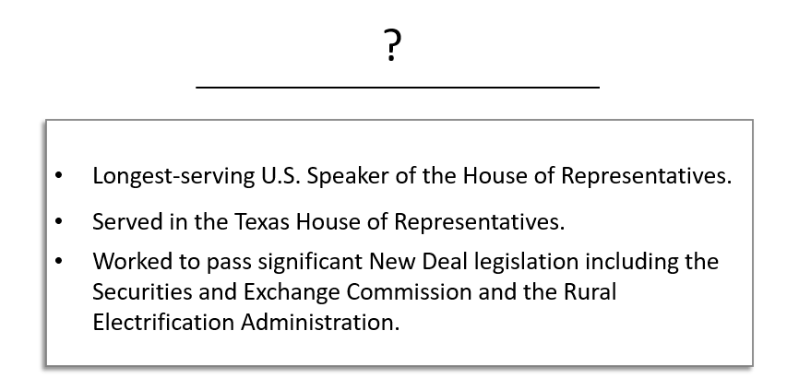
Which significant individual below correctly replaces the question mark for the list of accomplishments above?

  - Lyndon Baines Johnson
  - Sam Rayburn
  - John Nance Garner
  - Franklin Delano Roosevelt

- Which of the following headlines would you have been likely to find in a newspaper from October 29, 1929?

  - The Rural Electrification Administration Electrifies Texas Farms!
  - Franklin Delano Roosevelt Elected to His Second Term of Office!
  - Texas Panhandle Struck by Worst Dust Storm in History!
  - Stock Market Crash Causes the Loss of Millions of Dollars!

- Which statements most accurately explain the causes of the Dust Bowl?
Select two correct answers.

  - Over-farming the land and over-grazing cattle depleted the native grasses of the Great Plains.
  - A prolonged period of drought caused extremely dry topsoil that could be easily carried away by high winds.
  - The demand for crops rose exponentially in the decades prior to the 1930s due to the growing population and the demands of World War I.
  - Farmers planted an abundance of crops to help feed the millions of struggling Americans without enough food to eat during the Great Depression.
  - New Deal programs like the Civilian Conservation Corps initiated programs to replant native grasses in order to provide an anchor to the soil.

- Read the primary source excerpt below and answer the question that follows.
“The Brenham soil conservation was established in Brenham because a large group of public spirited men saw the need for this work in this county and requested that a camp be established here. Since October the 15th, 1934 the camp has supervised the soil and water conservation on 28 different farms, protecting approximately 3500 acres…”

- “Brenham Banner-Press (Brenham, Tex.), October 7, 1935.” The Portal to Texas History.

Which statement below most accurately relates to the information provided in the primary source excerpt above?
  - The federal government during the Great Depression was heavily focused on economic recovery and reform efforts.
  - Harmful farming practices of the prior decades depleted the native grasses of the Plains, and a prolonged period of drought made the loose soil very dry.
  - Addressing the environmental challenges facing the Great Plains was not a priority for President Roosevelt’s administration or his New Deal agenda.
  - During the Great Depression, people adapted to changes in the environment caused by the Dust Bowl and worked to address those changes.

- What was President Franklin D. Roosevelt’s plan to address the challenges and hardship caused by the Great Depression? Provide examples to support your answer.

Your response should contain three to five complete sentences.

- Which answer option below best explains the process that is depicted in the infographic below?

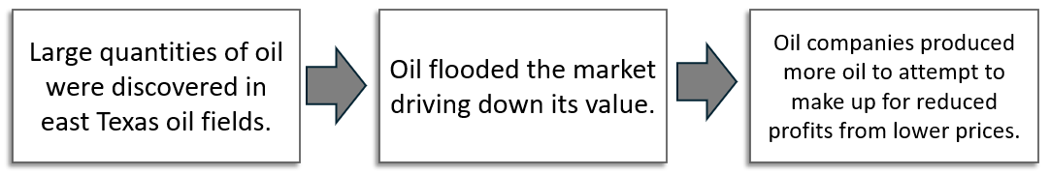

  - Boom and bust cycles in industry
  - The accumulation of debt due to buying stocks on margin
  - The harmful effects of over-farming and over-grazing cattle
  - Economic growth and development due to New Deal programs

