Texas Today Advanced
Unit 12: Great Depression

Name: |  | Date: |  | Period:

Texas State Parks:
The Legacy of the Civilian Conservation Corps in the Lone Star State
The Civilian Conservation Corps (CCC) played an integral role in establishing the state parks system that we have in Texas today. The CCC helped build 56 state, local, and federal parks in Texas during the 1930s. Out of the more than 90 state parks in Texas today, there are 29 CCC parks that are still in operation.  In this lesson, you will examine and report on one state park that the Civilian Conservation Corps helped establish during the Great Depression. | 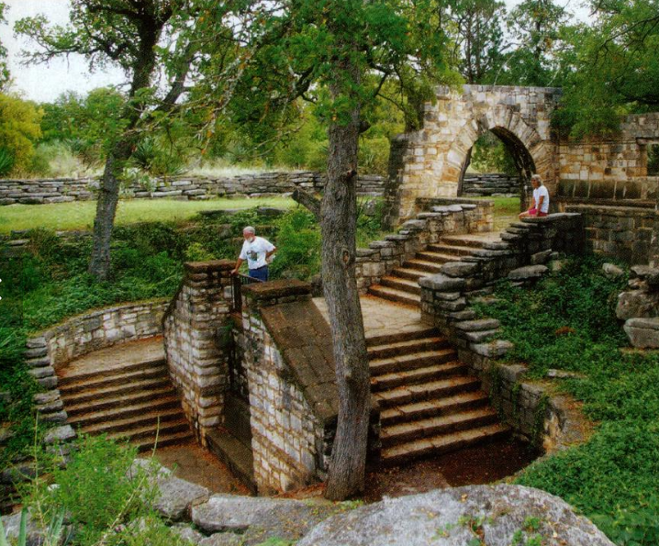  Figure 1: Longhorn Cavern state park, northwest of Austin. The Portal to Texas History.
Step 1: Choose one of the following state parks in the list below. Circle or highlight your chosen park. The page number next to your chosen park shows you where to locate information about your park in the next step.
Abilene (p.13) | David Mountains (p.24) | Lockhart (p. 34)
Balmorhea (p. 14) | Fort Parker (p. 25) | Longhorn Cavern (p. 35)
Bastrop (p. 15-16) | Garner (p. 26) | Meridian (p. 36)
Big Spring (p.17) | Goliad (p. 27) | Mission Tejas (p. 37)
Blanco (p.18) | Goose Island (p. 28) | Mother Neff (p. 38)
Bonham (p.19) | Huntsville (p. 29) | Palmetto (p. 39)
Buescher (p. 20) | Indian Lodge at Davis Mountains (p.30) | Palo Duro Canyon (p. 40)
Caddo Lake (p. 21) | Inks Lake (p. 31) | Possum Kingdom (p. 41)
Cleburne (p.22) | Lake Brownwood (p. 32) | Tyler (p. 42)
Dangerfield (p.23) | Lake Corpus Christi (p. 33)

Step 2: Conduct online research through the Portal to Texas History on your chosen state park. Follow the steps in the slideshow to navigate to the Portal to Texas History on any web browser to locate the Civilian Conservation Corps in Texas State Parks virtual book.
Name of your state park:

CCC Company or Companies that worked on this park (A 4 digit number in the top right corner) | Important Dates & their significance  Some parks do not have this information listed.

Interesting Facts & Information | Mark the approximate location of your park on the map.
 | 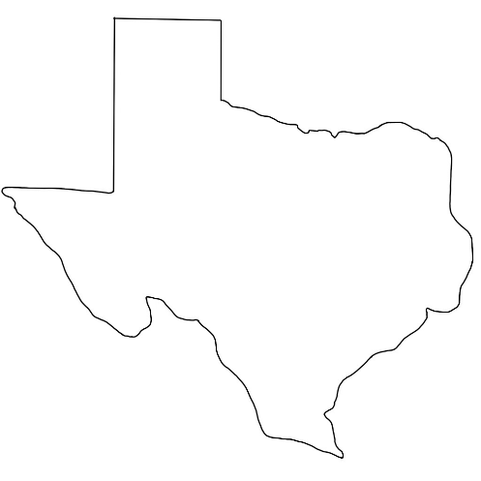

Identify 3 terms in your reading that might be unfamiliar to you or your classmates. Look up the definition of each term. Write the term below and use the definition to explain what it means in your own words.

Term 1:
Term 2:
Term 3:

Step 3: Learn from your classmates. Talk to THREE classmates about their parks and share information about your park with them. Record the information below.
Park #1: | Classmate’s name

1 interesting fact | Approximate Location | 1 new term & definition
 | 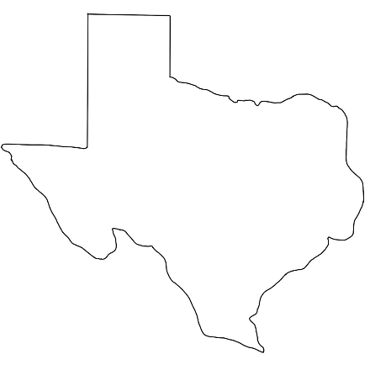

Use the new term in a sentence about this park

Park #1: | Classmate’s name

1 interesting fact | Approximate Location | 1 new term & definition

Use the new term in a sentence about this park
Park #3:
Classmate’s name:

1 interesting fact | Approximate Location | 1 new term & definition

Use the new term in a sentence about this park

Step 4: Read and respond to the prompt below. Write your response in 3 to 5 complete sentences.
Prompt: What was one way in which the Civilian Conservation Corps was significant to Texas during the Great Depression? How has the legacy of the CCC impacted Texas and Texans today?

