Texas Today Foundations
Unit 12: Great Depression

Name: |  | Date: |  | Period:

Texas State Parks:
The Legacy of the Civilian Conservation Corps in the Lone Star State
The Civilian Conservation Corps (CCC) played an important role in establishing the state parks system that we have in Texas today. The CCC helped build 56 state, local, and federal parks in Texas during the 1930s. Today, there are more than 90 state parks in Texas. Twenty-nine of those parks were established by the CCC.  In this lesson, you will examine and report on one state park that the Civilian Conservation Corps helped establish during the Great Depression. | 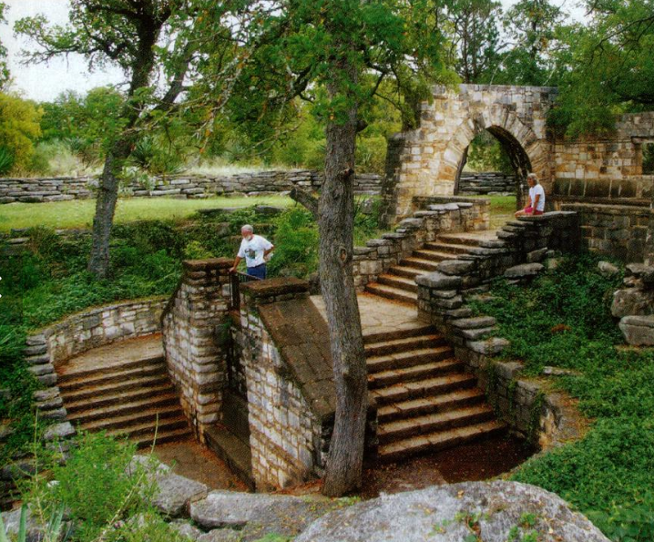  Figure 1: Longhorn Cavern state park, northwest of Austin. The Portal to Texas History.
Step 1: Choose one of the following state parks in the list below. Circle or highlight your chosen park. The page number next to your chosen park shows you where to locate information about your park in the next step.
Abilene (p.13) | David Mountains (p.24) | Lockhart (p. 34)
Balmorhea (p. 14) | Fort Parker (p. 25) | Longhorn Cavern (p. 35)
Bastrop (p. 15-16) | Garner (p. 26) | Meridian (p. 36)
Big Spring (p.17) | Goliad (p. 27) | Mission Tejas (p. 37)
Blanco (p.18) | Goose Island (p. 28) | Mother Neff (p. 38)
Bonham (p.19) | Huntsville (p. 29) | Palmetto (p. 39)
Buescher (p. 20) | Indian Lodge at Davis Mountains (p.30) | Palo Duro Canyon (p. 40)
Caddo Lake (p. 21) | Inks Lake (p. 31) | Possum Kingdom (p. 41)
Cleburne (p.22) | Lake Brownwood (p. 32) | Tyler (p. 42)
Dangerfield (p.23) | Lake Corpus Christi (p. 33)

Step 2: Conduct online research through the Portal to Texas History on your chosen state park. Follow the steps in the slideshow to navigate to the Portal to Texas History on any web browser to locate the Civilian Conservation Corps in Texas State Parks virtual book.
Name of your state park:

Interesting Facts & Information | Mark the approximate location of your park on the map.
 | 

Identify 1 term in your reading that might be unfamiliar to you or your classmates. Look up the definition of this term. Write the term below and explain what it means in your own words.

Term 1:

Step 3: Learn from your classmates. Talk to ONE classmate about their park and share information about your park with them. Record the information below.
Park #1:
Classmate’s name:

1 interesting fact | Approximate Location | 1 new term & definition
 | 

Step 4: Read and respond to the prompt below. Write your response in 3 to 5 complete sentences.
Prompt: What was one way in which the Civilian Conservation Corps was significant to Texas during the Great Depression? How has the legacy of the CCC impacted Texas and Texans today?
One way in which the Civilian Conservation Corps was significant to Texas during the Great Depression was ___________________________________________________________________________ _____________________________________________________________________________________________________
The legacy of the CCC has impacted Texas and Texans today by (a) terminating the state park system to reduce taxes and save money (b) helping establish numerous state parks that are still in operation today (c) providing reform to the banking system to protect peoples’ savings accounts and restore faith in U.S. banks.

